

GLASGOW CITY COUNCIL
SCHOOL-AGED CHILDCARE
FREE OR PARTIALLY FUNDED SUPPORT 26-27
April 26 - August 26

School Aged Childcare (SAC) – Early Adopter Programme in Glasgow
As part of the Scottish Government’s Tackling Child Poverty Delivery Plan, Glasgow City Council Education Services has received targeted funding to support the development and delivery of School Aged Childcare (SAC) that is accessible, affordable, and inclusive. This initiative is aligned with the national ambition to ensure that SAC is available to all eligible families, with free provision for the most vulnerable households.
Glasgow is one of several local authorities participating in the Early Adopter Programme, which aims to test models of SAC delivery in communities most affected by poverty. Funding has been allocated to support the costs of SAC for low-income families whose children are either currently attending or wish to attend SAC services within designated ward areas.
The following services are part of the EA programme.
Buddies Nursery Clubs & Services, Cojac, The Saturday Café.
If you would like to apply for this assistance, please complete the application form attached and return it to: educationsac@glasgow.gov.uk or your School Aged Childcare Provider.

GLASGOW CITY COUNCIL
SCHOOL-AGED CHILDCARE SUPPORT 26-27
Application Form April 26 - August 26

PART 1
To be considered for All Aged Childcare Funded Support, you must be able to select at least 1 box in each of the criteria 1 to 4.
Please either put an x or a tick in the box and return Part 1 and Part 2.
If you are unable to complete the application digitally, we can accept paper copies completed by hand. We are also more than happy to assist you in the completion of the application form.
If you are helping to fill out this form as a friend or relative, please put the details of the person who is applying.
Criteria 1.
Your child must be registered to attend one of the Services taking part in the Early Adopter Project. Currently, these are:
Buddies Nursery Clubs & Services, Cojac, The Saturday Café ☐
Criteria 2.
- You’re a parent of at least one child under 16 years old: Yes ☐
- You’re a kinship carer of at least one child under 16 years old: Yes ☐

Criteria 3.
You fall within one of the priority family types:
- Lone-parent families ☐
- minority ethnic families☐
- families with a disabled adult or child ☐
- families with a younger mother (under 25) ☐
- families with a child under one ☐
- Larger families (three + children) ☐
- Kinship Care Family: Yes ☐

Criteria 4.
Income
- Your Household earnings are below £50,000 and you receive the funded childcare element of support from Universal Credit/Working Tax Credit: Yes ☐
- Your Household earnings are below £50,000 and you do not receive the funded childcare element of support from Universal Credit/Working Tax Credit: Yes ☐
- You are a student and receive no/partial support with your childcare costs:
Yes ☐
- Kinship Care Family: Yes ☐

Current Benefits:
Are you or your partner at present receiving any of the following, either for yourself or for any children you have?
- Scottish Child Payment ☐
- Universal Credit ☐
- Working Tax Credit ☐
- Child Tax Credit ☐
- Best Start Foods ☐
- Best Start Grant ☐
- Council Tax Reduction ☐
- School Clothing Grant ☐
- Education Maintenance Allowance ☐
- Free School meals (on the basis of low income) ☐
- Income Support or Jobseekers' Allowance ☐
- Housing Benefit ☐
- Do you receive SDS child support from Social Work: Yes ☐
- None of the above: Yes ☐
PLEASE COMPLETE IN BLOCK CAPITALS
PART 2 – Tell us about you as the parent/guardian.
First name(s):

Last name :

Address

Postcode:

How will we contact you?

Your phone number
Is this phone a: mobile ☐ landline ☐
I do not have a phone number I can give you ☐
Your email:

We will communicate the outcome of the application by way of email in the first instance.

If you are a student, do you get support with your costs:
No: ☐ Partial: ☐ Full: ☐
Are you employed:
Yes ☐ No ☐
Would you be interested in training opportunities to become a childcare practitioner:
Yes ☐ No ☐
Would you be interested in employment and training opportunities:
Yes ☐ No ☐
If you are in employment, education or training (including if currently on leave or sick), around how many hours do you work/study/train in a normal week?
- 30 or more hours a week ☐
- At least 15 hours a week but less than 30 hours ☐
- Less than 15 hours a week ☐

Pattern of Children Attending All-Aged Childcare / School-Aged Childcare Sessions and Days
We need to know about the children attending the AAC/SAC Provider and the number of days and sessions.
Please tick the box(s) that apply to you.
Name of the AAC/SAC Provider attending: ……………………………………………………………….
Start Date: ………………………………………………….
Is this holiday provision only during the school term ☐
Is this Term Time Only ☐
Is this Summer provision only ☐
Is this all year ☐
Days of Attendance - Holiday provision during school term only:
Monday | Tuesday | Wednesday | Thursday | Friday | Saturday | Sunday

Days of Attendance - Term Time only:
Monday | Tuesday | Wednesday | Thursday | Friday | Saturday | Sunday

Days of Attendance - Summer provision only:
Monday | Tuesday | Wednesday | Thursday | Friday | Saturday | Sunday

Days of Attendance - All Year:
Monday | Tuesday | Wednesday | Thursday | Friday | Saturday | Sunday

Details of Children Attending the AAC/SAC Service
If you have more than three children attending and run out of space, please add the details of the other children in the box below.
1.
First name(s)

Last name

Date of birth D M YYYY
Is this child named on either you or your partner’s Child Tax Credit, Child Benefit, Universal Credit or Pension Credit claim, Kinship Care Agreement? Yes ☐ No☐

2.
First name(s)

Last name

Date of birth D M YYYY
Is this child named on either you or your partner’s Child Tax Credit, Child Benefit, Universal Credit or Pension Credit claim, Kinship Care Agreement? Yes ☐ No ☐

3.
First name(s)

Last name

Date of birth D M YYYY
Is this child named on either you or your partner’s Child Tax Credit, Child Benefit, Universal Credit or Pension Credit Claim, Kinship Care Agreement? Yes ☐ No ☐
Additional Children Details/ other details you think are relevant:

How did you hear about the AAC/SAC Service:

This lets us know how we can improve our engagement with families.
How did you hear about the SAC/AAC Support?
GFIS Website ☐
School ☐
AAC provider ☐
SAC provider ☐
Other ☐ Please specify ……………………………………………………….

Which of these phrases would you say best describes how you and your household are managing financially these days?
- Manage very well ☐
- Manage quite well ☐
- Get by alright ☐
- Don't manage very well ☐
- Have some financial difficulties ☐
- Are in deep financial trouble ☐
- Unsure ☐

How is your own health in general? Would you say it is:
- Excellent ☐
- Good ☐
- Fair ☐
- Poor ☐
- Prefer not to say ☐

How is your child's health in general? Would you say it is:
- Excellent ☐
- Good ☐
- Fair ☐
- Poor ☐
- Prefer not to say ☐

Would you like to take part in further engagement to allow us to understand how best to support your family's needs:
Yes ☐
No ☐

City-Wide Support to Glasgow Families

Would you like us to refer your contact details to Glasgow Life - Family Finance Approach?
They can help you get back into employment, maximize benefits, or progress in your career.
For further information, please see link - https://www.glasgowlife.org.uk/libraries/work-money-and-learning/family-finances-approach
Yes ☐
No ☐

Would you like us to refer your contact details to Glasgow Helps?
They can assist with holistic family support. They listen, understand your needs, and work with you to connect you to the right assistance, in the right place, at the right time.
For further information, please see link – https://www.glasgow.gov.uk/glasgowhelps
Yes ☐
No ☐


Please scan the QR codes below for more details on the above city-wide support available to Glasgow Families.


GCC - Glasgow Helps Glasgow Life - Family Finance

Further information/support available can be accessed by following the links below.

CHILDCARE CHOICES: -
https://www.childcarechoices.gov.uk/

FUNDED EARLY LEARNING AND CHILDCARE HELP WITH COSTS: –
https://www.mygov.scot/childcare-costs-help/funded-early-learning-and-childcare

SOCIAL SECURITY SCOTLAND :-
www.mygov.scot or by calling Social Security Scotland free on 0800 182 2222.
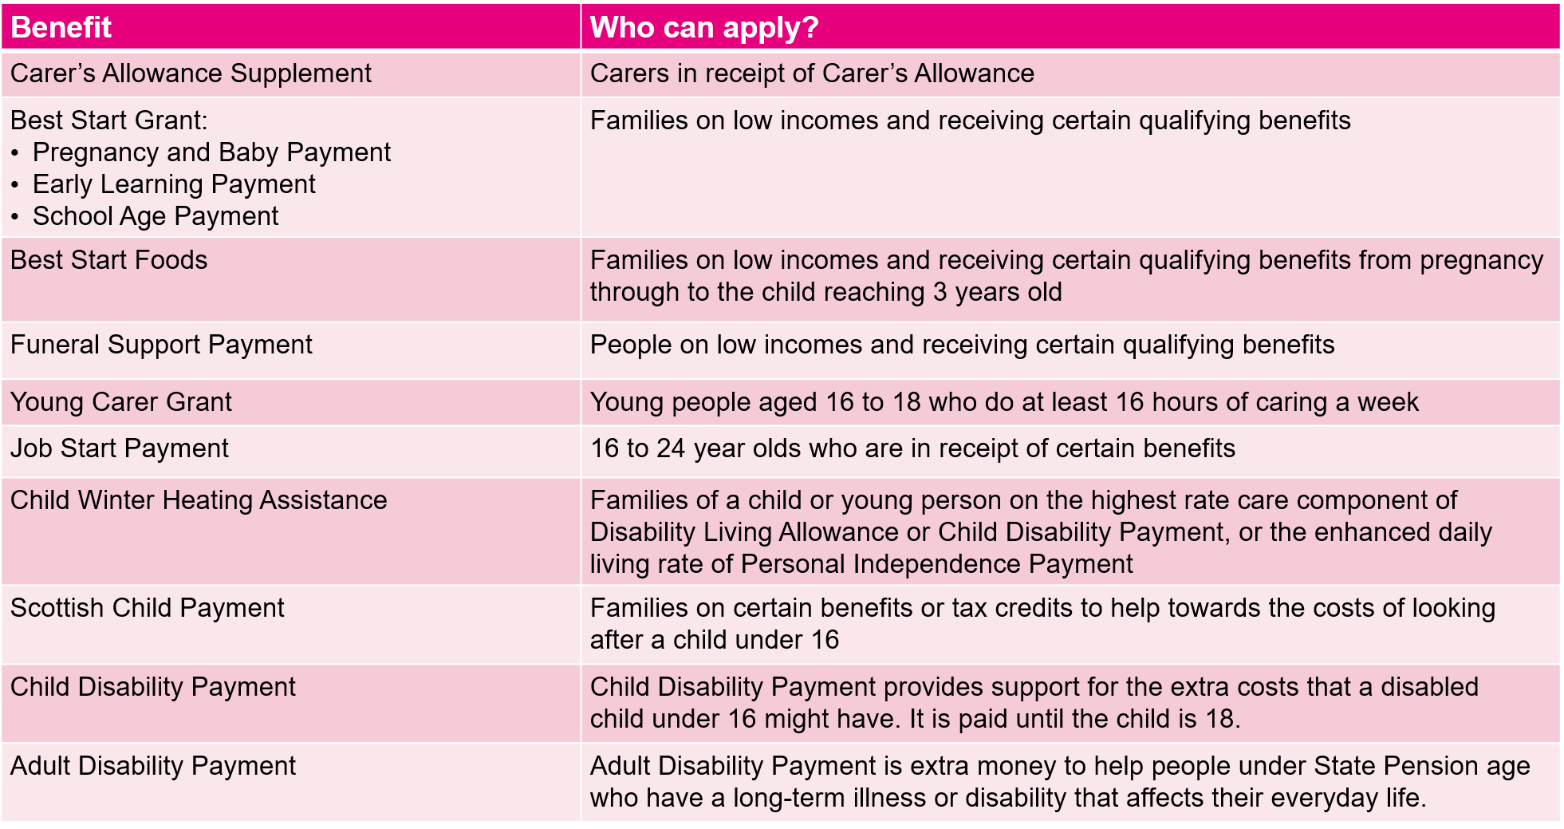

Things you need to understand/agree on before you submit your application form.
All sessions funded will be paid directly by GCC to the SAC/AAC provider and not the parent/guardian.
Please check with DWP, Social Security Scotland, to ensure that this support does not affect your current benefit entitlement.
Please check with Social Work if you receive SDS to ensure this support does not affect your current entitlement.
You agree to us updating the SAC/AAC provider when we have approved the application.
You may be contacted to offer assistance with benefit maximization.
Details submitted in the application may be anonymized and used for research and statistical reporting.
By signing this application, you agree to the following statements:
As far as I know and believe, I declare that the information I have given in this form is correct and complete.
I understand that I may be breaking the law and could be prosecuted if I provide details that are not correct and complete.
I agree to update Glasgow City Council by emailing educationsac@glasgow.gov.uk and the SAC/All-Aged Childcare provider straight away if there are any changes to the details of my circumstances that I have given in this form.
This could be if:
I’m no longer looking after a child.
My financial circumstances have changed.
The child no longer attends the SAC/AAC provider.
The number of attending days has increased/decreased.
I understand that if I do not report these changes:
I may be breaking the law.
It may affect my ongoing support.
I may be prosecuted.
Support may be reduced if I receive too much.
If I am acting on behalf of an entitled individual, I agree to be liable to pay Glasgow City Council the value of any assistance given in error, unless that error is neither my fault nor the kind of error that a person acting on an individual’s behalf could reasonably be expected to notice.

Your signature:

Date D M YYY

If you’re filling in this form on behalf of someone who cannot manage their own affairs, or if you’re helping a friend or family member to fill out the form. We’d like you to give us your details.

First name(s)

Last name

Company or organisation name:

Address

Postcode

Contact Number:

Please now return the complete application for consideration/approval to educationsac@glasgow.gov.uk or directly to your AAC provider.
If you would like to chat to us about your application, please call: 0141 287 4453.
For information on how we use your data, please refer to the following link:
https://www.goglasgow.org.uk/ResourceItems/Visit/2550

