Elmcroft Nursery
School Handbook
2022/2023

Elmcroft Nursery School
40 Croftcroighn Road
Ruchazie
Glasgow
G33 3SE

Tel: -0141 774 9311
E-mail: Headteacher@elmcroft-nursery.glasgow.sch.uk
Twitter @elmcroftnursery


Introduction

On behalf of all the staff I warmly welcome you to Elmcroft Nursery.

If this is your first experience of a nursery, then I hope this handbook will be a helpful guide and will give you a glimpse of the life at Elmcroft Nursery.

Please do not hesitate to contact the nursery if you require more information. We look forward to having you and your child join our service and hope that this will be the start of a strong partnership.

Yours sincerely

Cheryl Taylor
Head of Nursery




The Establishment and the Community
The nursery opened in 1976 and is an established part of the community. A few of today’s parents/grandparents are ex-pupils. The continuity of staffing has helped to produce the happy, relaxed relationship with the community at large.
The Nursery is also a part of Smithycroft Learning Community.
We also have formed close links with Craigend Gardens Care Home and Ruchazie Pantry and we are frequent visitors.

Staff Team
Leadership Team
Cheryl Taylor Head of Nursery
Kimberley Johnstone Depute of Nursery
Karen Beaton Team Leader
Courtney Williamson Lead Practitioner-Attainment

Child Development Officers
2-3 room
Danielle Panton
Kellyanne Burns
Tia Ashton (P/T)
Natalie Robinson (P/T)
Nicole Carroll

3-5 Room
Linda Reynolds
Liz Duffy
Marie McGoldrick
Frances Sharp
Leeann Stewart
Gillian Aitken
Angela Collins
Emma Neil
Leeann Patterson
Alan Whyte
Hannah Jenkins (Temporary Staff)
Carly McEwan (Modern apprentice)

Support for learning workers
Lisa McIntosh
Nicola Moore
Paula Lamont
Carly McEwan (Modern apprentice)

Additional Staff
Gillian Howie- Administrator (part time)
Jodie Adair Administrator (part time)
Sharon McAllister- Janitor
Sarah Smith/ Katie & Deborah- Day Cleaners
Mirannda McKillop- Dining Assistant
Carol Frew- Dining Assistant
Joyce Kenna- Dining Assistant

Services offered at Elmcroft:
The capacity of the Establishment agreed by the Care Inspectorate is 72 children in total per session.
60 children 3-5yrs. Ratio – 1 adult to 8 children
12 children 2-3yrs. Ratio – 1 adult to 5 children

Social, Moral and Cultural Values
Elmcroft Nursery aims to promote equal opportunities for every child, irrespective of gender, ethnic grouping, creed, disability, or social-economic background.
The nursery aims to raise awareness of the importance of relationships with others. We are committed to the promotion of support and mutual respect for all as part of the Health and Wellbeing Curriculum.


Denomination Status:
The nursery is non-denominational. We respect and welcome children, parents, and carers of all religions, faith and beliefs.

Nursery Hours
From August 2020 we have been offering all our 3-5 children and eligible 2-3 children 1140 hours free childcare as a result of The Scottish Government initiative.
If parents/carers require additional childcare out with their entitled hours please speak to the nursery Leadership team for more information.
The nursery provides lunches for all morning and full day children. Afternoon children will not receive a hot lunch but will have an enhanced snack during their session.

Morning Session - 8.00am - 12.45pm
Afternoon Session- 1.00pm – 5.45pm
Full day - 8.00am-5.45pm

It is important that children are collected and vacate the building on or before 12.45am/5.45pm as staff are involved in preparing the playrooms for the following sessions. Please contact the nursery if for any reason you are running late. The building will be locked at 6pm

Enrolment
All nursery places are allocated in line with Glasgow City Council’s Admission and Charging Policy for Early Years. Nursery staff will be happy to advise you how this policy operates when you apply for a place for your child. A leaflet detailing the Council’s policy is also available from all

establishments. If you wish a copy, please ask for one. When you are enquiring about making an application for your child to start nursery, we will make an appointment for you to come in, we will also advise you of what documentation is required for the application process.
Places are allocated by a local admissions panel. When a place becomes available you will receive a letter from the Head of Nursery detailing a start date and time. Please take some time to be with your child on their first week as part of our settling in process. Some children settle more quickly than others. On their first day they are invited to stay for an hour only. Your child’s keyworker with work with you at arrange when it would be available to leave your child.
Please note that it is necessary for an adult (age16 years or over) to bring your child to and from the nursery.

Charging Policy
These charges apply to paid places and additional hours

From the new term beginning August 2021 Glasgow has revised the prices of its Nursery Fees

Non-resident rate
£5.00 per hour – For people living out with Glasgow
If college/university are paying childcare charges.

Discounted Rate
£4.00 per hour -For all Glasgow residents (children 3-5 years)
£3.00 per hour- For all Glasgow residents (children 2-3 years)

Residents Reduced Rate: £1
The Residents Reduced Rate is offered to kinship carers, those parents who have a household income of less than £16,480, on Universal credit and take home is £625 per month or less or on Working tax credit earning can be £7,500 per year or less.

Resident Second Child Hourly Rate: £2.20
If you have another child already attending nursery

Meals and Snack
Lunch - £1.52
Snack - N/A


School term dates 2022/23
August
- Monday 15-16th August 2022 (Return date for Teachers & In-Service Day)
- Wednesday 17 August 2022 (Return date for the pupils)
September Weekend
- Friday 23rd to September 2022 Monday 26th September 2022
October
- Friday 14th October 2022 (In-Service Day)
- Monday 17th to Friday 21st October 2022 (October Week for Term time children)
December - Christmas and New Year
- Nursery close on Thursday 22nd December 2022-
- Friday 23rd December 2022 - Tuesday 3rd January 2023 (Christmas holidays)
January
- Schools return on Wednesday 4th January 2023
February Mid-term break
- Monday 13th February 2023
- Tuesday 14th February 2023
- Wednesday 15th February 2023 (In-service day)
April - Spring Holiday (Easter)
- Nursery close on Friday 31st March 2023
- Monday 3rd April to Friday 14th April 2023 (Spring break for term time children)
- Nursery return on Monday 17th April 2023
May
- Monday 1st May 2023 (May Holiday)
- Thursday 25th May 20223 (In-Service day)
- Friday 26th to Monday 29th May 2023 (May weekend)
June
- Nursery Close on Friday 24 June 202

Settling

The nursery operates a key-worker system. Your child’s key worker is simply your child’s special person whom they can relate to along with all other staff. Your child’s key worker will assist you in settling your child, progress meetings and other times you feel you wish to speak to them. Please spend time exploring the environment with your child on their 1st day and help them become familiar with the toilets and play areas. Children usually settle very quickly, however all children are different. This may take a few days or up to a couple of weeks for some. It is important for you to spend time to settle them and to ensure they feel safe and secure in our environment as leaving your parent/carer for the first time can be a daunting experience. Your child’s key worker will discuss what time to bring and collect your child and whether you can leave or are required to stay. Getting it right at this stage builds their confidence. Your child’s first visit is normally around 1 hour long depending on each individual child. Your child’s time will be extended on an individual basis and as the weeks go on. Your child’s key worker will keep you informed of these changes. It is important for parents/cares to remember that although people have busy lives and commitments, it is important that your child is happy, content and settled before you can leave the building.



Snacks and the Promotion of Healthy Eating
In line with Glasgow City Council’s policy on healthy eating, children are offered the following at snack time
- Plain milk or water
- A selection of fruit
- Foods relating to children’s learning
- Toast, sandwich, pancake, crackers, fruit loaf.

Nursery Visions, values and Aims
At Elmcroft Nursery our vision is to create a warm, nurturing, stimulating and secure environment in where everyone feels valued and included. We strive to provide a learning environment which is rich in opportunities to promote our children’s health& Wellbeing and their overall learning and development.

We aim to: -
- To foster a positive, inclusive partnership with all families and strong collaboration with colleagues from other services to support and meet the needs of our families.
- To provide a holistic learning environment which supports the individual needs of all learners.
- To build on the success children bring from home.
- To have our children and families at the heart of our decision-making processes.

Our values are:-
- We value good working partnerships with our parents and wider community to allow us to provide a high-quality service which meets the need of our individual children and families
- We value, respect and believe that everyone has a key role to play in our nursery
- We value learning and celebrate the achievements of all
- We value culture and celebrate all that makes us unique
- We value and create an ethos of respect which facilitates positive relationships and learning

Family Engagement
We encourage parents and carers to be involved in many ways and contribute to the life of the nursery. Throughout the year we invite you to parents’ meetings, nursery shows and to take part in fundraising events. We also are delighted to have parents involved from time to time with storytelling, gardening, and music activities and baking. If you have a skill or a hobby and would like to be involved, please speak to a member of staff. We also have a variety of nursery to home learning links, such as our lending library or story sacks which are available to borrow.


Parents Groups
The establishment has a Parents Group, and all parents are encouraged to take part. The groups aim to meet once a term to help raise funds and to discuss nursery business.
Please speak to any member of staff if you wish to be involved in any of these groups or if you wish to be involved in any other way at the nursery.

Promoting Emotional Wellbeing
The approach within Elmcroft Nursery is to build a positive ethos that demonstrates care and respect for all. Positive behaviour is recognised and celebrated. The PATHS (Promoting Alternative Thinking Strategies) programme operates within our nursery. PATHS is a social and emotional development programme aimed at children 3-5 years old. It supports the development of emotional awareness and the vocabulary and language of emotions. It teaches children problem solving skills and can help them develop positive peer relationships.
In our establishment and throughout the programme, staff consistently promote positive behaviour and provide opportunities for children to experience success. Staff recognise that all achievements are worthy of praise and recognition. Respect, Trust, Fairness, and equality is promoted and shared within our establishment.

Clothing
Parents are advised to put their children’s names on all items of clothing. Whilst every effort is made to ensure the safety of children’s possessions Glasgow City Council cannot take responsibility for any item which may go missing, so parents are advised not to leave expensive clothing in the cloakroom.

There are forms of dress which are unacceptable in the nursery, such as items of clothing which:
- Potentially encourage faction (such as football colours)
- Could cause offence (such as anti-religious symbolism or political slogans.
- Could cause health and safety difficulties, such as loose-fitting clothing, dangling earrings.
- Carry advertising, particularly for alcohol of tobacco.

Children have the best fun when they can get messy without worrying about dirt on their clothes. Please ensure that your child wears clothes that can allow for paint or other messy materials. We will always try to make sure that children wear an apron, but accidents happen so please dress

your child in suitable clothing. Please ensure your child has a pair of shoes that are suitable to be worn indoors and outdoors.

Children may occasionally have to change into dry clothing if they have become wet in the water or outdoors or through toilet training accidents. Please ensure that your child has a change of clothing (always including underwear) in their bag as well as a pack of wipes.


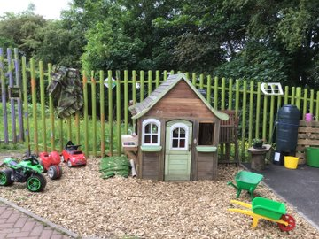
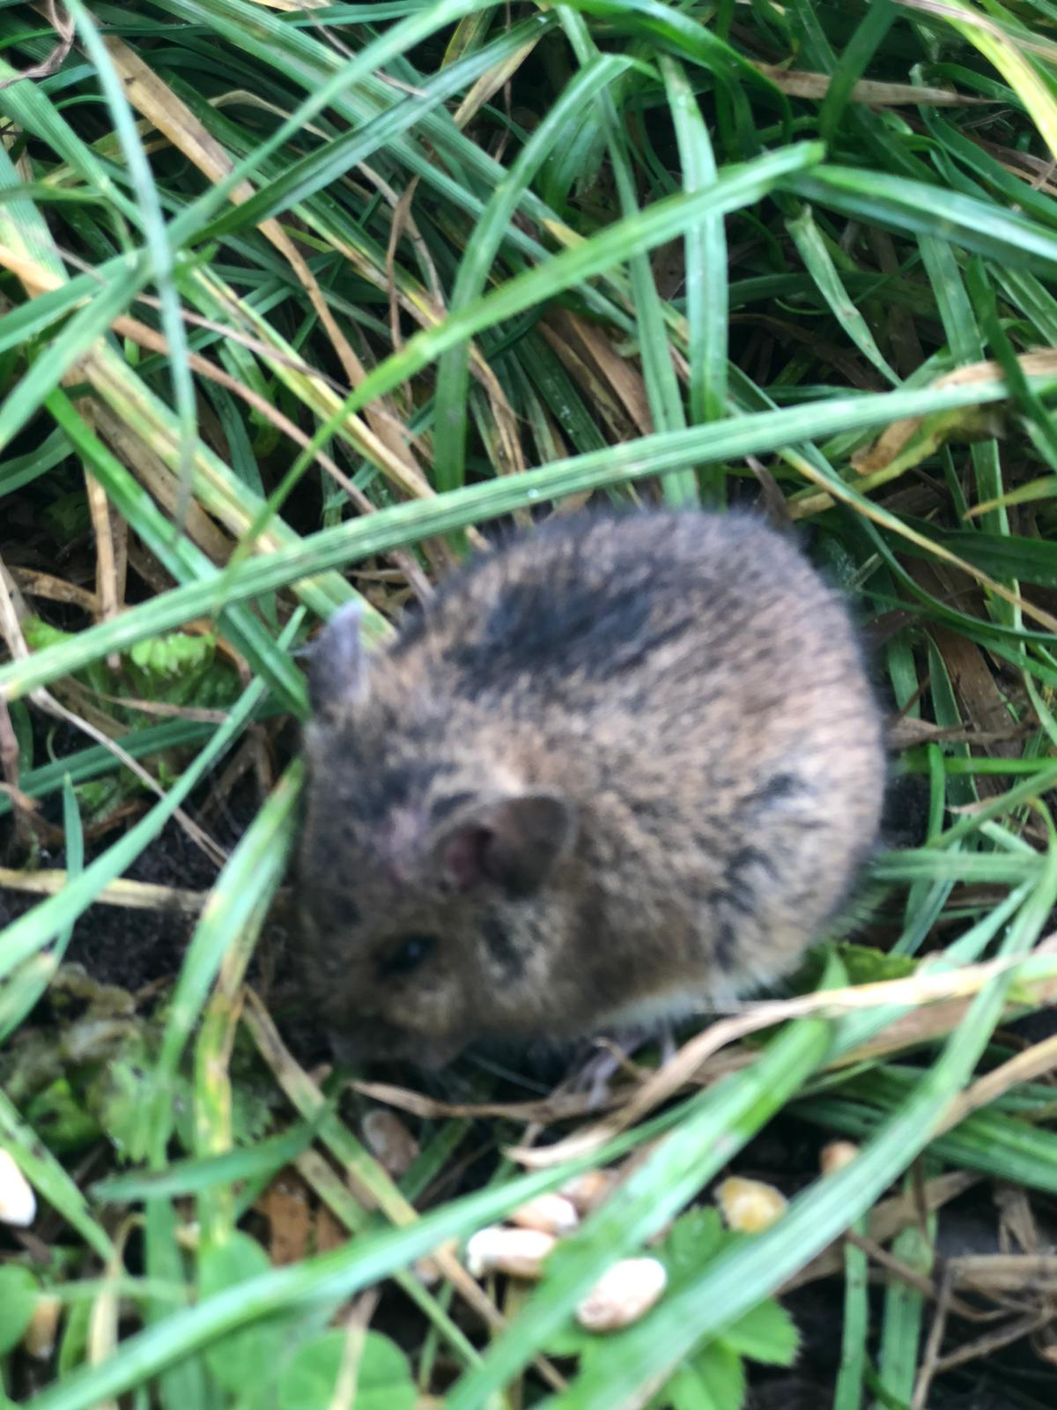

Outdoor Learning
At Elmcroft Nursery we place high importance on the benefits of outdoor play and spend extended periods of time exploring our garden, our very own forest and our community. Spending time outdoors has many benefits, and we aim to encourage all our children to take part and experience these wonderful opportunities.
Benefits of outdoor play
- Encourages an Active Lifestyle

Appreciation of Nature and the Environment

Develops Social Skills

Encourages Independence

Understanding and gain the ability to manage own Risks

Enhance gross motor skills

Develop their curiosity and imagination skills

Please also ensure that your child has suitable outdoor clothing appropriate for all weather conditions. No need to supply your own wellington boots or puddle suit- We have it covered!

Children Absences
Parents are requested to ensure that their child attends as regularly as possible, to get the most from their time at nursery. Although nursery is not statutory education, we have obligations through child protection procedures to check on absences. Please inform the nursery if your child is unwell to allow us to record the absence and the reason why. If we have not been informed a member of staff will contact the main carer through telephone or text message.

Should your child seem unwell, please do not bring him/her until completely recovered. Please keep in touch with the nursery school during an absence, as we do like to know how they are. Should a child be absent for 4 consecutive weeks without any contact, then we will letter you, if no response it will be assumed that the place is no longer required, and the place will be assigned to another child through the admission panel.



Medical Information
Many children will at some time require medication whilst attending the nursery. Whilst it is not our policy to care for sick children, we recognise that some children require medicating, to allow them to complete a course of antibiotics or for long term health reasons such as asthma.
If your child needs medication during his/her time at nursery, you should discuss his/her requirements with management. A member of staff will only administer drugs which are prescribed by a doctor and the child’s name is clearly printed on the medication, you will also need to fill a consent form, which authorises a member of staff to administer the drugs to your child. A member of management will give you the necessary forms to complete. All medical issues should be discussed with a member of management to ensure we are able to meet your child’s health needs. Please also ensure this information is included on their enrolment form and care plan.

If your child becomes ill
Please contact the nursery if your child is not able to attend on a particular day. If your child has vomiting or diarrhoea, they must not return to nursery until they have been clear for 48 hours. For any other illness please contact the nursery

If your child becomes ill while at nursery, you the parent/carer will be contacted by telephone. (Please note that the nursery number may show up as withheld or unknown)
Please ensure that all contact numbers are updated regularly. We require at least 2 emergency contact number for your child.

Minor Accidents and Upsets
We must emphasise that every precaution is taken to avoid accidents within the nursery. If any accidents occur staff will complete an Accident Report Form if first aid has been administered, which will then be discussed with you when you collect your child. If your child has a head bump our policy is to give you a curtsy call or , If a more serious accident should occur every effort will be made to contact the parent and any further assistance required will be offered. If a parent cannot be contacted arrangements will be made to seek medical advice for the child.



Teaching and Learning
The Planning Curriculum(s)
In line with all other educational establishments, Elmcroft nursery will be using the document “A Curriculum for Excellence” for our children aged 3-5 years. As the parent/carer we value your role as the prime educator, and we aim to develop and build upon the fantastic work that you have begun and to establish a partnership with you for the benefit of your child. We shall provide quality childcare and education within a flexible service, meeting the needs of the individual child and family, offering a balanced curriculum in a happy, safe and stimulating environment.
In our 2-3 playroom the staff use the Pre-Birth to three Document alongside Realising the Ambition and Schematic Play documents, to plan for the children’s learning. If you are interested in finding out more about your child’s learning or the curriculum, please speak to a member of the nursery Leadership team.
Most children that have a place at Elmcroft nursery will transition from one playroom to another as they get older and will move from 2-3 room to the 3-5 playroom. Staff will use the curricular planning document that is appropriate to the child’s age/stage or his/her developmental stage. All nursery children will have ample opportunities for a smooth transition to their new playrooms in the days and weeks before they finally move.

Assessment/Reporting
Children are assessed informally throughout the year. This allows staff to identify your child’s strengths and learning priorities. A range of informal assessments strategies are used; learning conversations with your child, observations of their play and learning and some of children’s work. We have recently introduced trackers to allow staff to make judgments on the children’s progress. A written report is completed on the last term and discussed with parents. Staff will also have meetings with parents at another point during the year to discuss your child’s progress and development. Remember if you have any concerns, please bring them to the attention of staff at any time.

Children’s Profiles
Your child will have their own individual ‘Learning Story’ which will be used to record their significant learning and achievements. These are individual and personal to your child to record their learning and achievements. We are moving to online learning journals through Seesaw which will afford you with the opportunity to have daily access to your child’s learning journal.
The children will be encouraged to have ownership of their journals and be involved in adding photographs and comments. Over the weeks and months nursery staff, with your child, will add to the learning story.
The stories will contain observations of your child’s learning and photographs highlighting specific aspects of their development. This is one of many tools we use to track children learning and plan for next steps in their development.

Support for Pupils
Nursery staff have a duty to ensure that all children are supported to achieve their potential. They are committed to working closely with parents/carers and other professionals such as Health
Visitors, Doctors, Speech and Language Therapists, Educational Psychologists, Social Workers and others to provide whatever support is required to assist children with their individual needs and
requirements in learning development, pastoral care and health issues. If you feel that your child requires additional support in any way please speak to a member of staff. When children with support needs are transferring to Primary School, arrangements will be discussed with parents/carers and the receiving school. We are committed to working closely with parents/carers to ensure that they are fully involved in any decisions about support for their child’s needs.

GCC Policy – Glasgow City Council has a duty, as outlined in the Standards in Scotland’s Schools 2000 Act, to ensure that your child achieves their potential. Glasgow’s Education Services is committed to the inclusion of all children and young people with additional support needs, where possible, within mainstream schools. This is in accordance with the statutory requirement in the 2000 Act. It is also part of Glasgow’s policy to maintain a range of special educational establishments.

Any parent/carer seeking further advice regarding this policy should contact the Head of Nursery in the first instance.


Child Welfare and Safety
All educational establishments and services must take positive steps to help children protect themselves by ensuring that programmes of health and personal safety are central to the curriculum and should have in place a curriculum that ensures that children have a clear understanding of the difference between appropriate and inappropriate behaviour on the part of another person, no matter who.

As with other areas of the curriculum, you will be kept informed of the health and personal safety programme for your child’s establishment.
Educational establishments and services must create and maintain a positive ethos and climate which actively promotes child welfare and a safe environment by:

- Ensuring that children are respected and listened to
- Ensuring that programmes of health and personal safety are central to the curriculum
- Ensuring that staff are aware of child protection issues and procedures
- Establishing and maintaining close working relationships and arrangements with all other agencies to make sure that professionals collaborate effectively in protecting children

Should any member of staff have concerns regarding the welfare or safety of any child they must report these concerns to the Head of Establishment or the person deputising for the head of establishment. He/she after judging that there may be grounds for concern regarding the welfare
or safety of any child must then immediately advise the duty Senior Social Worker at the local Social Work Services area office of these circumstances.

Accessible Access: The nursery has an accessible entrance at the side of the building and an adult toilet in the main building. No children’s toilets have been adapted as yet.


Services within the Community
The nursery has friendly links with the local Social Work Department and Quarriers Family Resource Project. Should there be an emergency in a family, we work together to assist children and parents.

We also have close links within Craigend Care Home where the children enjoy frequent visits, and we plan to extend this further over the upcoming year. We know that both the residents in the home and the children benefit greatly from intergenerational working.
Members of the community also support us with our Eco work and garden improvements.
We are continually building relationships with Ruchazie Pantry a new community run shop that tackles food waste and food poverty.

Links with Primary Schools
The nursery maintains close links with Sunnyside, Avenue End and St. Rose of Lima Primary Schools and staff visits in both directions are encouraged. All primary schools organise transition programmes to which parents and children are invited to visit the schools. A teacher will visit the nursery to see the children at play and a transition record is completed for the receiving primary school, to pass on relevant information.
As part of Smithycroft Learning Community we have established links with other primary schools, early learning and childcare establishments and Smithycroft Secondary School.

Medical & Healthcare
At various times during the year health care service visit the nursery to work with the children; Visions Screening, Fluoride Tooth Varnishing. We shall keep you informed of dates and issue the necessary permission forms for you to complete.

Information in Emergencies
We make every effort to maintain a full educational service, but on some occasions, circumstances arise which lead to disruption. Establishments may be affected by, for example, severe weather, temporary interruption of transport, power failures or difficulties of fuel supply. In such cases we shall do all we can to let you know about the details of closure or re-opening. We shall keep you informed by using letters, notices in local shops and community centres, announcements in local places of worship and announcements in the press and on local radio.

Dealing with Racial Harassment
The Race Relations Act of 1976 makes it unlawful to discriminate against someone because of his/her colour, race, nationality, ethnic or national background. The Act makes it the duty of Glasgow City Council to eliminate unlawful racial discrimination.
In 1999 the guidelines ‘Dealing with Racial Harassment’ were issued to assist all teaching staff in dealing with such incidents.
The adoption of an anti-racist approach should be seen as one part of the continuing attempt to improve the quality of education.
Glasgow City Council recognises that support from the home is essential if these aims are to be achieved. Every child in Glasgow has the right to be happy and secure at establishment.

Care Inspectorate
The Care Inspectorate are responsible for regulating care services against national Health and Social Care Standards according to the requirements of the regulation of care (Scotland) Act 2001 and associated regulations. HM Inspectorate of Education is jointly responsible with Care
Inspectorate for the inspection of early education and childcare and every three years, each nursery will be jointly inspected by Care Inspectorate and her Majesty Inspectorate of Education.
Our reports from Care Inspectorate and HMIE can be found on display in the parent area as can their contact details should you wish them

Nursery Policies
There are a wide range of policies covering aspects of the work and routines of the nursery. These include; Management of Health and Safety, Curriculum, Administering First Aid, and Child Welfare and Safety. The complete range of policies are available in the school office.
A summary booklet on curriculum and routines is provided on enrolment.

Data Protection
As a local authority our schools and early year’s establishments process information about children and young people in order to provide education and care. In doing so we must comply with the Data Protection Act (1998). This means, amongst other things that the data held about children and young people must only be used for specific purposes. However, you should be aware that we may use this information for other legitimate purposes and may share this information where necessary with other bodies responsible for administering services to children and young people, or where otherwise required by law. We may also use any information for research purposes. However, all data is treated as confidential and is only used in accordance with the Data Protection Act and the Information Use and Privacy Policy approved by the City Council.

Nursery Improvement

The key to improvement for Elmcroft nursery lies in reflective practice. The more that we are able to reflect on and analyse what we do at present time, the more able we are to build on our strengths and improve our weaknesses. The central purpose of self-evaluation is to improve our provision and to ensure better outcomes for our children and families. Self-evaluation works best when everyone is involved.
On an annual basis, you will have access to our Standards and Quality report. This report highlights progress in key curricular areas such as Literacy, Numeracy and health and wellbeing. Our priorities for improvement for the year ahead are detailed in our nursery improvement plan which is available on our parent notice board.



Concerns and Complaints
In Elmcroft nursery we aim to have positive relationships at the heart of everything we do. However, if you have a concern or complaint, please approach the Head of nursery in the first instance.

Glasgow City Council complaints procedures are available
https://www.glasgow.gov.uk/index.aspx?articleid=16133

Customer Care Team
Customer & Business Services
Glasgow City Council
City Chambers
Glasgow G2 1DU
Tel 0141 287 0900
Email: customercare@glasgow.gov.uk

Other relevant Contacts and addresses

Early Years Charging Team
Glasgow City Council
Centenary House
100 Morrison Street
Glasgow
G5 8LN
0141 287 4702

Executive Director of Education:
Douglas Hutchison 0141 287 2000
Education Services
Glasgow City Council
City Chambers East
40 John Street
Glasgow
G1 1JL
0141 287 2000

