Green Trees Nursery

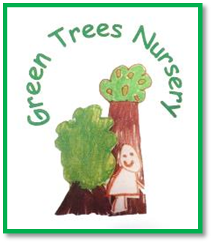

111 Baltic Street
Glasgow
G40 3BA

Tel. No. 0141 554 0578
Email Headteacher@greentrees-nursery.glasgow.sch.uk

Nursery Hand Book

Green Trees Nursery

111 Baltic Street
GLASGOW
G40 3BA

Tel 0141 554 0578
Email headteacher@greentrees-nursery.glasgow.sch.uk
Web www.greentrees-nursery.glasgow.sch.uk



Dear Parents/Carers,

Welcome to Green Trees Nursery!
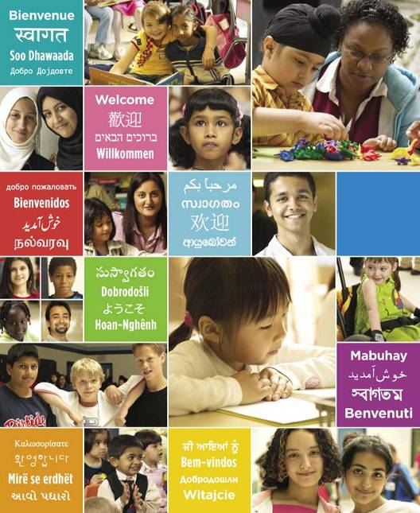
The nursery provides a safe and welcoming atmosphere, which will encourage your child to develop and learn. This hand book is to let you know about our school, the education we offer, and the ways in which we provide it and what we expect of you as partners in learning.
Parents and carers are invited to play an active role in this very important stage of your child’s development. During the year we will keep you up to date with the life and work of the school with regular newsletters, informal chat, and our notice boards and displays.
The staff and I are always pleased to talk with you and to answer any questions you may have but this not always easy to do in the middle of a busy playroom. If you wish to discuss something in detail, or to talk privately, please let me know and I shall arrange a time to meet with you.
We hope you will enjoy your time at Green Trees Nursery and look forward to working with you and your child.
This nursery is part of Eastbank Learning Community. (A cluster of schools working together to promote lifelong learning, employability, a sense of community as well as health and wellbeing).

Wendy McLauchlan, Acting Head of Establishment

CONTENTS:

PAGE 4-5 VISION STATEMENT AND STAFF MEMBERS
PAGE 6 GENERAL INFORMATION AND OPENING TIMES
PAGES 7 - 16 APPLYING FOR PLACES, INCLUDING FULLTIME AND STARTING NURSERY
WHAT YOU NEED TO DO IF YOUR CHILD IS SICK
ALSO WHAT THEY WILL LEARN AT NURSERY
PAGE 17 GIRFEC
PAGE 18 CHILD SAFETY & WELFARE & POLICY INFO
PAGE 19 ACCESSIBILITY & DATA PROTECTION INFO
PAGE 20 CONTACTS AND COMPLAINTS & FREEDOM OF INFORMATION

PAGE 21 HOLIDAY INFO/WHERE TO FIND US

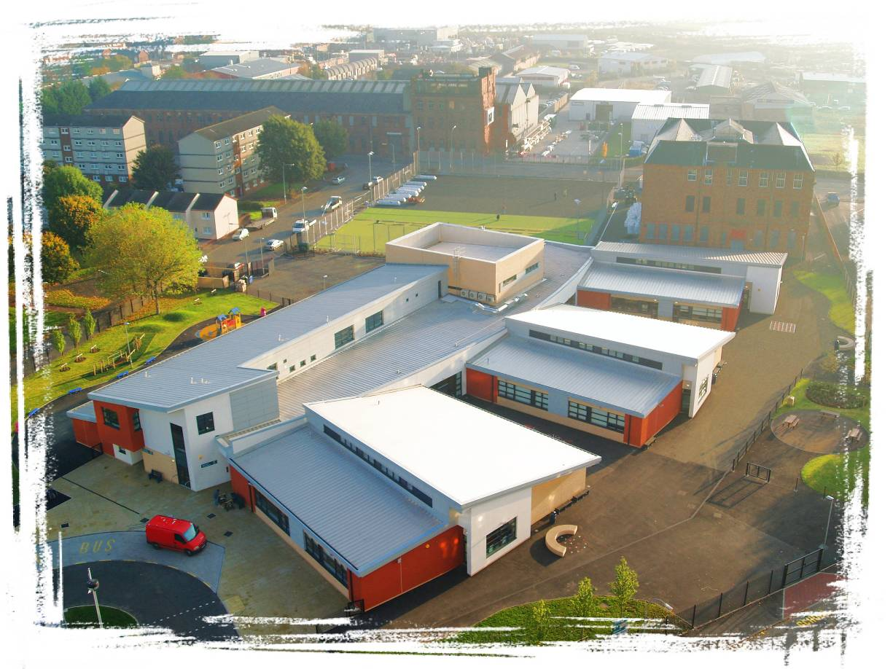


Green Trees Nursery
Our Vision and Values
In our school we are all learning and growing together. We have a shared vision and set of values which support this work.
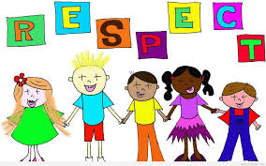
We value:

Respect
Positive relationships


Fairness and equality



Individuality

Achievement
Our Vision Statement
We work to create and maintain an ethos where all learners are supported and nurtured in a caring and stimulating environment. We actively promote play and creativity as the main drivers of our learning.
Nursery Staff

Acting Head of Centre Wendy McLauchlan 52 weeks NNEB, SVQ4, BA Childhood Studies
Acting Depute Head of Centre Lesley Murray 52 weeks SVQ 4; BA Childhood Practice
Child Development Team Leader: Irene Lang 52 weeks HNC, BA Childhood Practice
Child Development Team Leader: Catherine McKay 52 weeks HNC, BA Languages
Lead Practitioner of Attainment: Sarah Kate Kelly Term Time HNC, BA Childhood Practice, PDA Childhood Practice
Child Development Officers: Leighann Carroll 52 weeks HNC
Chloe Fraser 52 weeks SVQ3
Ashleigh Harvey 52 weeks SVQ3
Lianne Garrity 52 weeks SVQ3
Ann Scanlon 52 weeks HNC
Emma Clelland 52 weeks HNC
Brogan Donachie 52 weeks HNC
Carla Grant 52 weeks HNC
Alanna Storrie 52 weeks HNC
Lisa Sinclair 52 weeks HNC
Kimberley Prentice 52 weeks HNC
Claire Falconer 52 weeks HNC
Pauline Connor Term time HNC
Michelle Munn Term time HNC, BA Childhood Studies
Susan McEnroe Term time HNC, BA Childhood Studies
Audrey Allan Term time HNC
Kirsty Goodfellow Term time HNC
Isobel Murray Term time NNEB Job Share (21hrs)
Cathy Storrie Term time NNEB Job Share (17.5hrs)
Sarah Blake Term time NNEB Job Share (17.5hrs)
Jackie Flynn Term time NNEB (8hrs)
Fiza Hussain 52 weeks SVQ 3
Laura Wood 52 weeks BA Honors Education Social
Craig Walter 52 weeks HNC
Michael Greechan 52 weeks HNC
Support for Learning: Charlene Morrison 52 weeks

Clerical Officer: Lauren Davey 52 weeks (27hrs – Mon, Tues, Wed)
Ella McAlister 52 weeks (18hrs – Thu, Fri)

GENERAL INFORMATION
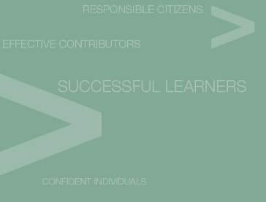
Learning programmes are based on children’s interests and seasonal events and follow the National Curriculum for Scotland - A Curriculum for Excellence.
To ensure the highest standards for your children, the nursery is inspected annually by the Scottish Care Inspectorate every third year and reviewed every three years by Glasgow City Council.
Glasgow City Council also regulates the work of the nursery through its Management Circulars, Health and Safety regulations, Policy guidelines and meetings.
Standards are monitored annually within the nursery using the Performance Indicators of the national guidelines, “How Good is Our Early Learning and Childcare” and “Building the Ambition”.
The Care Inspectorate and Education Scotland carry out inspections in all Scottish establishments.
Green Trees Nursery reports may be found on their websites or by calling the Nursery office.
www.educationscotland.gov.uk/parentzone/index.asp
www.careinspectorate.com

NURSERY SERVICES
Nursery Session Times: Open between 8.00am and 6.00pm - Monday to Friday

Morning Session: 8.00am - 12.45pm up to 100 places (3-5s)

Afternoon Session: 1.00pm - 5.45pm up to 100 places (3-5s)
2-3s Room has 15 places morning and afternoon.

The nursery is growing the service in order to meet 1140 hours of government funding for all 3 – 5 year old children and eligible 2 year olds by August 2020. The nursery operates between the hours of 8.00am and 6.00pm. Please note:

- Funded places are allocated in accordance with Scottish Government and Glasgow City Council’s Funding Policy.
- Invoices are sent out from CBS (Customer Business Services) if additional hours are required and are available every four weeks.
- Glasgow City Council reviews charges annually.

Application for places:

This nursery follows the policy/procedures on admissions set by Glasgow City Council Government Policy. Applications should be made directly to the nursery. Length of time on the waiting list does not give a priority. Any parent wishing a place for their child may telephone for an appointment to complete an application form with a member of the management team.

This nursery meets with other local nurseries at an ‘Admissions Panel’ to ensure that the most vulnerable children are given priority admission in accordance with Local Authority Guidelines. Health and Social work staff may provide a supported application.

Starting nursery:

When your child starts nursery please be prepared to stay for a ‘settling in period’ which could last a few days or some weeks. We work with you to suit the needs of your child and rely on your good sense and judgement at this sensitive time. Please use this time for you and your child to get to know us and for us to get to know you both.
The school welcomes all children regardless of religion or ethnic background. Children should be brought to/from the nursery by the parent/guardian, or other adult (over the age of 16 years) designated by the parent/guardian.
Parents are always welcome in the nursery to play with their own child/children and to participate in nursery outings and activities where possible.

If your Child is Sick

Child Safety procedures states that you MUST telephone/send a message to the nursery and inform them if your child is unwell or not able to attend for ANY REASON.
Green Trees Nursery Telephone No. 0141 554 0578
The policy also states that we should have up to-date contact information (i.e. telephone/mobile numbers and contact address) at all times so that we are able to contact yourselves if an emergency occurs.

It is inevitable that young children will develop coughs, sneezes and other bugs and infections. If your child develops any such symptoms please speak to your doctor and/or keep him/her off until the risk of infection to others has gone.
Please do not bring you child to nursery if he/she has experienced sickness or diarrhoea.

We operate the 48 hour Infection Control Rule.

If vomiting or diarrhoea has occurred then they must remain at home for 48 hours after the time of the last bout of sickness or diarrhoea.
CHILDREN’S LEARNING

There is a curriculum for children under three and parents will find more information on the web at, http://www.ltscotland.org.uk/what-is-the-curriculum-forexcellence/

Pre-birth to three: supporting our youngest children describes how babies, young children and their parents can best be cared for as they begin to learn about themselves and the world around them. It shows how this is most successful when adults are aware of the important role of three key features of effective practice.

These three key features are very closely linked:

Relationships

Responsive Care

Respect


Curriculum for Excellence:

Curriculum for Excellence aims to provide a coherent, more flexible and enriched curriculum from 3 – 18, firmly focused on the needs of the child and young person and designed to enable them to develop the four capacities – Confident Individuals; Successful Learners; Responsible Citizens & Effective Contributors.

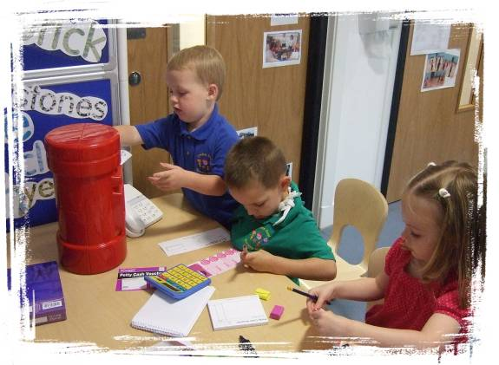
This is the national curriculum for all Scottish children aged 3-18 years. Get more information at,
http://www.ltscotland.org.uk/what-is-the-curriculum-forexcellence/

These guidelines promote and support play as the main vehicle for learning with the child as an active participant. This learning environment allows the development of the skills and concepts needed for living in a multicultural society. We promote equal opportunities for every child irrespective of gender, ethnic grouping or disability.
Parents are valued for their role in this educational partnership and respected as first and continuing educators of their children.

Parents as Partners for Learning:

Parents are encouraged to participate in their child/children’s learning Examples include:
- Commenting on learning on the display walls.
- Adding their own views to their child’s learning journal.
- Receiving information on current learning through “Newsletters” and meetings.
- Sharing in “Stay and Play” days.
- Discussing the work of the nursery at “Tea, Toast and Talk” on Thursdays.
- Participating in outings and questionnaires relating to the work of the school.
Green Trees Nursery School encourages children to
Try, Try and Try again. We are an ‘I CAN DO IT!’ nursery.

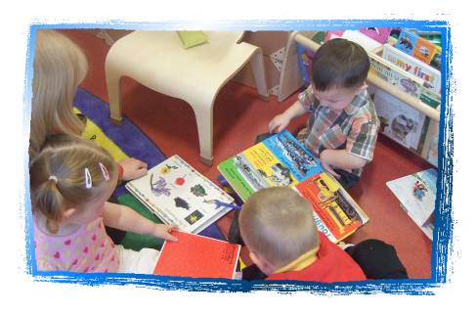
We actively promote the processes of learning, the abilities to communicate, persevere, organise and investigate.
The nursery curriculum is planned and resourced to provide broad and balanced learning experiences, suited to the needs and developmental stages of every child.
We aim to help develop the ‘whole child’ and not just the part going to school!

- Children need to be able to communicate with others.
- They must learn to work with others.
- They need to learn to share the adult’s attention with other children.
- Most importantly they need to feel good about themselves
- And not be worried about making mistakes or not being able to do something.

Children will be at different stages of development. Just because they are good/not so good at one thing doesn’t mean they will be at the same stage with something else.
All learning takes place at the child’s own pace and starts from where s/he is at.

Smaller table-top equipment and drawing helps children to work accurately and precisely with their hands by developing hand-eye co-ordination -valuable skills for when your child begins to read and write. Children are encouraged to ‘write’ from the very beginning, practising shopping lists and birthday invitations.
You can help your child to develop a greater awareness of print/ language by reading stories and rhymes, writing shopping lists and pointing out print in the environment.

We aim to promote self confidence and self esteem so that your child feels he/she can cope with anything, anywhere, anytime!!
to enable all young people to become
successful learners with

enthusiasm and motivation for learning
determination to reach high standards of achievement
openness to new thinking and ideas
and able to
use literacy, communication and
numeracy skills
use technology for learning
think creatively and independently
learn independently and as part of a group
make reasoned evaluations
link and apply different kinds of learning in new situations

confident individuals with
self respect
a sense of physical, mental and emotional wellbeing
secure values and beliefs
and able to
relate to others/manage themselves
pursue a healthy and active lifestyle
be self aware
develop and communicate their own beliefs and view of the world
live as independently as they can
assess risk and take informed decisions
achieve success in different areas of activity
responsible citizens with
respect for others
commitment to participate responsibility in political, economic, social and cultural life
and able to
develop knowledge and understanding of the world and Scotland’s place in it
understand different beliefs and cultures
make informed choices and decisions
evaluate environmental, scientific and technological issues
develop informed, ethical views of complex issues
effective contributors with
an enterprising attitude
resilience
self-reliance
and able to
communicate in different ways and in
different settings
work in partnership and in terms
take the initiative and lead
apply critical thinking in new contexts
create and develop
solve problems

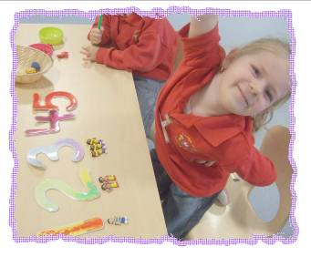
CONFIDENT INDIVIDUALS:
The way that children feel about themselves affects the way they approach all learning and the way they behave toward others. Staff encourage and support all children to develop self-esteem and self-confidence.
Being confident, self reliant and with independent self help skills underpins all learning.

SUCCESSFUL LEARNERS: Being a successful learner is more about attitudes and dispositions to learning rather than about a body or knowledge or subject content. It’s about being able to concentrate on the task; persevering when things get difficult so that we don’t give up too easily. It’s about knowing where to go for information and who or when to ask for help. It’s about knowing that we will and can make mistakes…but we can learn from them.
While at nursery your child will explore and engage in learning around the following key areas of learning,
Expressive arts Religious and moral education
Sciences Social studies
Technologies Languages and literacy
Health and wellbeing Mathematics and numeracy

EFFECTIVE CONTRIBUTORS:

The development of children’s language skills is central to their abilities to communicate in relationships and learning, to understand ideas, to order, explore and refine their thoughts.
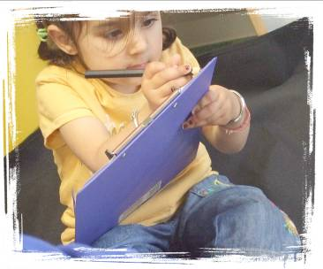
At nursery, children will engage in a range of fun, challenging learning activities and experiences leading to them making successful transitions to school, work and life!
Children will be expected to take an active part in the life of the nursery and their community.

RESPONSIBLE CITIZENS:

From an early age, children and young people can develop an understanding of how their actions and decisions are affected by and affect others, recognising how important it is to behave in ways that can have a positive effect on other people and the environment. Responsible citizens care for, and show respect for others and others’ property. They have an active and healthy lifestyle.

Promoting Positive Behaviour

Rational: Children learn better in a risk free supportive environment.

This is a Glasgow City Council and Learning Community priority and all staff recognises the need to have a team approach to ensuring this nursery promotes a positive ethos.

We Aim:

- To work in partnership with parents to promote and maintain a positive ethos.
- To promote a clear code of behaviour.

Our Objectives Are:

- To ensure a welcoming and inclusive environment.
- To develop simple rules in consultation with children and parents.
- To work in partnership with parents to apply a consistent approach to managing behaviour.
- To apply a code of behaviour with is understood by staff, parents and children.
- To manage behaviour in a sensitive and caring manner.
- To use praise appropriately to support learning and behaviour.
- To use descriptive feedback to reinforce positive aspect of behaviour.

Success Criteria:
- Challenging behaviours will be reduced.
- Children will make progress in their learning, development and social skills.
- Children will actively manage their own behaviour.

It is hard work being a parent!

Give children their say but YOU as the parent make the decisions.

Agree rules and stick with them.

Try to praise/reinforce good behaviour rather than focus on the bad.

It is okay to say NO!

Explanations/reasoning can wait until you and your child are calm.

Language and Literacy

“Literacy is fundamental to all areas of learning, as it unlocks access to the wider curriculum. Being literate increases opportunities for the individual in all aspects of life, lays down the foundations for lifelong learning and work, and contributes strongly to the development of all four capacities of “Curriculum for Excellence”.

Children have a desire to communicate through talking and listening, reading and writing. Through play and exploring hands-on activities, children develop skills and knowledge regarding their world. Story books and reference books are readily available as well as a wide range of writing tools for children to access. The development of early literacy skill is a strong focus of the nursery and is reported on regularly through the child’s learning journal. Parents can contribute to this learning through regularly sharing stories and nursery rhymes. Talking with and listening to their child is also very important for the developing child.

Mathematics and Numeracy

“Mathematics is important in our everyday life. It allows us to make sense of the world around us and to manage our lives”.

In accordance with Glasgow City Council policies and priorities the development of skills and knowledge in this area of the curriculum is included in every plan. Numeracy skills are used throughout the day. Our staff strive to create purposeful, relevant opportunities for children to apply their counting skills as well as a range of mathematical concepts. This area of the curriculum is assessed and reported on a regular basis through the child’s learning journal.


CHILDREN AND INFORMATION, COMMUNICATION TECHNOLOGY (ICT)
There is now national recognition of the need to acknowledge the wide and many experiences children bring with them from home and to build on this within the nursery. The nursery is now looking towards meeting the challenge of living in a digital world. Staff plan for a variety of purposeful experiences using a range of technology. Children will engage in opportunities to explore and create through STEM activities (science, technology, engineering and maths).
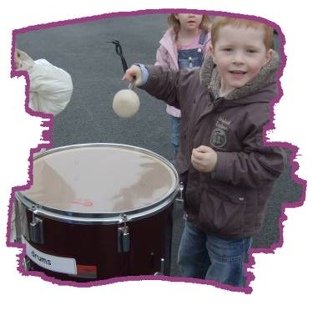

EXPRESSIVE ARTS…their creative side!
(Art, music, dance, drama, role play, creativity)

Expressing and creating ideas, feelings and imagination as well as having opportunity to enjoy all manner of sounds, sights, shapes and textures are vital parts of the young child’s development.
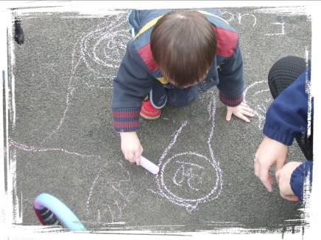

A wide range of experiences encourage children to make choices in their creativity. Art, music and movement, role-play and STEM allow your child’s natural creativity to develop.

Assessment and Recording

Children learn through and with other children or adults. Play is a powerful means for children to explore their world and begin to make meaning of things.

Staff regularly engage in learning conversations with children to support and extend their learning.
Staff use planning to respond to needs and the development of learning.
Staff use observations of children at play to assess learning. They gather evidence of what children say write/draw make or do. Photographs, pictures and comments are used to assess progress and celebrate individual achievement. This is shared with parents through the child’s learning journal and learning walls.

All information on children’s achievements is recorded and shared with our learning partners, parents, visiting specialists (where appropriate), and primary school colleagues at points of transition.

Transition to Primary School:

To support a smooth, happy and confident move from nursery to primary school, we work closely with our main feeder schools. Children make visits and staff engage in information sharing meetings.

Our main feeder Primary Schools are:

Dalmarnock Primary School, 111 Baltic Street, Glasgow, G40 3BA - 0141 554 3558
Sacred Heart Primary School, 31 Reid Street, Glasgow, G40 4AR - 0141 554 5949
St. Anne’s Primary School, 35 David Street, Glasgow, G40 2UN - 0141 554 2734
Riverbank Primary School, 1 Sunnybank Street, Glasgow, G40 4RX - 0141 550 3679

We also provide formal meetings for parents and staff to discuss children’s development and learning. These meetings take place in October and May.

Additional Support for Learning

Pupils who appear to need additional support with learning are identified through the process of assessment. This is done at as early a stage as possible, in order that any extra help if required may be given. Where appropriate an outside agency may be called in to support your child. This may result in a plan being prepared for the child with long/ short term targets being set. This plan is discussed with parents and is reviewed termly or sooner if required.

If a parent has any concerns regarding their child’s development they may speak with the Head Teacher who will provide information and guidance.

Glasgow City Council’s Policy

Glasgow City Council has a duty, as outlined in the Standards in Scotland’s Schools 2000 Act, to ensure that your child achieves their potential. Glasgow’s Education Services is committed to the inclusion of all children and young people with additional support needs, where possible, within mainstream schools. This is in accordance with the statutory requirement in the 2000 Act. It is also part of Glasgow’s policy to maintain a range of special educational establishments. This recognises the key role to be played by specialist provisions in addressing severe low incidence disabilities. The authority recognises that there are a wide range of factors, which may act as a barrier to your child’s learning.
We are committed to working closely with parents and carers to ensure that you are fully involved in overcoming barriers to learning. Additional support needs may be linked to a learning difficulty or disability but could also apply to a child suffering from bereavement who requires pastoral support, a more able child or those with a particular talent, which needs to be fully developed.
The policy requires all establishments to provide an environment where children with additional support needs are actively encouraged to be effective learners and benefit from their school education.
Any parent or carer seeking further advice regarding this policy should contact the head teacher in the first instance. If a parent is unhappy with the support their child is getting they must first discuss this with the school in order to seek a resolution.

Further information relating to Additional Support Needs is also available on the Glasgow City Council website –

http:/www.glasgow.gov.uk/en/Residents/GoingtoSchool/AdditionalSupportNeeds/

Other organisations which provide advice, information and support to parents of children with ASN are identified under The Additional Support for Learning (Sources of Information) (Scotland) Amendment Order 2011 as:

- Children in Scotland: Working for Children and Their Families, trading as ‘Enquire – the Scottish advice and information service for additional support for learning’

- Scottish Independent Advocacy Alliance.

HEALTH & WELLBEING –
(Health, safety, fitness, spatial awareness, large muscle movements, small muscle movements, indoor/outdoor play)

Physical Development is important for promoting health and wellbeing in the growing confidence and enjoyment that physical play provides.
Physical play opportunities allow children to work individually and alongside others, sharing games and resources, co-operating, negotiating and learning fairness, turn taking and respect for others.
A wide range of opportunities allows children to practice a range of skills.
Children also have daily opportunities to develop fine control of their fingers/hands through jigsaws, drawing and small world toys.
We are fortunate in having very good physical play equipment and many children can play on this. Children have daily opportunities to experiment with movement but are also guided, directed and challenged by staff.
Parental support is needed to ensure that children wear correct footwear, light suitable clothing and NO jewellery for safety reasons during active play sessions.

Health and Safety rules and consideration for others in physical play is developed and supported by all staff.
Outdoor learning is a strong feature of our school. There are daily opportunities for children to learn outdoors in all weathers.
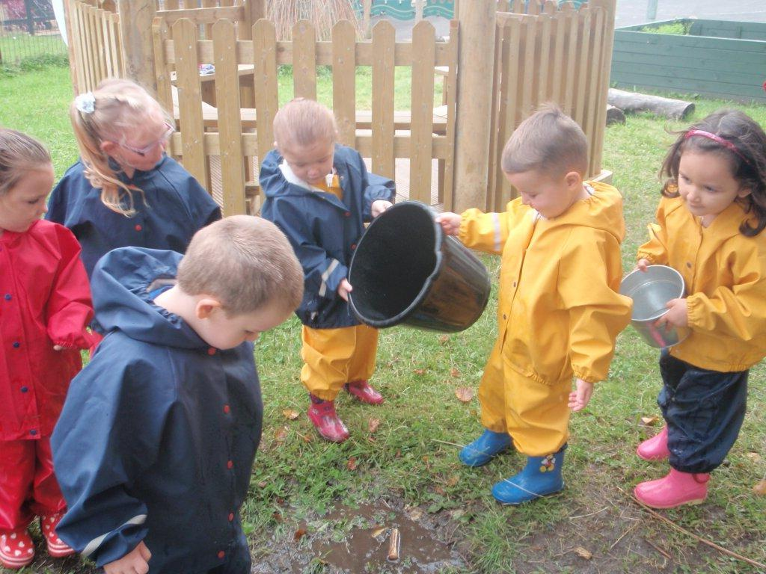
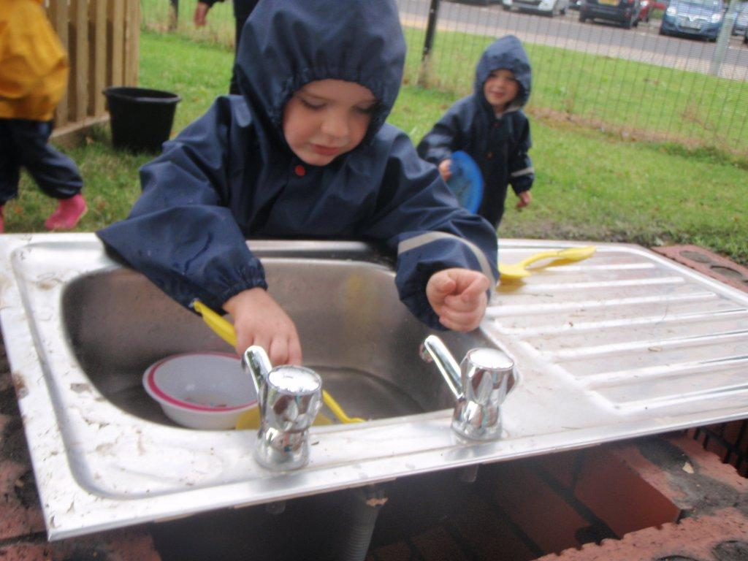
We support and develop children’s skills in making good choices and assessing risks. Children participate in our mud kitchen and camp fire days – promoting a safe and healthy lifestyle. Lifelong learning is a meaningful and real situation.

GIRFEC

GIRFEC isn’t an extra thing people have to do. It’s a way for those who support children to work differently, making sure that they are all on the same page. Where needed, GIRFEC links day-to-day work in education, health, policing, social work and the voluntary sector – in fact any organisation whose staff come into direct contact with children. It makes it easier for those different organisations to communicate consistently with each other, and with parents, carers, children and young people.
GIRFEC provides a structure that helps people to work in the same way and use the same language. This allows discussions with the child and their family to focus on what is good in a child’s life, and what might need attention or support.
It’s the bedrock for all children’s services and can also be used by practitioners in adult services who work with parents or carers.
The approach helps practitioners focus on what makes a positive difference for children and young people – and how they can act to deliver these improvements. Getting it right for every child is being threaded through all existing policy, practice, strategy and legislation affecting children, young people and their families.
What Getting it Right for Every Child means:
For children, young people and their families:
- They understand what is happening and why
- They have been listened to carefully and their wishes have been heard and understood
- They will feel confident about the help they are getting
- They are appropriately involved in discussions and decisions that affect them
- They can rely on appropriate help being available as soon as possible
- They will have experienced a more streamlined and co-ordinated response from practitioners
For practitioners:
- Putting the child or young person at the centre and developing a shared understanding within and across agencies
- Using common tools, language and processes, considering the child or young person as a whole, and promoting closer working where necessary with other practitioners

Child Welfare and Safety:
All educational establishments and services must take positive steps to help children protect themselves by ensuring that programmes of health and personal safety are central to the curriculum and should have in place a curriculum that ensures that children have a clear understanding of the difference between appropriate and inappropriate behaviour on the part of another person, no matter who.

As with other areas of the curriculum, you will be kept informed of the health and personal safety programme for your child/children within the establishment.
Educational establishments and services must create and maintain a positive ethos and climate which actively promotes child welfare and a safe environment by:
- Ensuring that children are respected and listened to
- Ensuring that programmes of health and personal safety are central to the curriculum
- Ensuring that staff are aware of child protection issues and procedures
- Establishing and maintaining close working relationships and arrangements with other agencies to make sure that professionals collaborate effectively in protecting young children.

Should a member of staff have concerns regarding the welfare or safety of any child they must report these concerns to the Head of Establishment, or the person deputising for the Head of Establishment. He/She after judging that there may be grounds for concern regarding the welfare or safety of any child must then immediately advise the duty Senior Social Worker at the local Social Work Services area office of the circumstances.

General Policy Information:

Policy and Guideline information provides clear advice to staff, students and parents about the procedures and practices of Green Trees Nursery. Well written polices ensure that all staff and service users are provided with up to date, relevant information about their respective roles and responsibilities. Establishment polices work in conjunction with Glasgow City Council and national Guidelines.
A Policy Folder is available in the reception area for parents to browse.

Policy information is available to parents in a variety of forms, policy leaflets and formal Policy Documents in the Policy Folder which is in the main school office.
All enquiries regarding establishment policies should be made to the Head Teacher.
Each year the Head Teacher writes, in consultation with staff, an Improvement Plan for future priorities together with a Standards and Quality Report of the Centre’s achievements.
Both are available for parents to read. They are on the main notice board in the main entrance of the nursery.

Dealing with Racial Harassment:

The Race Relation Act of 1976 makes it unlawful to discriminate against someone because of his/her colour,
race, nationality, ethnic or national background. The Act makes it the duty of Glasgow City Council to eliminate unlawful racial discrimination.
In 1999 the guidelines, “Dealing with Racial Harassment” were issued to assist all staff in dealing with such incidents. The adoption of an anti racist-approach should be seen as one part of the continuing attempt to improve the quality of education.
Glasgow City Council recognizes that support from the home is essential if these aims are to be achieved.
Every child in Glasgow has the right to be happy and secure at school.

Additional Support Needs/Accessibility Strategy

The school has a duty to ensure that all our pupils have equal access to the curriculum, supported as appropriate to their individual needs. This covers not only the content of lessons and teaching strategies but also minor adaptations to the physical environment of our buildings to address the needs of pupils with physical or sensory impairments. We also need to ensure that parents and carers who have a disability have equal access to information about their children. This will involve, for example, relocating the venue for parents/guardians meetings to facilitate physical access; provision of an interpreter; agreeing a phone contact system to provide direct feedback to parents and carers.

Data Protection

Information on children and young people, parents and carers is stored on a computer system and may be used for teaching, registration, assessment and other administrative duties. The information is protected by the Data Protection Act 1998 and may only be disclosed in accordance with the Codes of Practice. For further information please contact the school. We are also updating our practice in accordance with the new national guidelines for Data Protection and storage of information.

Conclusion

It is hoped that this booklet has been informative and helpful. As your child’s first and continuing educator we hope that together we can support your child’s learning and development. You will be kept informed through notices in the nursery, newsletters and information sheets.

Wendy McLauchlan, Acting Head Teacher

Suggestions and complaints

We are always interested in maintaining and improving the service we offer. If you have any concern or suggestions to make about the service please contact the Head Teacher.
Douglas Hutchison , Service Education Director,
287 2000
Heather Douglas, Principal Officer, Early Years, 287 2000

They can be contacted in writing at,
City Chambers
40 John Street
Glasgow G1 1JL
Similarly, if you have a complaint about any aspect of the service you should contact the Head Teacher.

If you feel that your complaint has not been satisfactorily resolved at establishment level, please contact any of the Principal Officers at education headquarters.

You also have the right to take a complaint or suggestion direct to Scottish Care Inspectorate.
From 1 April 2011, Scotland has a new regulator and inspector of care and social work services and child protection “The Care Inspectorate”.
From 1 April 2011, the Care Commission and SWIA (Social Work Inspection Agency) will no longer exist.

Website: www.careinspectorate.com The Care Inspectorate
Email: enquiries@ careinspectorate.com Compass House
The Care Inspectorate enquires: 0845 600 9527 11 Riverside Drive
Dundee , DD1 4NY
Freedom of Information
The Freedom of Information (Scotland) Act 2002 enables any person to obtain information from Scottish public authorities. The Act applies to all Scottish public authorities including: The Scottish Government and its agencies; Scottish Parliament; Local Authorities; NHS Scotland; Universities and further education colleges; and the police.

Public authorities have to allow access to the following information;
- The provision, cost and standard of its service;
- Factual information or decision-making
- The reasons for decisions made by it.

The legal right of access includes all types of ‘recorded’ information of any data held by the Scottish public authorities. From 1st January 2005, any person who makes a request for information must be provided with it, subject to certain conditions.
Further information is provided on the Glasgow City Council web-site;
www.glasgow.gov.uk/en/yourcouncil/freedomofinformation
Internet facilities are provided at all Glasgow City Council Public Libraries and Real Learning Centres.

Holidays/In-Service Days 2022/23
October
- Friday, 14 October 2022 (In-Service Day)
- Monday, 17 to Friday, 21 October 2022 (October Week)
December - Christmas and New Year
- Schools close at 2.30 pm on Thursday, 22 December 2022
- Friday, 23 December 2022 - Tuesday 3 January 2023 (Christmas holidays)
January
- Schools return on Wednesday 4 January 2023
February mid-term break
- Monday, 13 February 2023
- Tuesday, 14 February 2023
- Wednesday, 15 February 2023 (In-service day)
April - Spring Holiday (Easter)
- Schools close at 2.30 pm on Friday, 31 March 2023
- Monday, 3 April - Friday, 14 April 2023 (Spring Break)
- Schools return on Monday, 17 April 2023
May
- Monday, 1 May 2023 (May Holiday)
- Thursday, 25 May 2023 (In-service day)
- Friday, 26 May 2023 and Monday, 29 May 2023 (May Weekend)
June
- Schools Close at 1.00 pm on Friday 23 June 2023

Where to find us…111 Baltic St., Glasgow,
G40 3BA
Travel Directions:
Car access is via Dalmarnock Rd into Queen Mary Street, then a right turn into Baltic Street.

Bridgeton Cross railway station is less than 10 minutes walking.
GLASGOW FIRST BUSES:-

Bus Nos. 18 & 46 along Dalmarnock Road.
Bus Nos. 43 & 64 run along London Road.

