Milton Community Nursery
Handbook
2025-2026

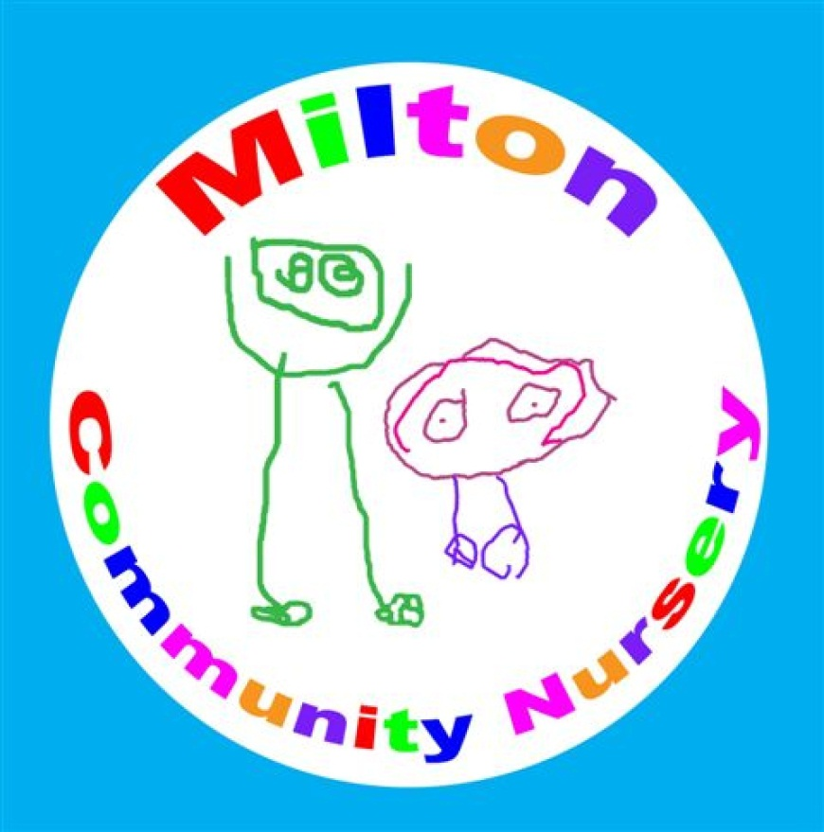

Milton Community Nursery, 200 Liddesdale Road, G22 7QR, 0141-772-6319

Milton Community Nursery Staff Team

Shona Young | Head of Centre
Jamielee Mullins | Depute
Catriona McMillan | Team Leader
Kimberley Scott | Child Development Officer (currently Acting Team Leader)
Lesley Murray | Lead Practitioner (Secondment)
Maureen Neill | Child Development Officer (term time)
Elizabeth McRae | Child Development Officer (job share term time)
Marlene Forde | Child Development Officer (job share)
Mandy Bruce | Child Development Officer (job share)
Louise Connor | Child Development Officer
Pauline Dowd | Child Development Officer (term time)
Stephanie Langford | Child Development Officer
Sarah Kerr | Child Development Officer (job share) (Mat Leave)
Jasmine Neill | Child Development Officer
Abby Duffy | Child Development Officer (currently on Maternity Leave)
Stephanie McLaughlin | Child Development Officer (job share)
Ashley Murray | Child Development Officer (job share)
Karen Whyte | Child Development Officer
Joanne Reid | Child Development Officer (Secondment)
Nicola Bowers | Child Development Officer
Amy Aiton | Child Development Officer
Skye Anderson | Child Development Officer (Temp)
Stephanie McMillan | Support for Learner Worker (term time)
Paton Glen | Child Development Officer
Fiona Oliver | Child Development Officer (term time)
Christina Walker | Child Development Officer (term time)
Kerrianne McFarlane | Support for Learner Worker
Natasha Ainslie | Support for Learner Worker
Zara Colquhoun | Modern Apprentice
Caitlin Hoolighan | Child Development Officer (job share)
Binta Bojang | Support for Learner Worker
Taylor Smith | Child Development Officer (temporary)
Tammy Smith | Child Development Officer (temporary)
Kelsey Rhodes | Child Development Officer (temporary)
Rachel McKerrow | Child Development Officer (temporary)
Hasharon Singh | Support for Learner Worker (Mat Leave)
Kiera Smith | Modern Apprentice
Ting Ting | Child Development Officer (Temp)
Maeve McMurtrie | Clerical Assistant
Anna Symirioti | Clerical Assistant
CORDIA
Jack McFalls | Facilities Officer
Sharon | Day Cleaner
Lynn | Night Cleaner

OUR VISION, VALUES AND AIMS

Vision: To provide high quality early learning and childcare and to nurture a positive attitude for lifelong learning.

Values: Nurturing Fun
We are welcoming and caring. We provide play experiences indoors
We have a safe and comfortable and outdoors that enrich learning and
environment. are fun.

Inspiring Equality Family
We are ambitious, pro-active We are inclusive, We promote a sense of
creative, skilled and motivated. respectful and fair. belonging and togetherness
Aims:
- To provide a happy and safe environment for children working in partnership with their parents and carers.
- To involve and maintain partnerships with schools, local agencies and the community to support children's learning and progress.
- To engage children in learning experiences that are stimulating, engaging, challenging, enjoyable and based on interests.

WORKING IN PARTNERSHIP WITH PARENTS/CARERS

It is important to us that your child is safe and happy in Milton Community Nursery. Each member of staff is allocated a group to whom she/he is responsible and will develop a trusting relationship with you and your child. In order to assess your child’s progress and plan for learning, nursery staff will observe and record your child’s achievements. These observations occur during playroom activities and over a period of time will form a record of your child’s progress. Your child’s learning is evidenced on Seesaw you will receive an individual QR Code at enrolment.

Parents are invited to spend time in the playroom, either to observe their child or help with activities. The nursery aims to maintain positive relationships with families and recognises this as an essential element in providing effective learning for the children in the nursery. Children’s learning is shared using our online journal platform, Seesaw. This is an opportunity for parents to become involved in their child’s learning during current projects and particular interests.

We have a face book page, a blog and share information consistently on Seesaw.

PROMOTING POSITIVE BEHAVIOUR:

Staff place a great deal of emphasis on children learning to respect one other and are aware of the importance of being positive role models for the children to copy and learn from. Children are encouraged to resolve conflict in a positive manner, with staff being observant and ready to intervene if necessary. It is important that we work closely with you on this.

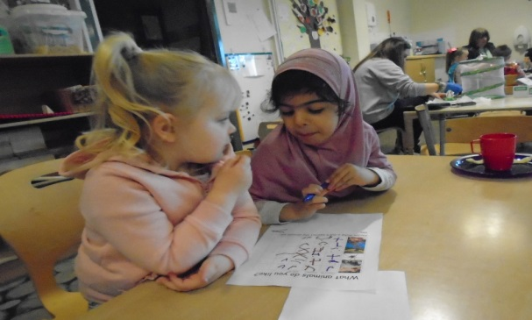
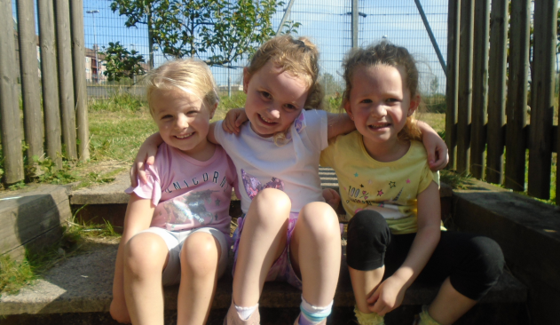

NURSERY POLICIES

We have a number of policies which have been created with parents and children. The policy folder is located on the table in the in the corridor and on the nursery Blog online. As they are updated you may be asked to contribute.

EQUAL OPPORTUNITIES POLICY:

All early year’s services should reflect Glasgow City Council’s equal opportunities policies and be anti-racist, anti-sexist, multi-cultural and recognise the rights of both men and women to work, or care for children. Provision should take account of the needs of children with additional support needs, disabilities or chronic illnesses. These principles are reflected in the criteria used to admit children to nursery and in the curriculum of all educational establishments.
The nursery is non-denominational – we respect and welcome children and parents of all religions, faiths and beliefs.

ADMISSIONS POLICY:

All places are allocated in line with the council’s policy. An Admissions Panel which meets to allocate places consists of the Heads of local nurseries, local Health Visitor, and a representative from education services. A register of applicants is held in a database and the information contained in the applications will be considered by the admissions panel to assist in the allocation of places.

THE NURSERY CURRICULUM

Early education adopts a holistic approach to young children’s learning and responds to each child’s individual needs and values learning from home. .
0-3yrs: Staff are very aware that this will may be the first period of separation between the child and parent/carer and can be an upsetting time for both. Staff are very sensitive to individual needs and take time to get to know the family and build relationships. As the children mature they will be developing a growing independence, wanting to do more and more by themselves. Staff will build on this and work closely with the parent on aspects of toilet training and personal care. Staff are guided by national practice guidance, Pre-Birth to Three and Realising the Ambition.
3-5yrs: At this stage children continue their learning journey gaining knowledge, skills and attributes supported by Curriculum for Excellence. Its purpose is summed up as helping children to become: successful learners, confident individuals, responsible citizens and effective contributors. Children are involved in planning their learning with staff, discussing interests and ideas for activities and projects. Staff plan learning opportunities for maths, science, health & wellbeing, literacy, expressive arts, religious and moral education, technologies, and social studies.

Please take time to look at displays and children’s work on the walls and in their profiles to see the curriculum in action. Staff will be pleased to answer any questions that you may have.

HEALTH PROMOTION: We have a whole nursery approach to improving the health and wellbeing of all children. Her Majesty’s Inspectorate emphasise the need for education to:
“*promote positive relationships within a caring and inclusive school community;
*provide the whole school community with positive experiences that promote and protect their health; and
*promote positive and healthy attitudes and behaviour”
Through working with parents, and the community, we hope to take children’s learning forward in health promotion within the nursery. We spend time outdoors daily and provide healthy snacks/lunches.

SUPPORT FOR CHILDREN: Children develop at their own pace. However, sometimes a child may need additional help. Staff may approach you if they feel there is an area where your child may need additional support and discuss this with you. If you are concerned about any aspect of your child’s development, please talk to his/her keyworker.

MEDICAL INFORMATION

MEDICATION: If your child is in need medication during his/her time at nursery, you should discuss their requirements with a member of the management team. Prescribed medicines will be given at the discretion of the Head of Centre and you will need to complete a series of forms. This authorises nursery staff to administer medicine to your child. You will also need to sign when the medicine is finished or removed from the nursery and re-confirm after every 3 month period if the medicine should be continued or not. If your child suffers from asthma you must inform the Head of Centre if there are any activities or special circumstances which are likely to exacerbate an attack.
Please note: Staff will not administer paracetamol/Calpol, even if prescribed.

ILLNESS: Please contact us if your child is unable to attend nursery due to illness. If your child becomes ill at nursery and we feel she/he would be better at home, we will contact you. In the extreme event of it being serious, we will arrange transport to take the child to hospital, and contact you, or your emergency contact to meet us there. If your child has diarrhoea/vomiting you must keep him/her off nursery for 48 hours from when the symptoms have ceased, as this is extremely infectious in a nursery environment.

MINOR ACCIDENTS & UPSETS: If your child has a bump he/she will be examined by the nursery First Aid Designate, a member of staff will report this to you and it will be recorded. If your child has had a bump, or is upset coming into nursery, it would be helpful to let staff know. Any accident to the head will be reported to parents/carers immediately.

HEAD LICE: If you find head lice or nits in your child’s hair, please treat the hair with the appropriate solution and inform nursery staff. We will regularly, as a precaution, ask parents to check their child’s hair. Please do not worry, we do not report individual cases of head lice.

JEWELLERY: For health and safety reasons, bracelets and necklaces must not be worn in the nursery. Earrings are dangerous, as children could pull them out and there is a risk that bits may be swallowed. During physical play small fingers could be caught in earrings resulting in damage to ears or the back of head. Therefore, for your child's safety, please keep jewellery at home.

SAFETY IN THE SUN: During the summer months staff are vigilant about the amount of exposure children have to the sun. The temperature does not have to be really warm for damage to be done to a child's skin, please put sun cream on your child before they come into nursery. We also have sun cream available in nursery.

VISITS TO THE NURSERY BY MEDICAL STAFF: We are visited regularly by the NHS staff to varnish the children’s teeth. Staff talk to the children about the importance of looking after their teeth, using stories and visual aids. Children in their pre-school year will receive an eye test.

GENERAL INFORMATION
ENROLMENT PROCEDURES: Staff will make a visit to your home, with your permission, to begin forming a close relationship with you and your child, you will then be invited to the nursery for an initial short visit. The first few days of nursery will be for reduced periods of time, with the adult staying, so that the child can become familiar with new surroundings. The Keyworker will discuss with the parent/carer about how they feel their child will settle and cope without them. We try to give as much time to this as possible, as it is difficult for some children to separate from a loved one.

ATTENDANCE: Please attend as regularly as possible so that your child can benefit from the learning experiences that nursery offers. If your child is ill, or you are not coming to nursery for a specific reason, please telephone the nursery and let us know, as we must account for absences.

EMERGENCY CONTACTS: Parents whose children are in nursery are asked to provide the establishment with names, addresses and telephone numbers of two contact persons for use in case of an emergency. Parents are asked to keep the nursery up to date with any change in this information.

INSURANCE: Sometimes children like to bring something special or new to nursery for their friends to see. However, parents should ensure that valuable items are not left at nursery, particularly as the authority has no insurance to cover the loss of such personal items. Claims submitted are only likely to be met where the authority can be shown to have been negligent. Please put names on hoodies, wellies etc.

ARRIVAL & COLLECTION OF CHILDREN: It is expected that a responsible adult will bring and collect your child from nursery. Please ensure that you introduce the Keyworker to any other person(s) who is likely to be coming at home time as nursery staff will not allow a child to leave the nursery with an adult who is not familiar to them.

EMERGENCY CLOSURE ARRANGEMENTS: The nursery will be opened on the times already outlined, but on some rare occasion’s circumstances arise which mean the nursery has to close; establishments may be affected by severe weather or power failures etc. If this happens we will do all we can to let you know about the details of closure and re-opening.


CLOTHING: Children have the best fun when they are involved in messy activities! We will always try to make sure that they wear an apron, but accidents do happen, so please dress your child appropriately – not in lovely new clothes. Please be aware of dressing your child suitably for the weather conditions, for example, we still go outside in the winter months, therefore hat and gloves are essential.

FUNDRAISING: A contribution of £2 every week toward the Nursery Fund is a great help as it allows us to purchase books, baking items and fund Christmas etc. Once a year we organise a fund-raising event to finance a special treat/buy specific resources for the children. If you have any ideas for fund raising please let us know.

MEALS: are provided by GCC Fuel Zone. Halal/vegetarian/dairy free and other allergen options are available on request. Children also have healthy snacks: a sandwich, fruit loaf, oatcakes and cheese, fruit etc
We are a Smile Too Nursery and children are encouraged to brush their teeth at nursery every day.

BIRTHDAYS: Birthdays are celebrated at snack time. We will supply a small cake for children.
We cannot accept a home-made cake as some children with allergies will not be able to eat it.

THE WIDER COMMUNITY

Children who attend Milton Community Nursery will mainly attend one of the three local primary schools; however, some may attend school further away. Information is shared with the relevant primary school regarding your child’s learning and to celebrate your child’s achievements. Additionally, nursery and school staff meet to plan transitions for the children moving on to primary.
We make visits to Liddesdale Gardens, the library and local parks. Children sometimes walk the Milton Mile round the school perimeter.

OUTINGS: If we can arrange to take the children on excursions we prefer to keep the size of the group to a minimum for the children’s safety and enjoyment. Staff will seek parent’s permission to allow their child to go out of nursery, where transport is involved, carers will be asked to complete consent forms which give permission for the child to participate.

SUGGESTIONS & COMPLAINTS:

We are always anxious to maintain and improve our service. If you have any suggestions to make about our service, please contact the head of the establishment in the first instance. Similarly, if you have a complaint about any aspect of the service you should contact the establishment head. If you feel your complaint has not been satisfactorily resolved with the establishment head, please contact:
Education Services
East Building (City Chambers)
40 John Street
G1 1JL
0141 287 5384

The Care Commission can also be contacted, their address and telephone number are:
Care Inspectorate, Compass House,
11 Riverside Drive, Dundee, DD1 4NY
Tel: 0845 600 9527 Email: enquiries@careinspectorate.com

USEFUL ADDRESSES:
Scaraway Nursery School 24 Shapinsay Street 0141-772-1604
St. Monica’s Primary School 200 Liddesdale Road 0141-772-0026
Chirnsyde Primary School 288 Ashgill Road 0141-336-8672
Miltonbank Primary School 11 Skerray Street 0141-772-8877
Milton out of School Care 288 Ashgill Road 0141-772-2011
Milton Library 204 Liddesdale Road 0141-276-0885
Social Work Department Mansion Street 0141-276-6210
Possilpark Health Centre 99 Saracen Street 0141-800-0600

STAFF QUALIFICATIONS

Shona Young | B.A., N.N.E.B., S.V.Q.4. P.D.A.
Jamielee Mullins | B.A., HND., HNC
Catriona McMillan | B.A., N.N.E.B., S.V.Q.4
Lesley Murray | B.A.
Maureen Neill | N.N.E.B.
Marlene Forde | H.N.C.
Mandy Bruce | S.V.Q. 2 & 3
Louise Connor | H.N.C.
Pauline Dowd | N.N.E.B.
Amie Dickson | H.N.C.
Elizabeth McRae | S.V.Q 2 & 3
Stephanie Langford | H.N.C
Sarah Kerr | H.N.C
Jasmine Neil l | H.N.C.
Abby Duffy | S.V.Q.3
Lesley Murray | B.A.
Joanne Reid | B.A., S.V.Q.3 P.D.A
Stephanie McLaughlin | B.A. Honours in Primary Teaching.
Karen Whyte | S.V.Q.3
Ashley Murray | H.N.C
Kimberley Scott | H.N.C, B.A. In Childhood Practice
Fiona Oliver
Skye Anderson
Nicola Bowers
Amy Aiton
Stephanie McMillan
Paton Glen
Christina Walker
Kerrianne McFarlane
Natasha Ainslie
Zara Colquhoun
Caitlin Hoolighan
Binta Bojang
Taylor Smith
Tammy Smith
Taylor Campbell
Kelsey Rhodes
Rachel McKerrow
Hasharon Singh

*Guide to qualifications:

B.A.: - Degree in Childhood Practice.

NNEB: - Nursery Nurse Examination Board.

HND – Higher National Diploma

HNC: - Higher National Certificate in Childcare and Education.

SVQ: - L2, L3 & L4 This is a series of Scotvec Modules in Childcare Studies.

BSL: - British Sign Language certificate, used by deaf, sign language users.

P.D.A.: - Qualification in Early Years Education

