Molendinar Family Learning Centre



Early Years Handbook
84 Craighead Avenue
Blackhill
G33 1LH
Tel: 0141 770 7692
Email: Headteacher@Molendinar-Nursery.glasgow.sch.uk
http://www.molendinar-nursery.glasgow.sch.uk/



Molendinar
Family Learning Centre

Dear Parents/Carers

Welcome to our Molendinar Family. We hope that you and your child will have a very positive and enjoyable experience in our nursery.

This handbook contains various information in relation to the service and practice our nursery provides, which you may find useful. I hope that it will help to answer any questions you may have.

If you still have questions after reading through our handbook, please do not hesitate to ask us.

Kind Regards

Sharon McLarnon

Sharon McLarnon
Head of Centre

Contents

Title | Page No.
Front Cover | 1
Welcome | 2
Contents Page | 3
Introducing our team | 4
About Us | 5
Our Achievements/ Recent Developments | 6
Our Vision, Values and Aims | 7
Nursery Information | 8
Dates for your Diary | 9
Information you may need | 10
How to Apply | 11
Glasgow City Council Charge Rates | 12
Arrival & Collection of Children, Emergency Contacts, Security & Attendance | 13
Suitable Clothing, Consent forms, Insurance, Emergency Closure Arrangements | 14
Meals, Birthdays, Fundraising | 15
Curriculum for Excellence | 16-17
Early Years Self-Evaluation, Assessment, Supporting Children, Working Together | 18
Outdoor Learning | 19
Nursery Groups, Communicating with Parents | 20
Other Information & Car Parking | 21
Child Safety/Child Protection Policy | 22-24
Mobile Phone Use Policy | 25
Links with Primary Schools, Accessibility Strategy | 26
Complaints procedure | 27
Useful Addresses and Contacts | 28



Introducing our Team….
Head of Centre: Sharon McLarnon
Depute: Susan Murdoch
Team Leader/Depute: Jacqueline Smyth
Team Leader: Irene Muldoon
Lead Practitioner for Attainment: Lara Purvis
Clerical Assistant: Sharon Ford

Child Development Officers:
Kirsten Bell | Katherine Mencia
Colette Bovill | Susan Millar
Emma Crooks | Robyn Priestley (Maternity Leave)
Emma Faulkner | Margaret Scott
Gillian Fyfe | Lauren Smith
Janet Hillhouse | Nicola Thom
Skye Hughson | Natalie Thompson
Karen Kerr | Shanisse Wilson
Danielle McCorquodale
Ashley McKenzie (Maternity Cover)
Gemma McQuade

Support for Learning Workers: Samantha McKay, Eva Wilson and Nicola Wishart

All our staff are fully qualified Child Development Officers registered with the Scottish Social Services Council (SSSC) and have been Protecting Vulnerable Groups (PVG) checked by Glasgow City Council. Our Support for Learning Workers are also fully qualified or are working towards their qualification. They too are fully registered with the SSSC and have been PVG checked by the council.

At Molendinar Family Learning Centre, we like to support student Child Care Officers and Teachers from local colleges & universities. Therefore, from time to time, these students may be part of your child’s care whilst at nursery. We also welcome the parents of our children in assisting the nursery through participation in our Parent Council meetings.

In addition to students visiting our nursery, we do receive visits from Childsmile
in relation to your child’s oral health, NHS Vision screening for our pre-schoolers, and your child’s Health Visitor to assess their development. We may also have speech therapists and Educational Psychologists visit us following a referral for assessment if applicable.

About Us
Molendinar Family Learning Centre is a non-denominational Early Years has been serving the Blackhill and surrounding areas since the late 1980s before moving into our current home in 1995. We have witnessed various changes throughout the years, but our children and their families have always remained our priority.

Our children are aged between 6-months old to 5 years old. The children’s environments have been created to ensure that your child has the opportunity to have a rich learning experience within the three key areas of Literacy, Numeracy and Health and Wellbeing as part of the Curriculum for Excellence.

It is important to us that all our children, from our babies to our pre-schoolers, are welcomed into a loving, caring environment where their voice is heard, they are respected and valued by all our staff. We do this by creating an environment that is safe, happy and caring full of opportunities, inclusion, equality, and fairness that meets the diverse cultures and abilities of all our children.

We promote a respectful setting where children are taught that their and their peers feelings matter. We endeavour to build relationships with our parents to ensure we are Getting it Right for Every Child and as part of this, we may collaborate with our parents and any external agencies that may be useful in this process.

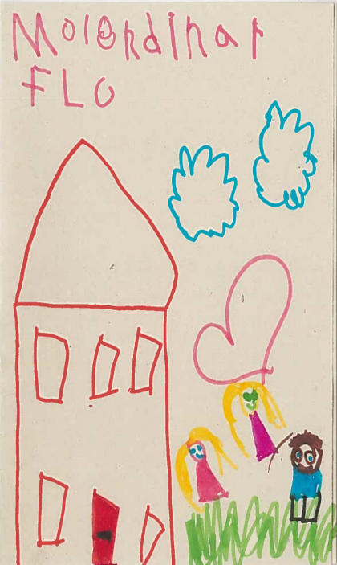

Achievements/ Recent Developments
In February 2024, Molendinar Family Learning Centre were the first nursery within Glasgow City Council to achieve a Bronze – Rights Respecting School Award from the United Nations Convention on the Rights of the Child (UNCRC). We featured in the Glasgow Evening Times to showcase our achievement. Since then, we have worked very hard with the children to embed Children’s Rights as part of our nursery culture. In recognition of this, in October 2024, we proudly received our Silver – Rights Respecting Award and received a visit from our Director of Education, Douglas Hutchinson who helped us to hang our banner.

In June 2024, we won The Trades House of Glasgow Citizenship award for the second time. We first won this award in 2016. This award was in recognition of the work that our nursery does with, in and for our community. Our Head of Centre, some staff and some of our parents and children were invited along to The Trades House where we were presented with our certificate from Jacqueline Mullen, Lord Provost of Glasgow.
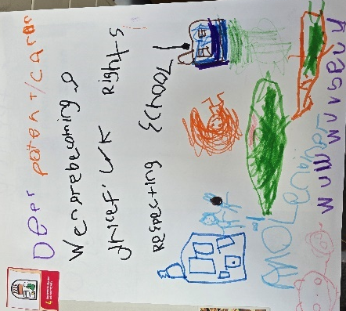
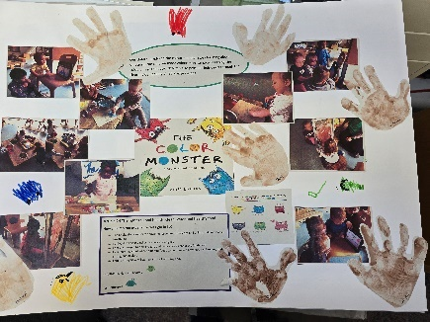
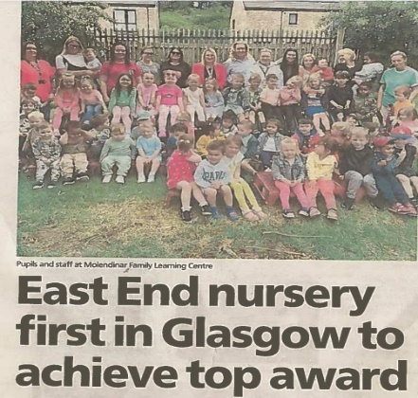





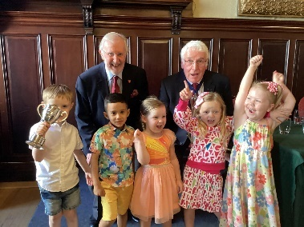

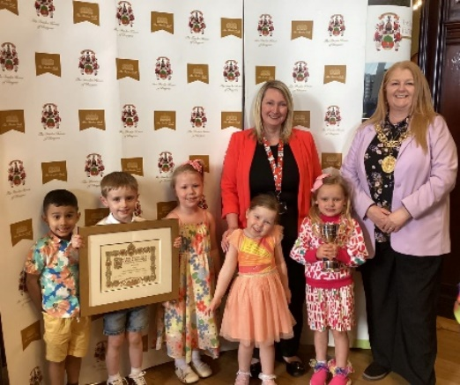





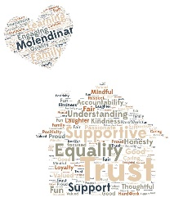


Effective Contributors
Confident individuals
Successful Learners
Responsible Citizens

Our Vision
At Molendinar Family Learning Centre our visions are:
- Provide an environment that is stimulating and engaging for all our learners.
- Outdoor learning is available daily and freely accessible for all.
- Learning experiences are high quality, fun and offer challenge.
- Our families are an integral part of our centre, and we offer a range of support to meet their needs.
Our Values
Motivational staff that support our children and families.
Opportunities for parents, carers, children and staff to reach their full potential.
Learning through play.
Enriching environments that make a difference to the lives of our children and families.
Nurturing environments.
Devoted staff who understand every child is unique.
Inspiration for our children to learn.
Nurturing, caring staff.
Active and creative professionals who inspire our children to learn.
Reflective, responsible citizens of tomorrow.

Our Aims
At Molendinar Family Learning Centre we pride ourselves on ensuring that all children are coming into a loving, caring environment where they are all valued, listened to and respected. We endeavour to:
- create a nursery that provides a safe, happy, caring and secure environment.
- promote wellbeing and respect.
- build loving and nurturing relationships to provide an extended family environment.
- work together with parents as partners to improve learning and care.
- work in partnership with other agencies and our communities to promote the welfare of our children.
- raise attainment by engaging our children in the highest quality teaching and learning to maximise success for all.
- promote a culture of inclusion, diversity, equality, fairness and opportunity.
- value and empower our children and Practitioners by recognising and celebrating successes and achievements.

Nursery Information

NURSERY NAME & ADDRESS: Molendinar Family Learning Centre
84 Craighead Avenue
Blackhill
Glasgow
G33 1LH

TELEPHONE NUMBER: 0141 770 7692

Care Inspectorate Registration: CS2003014834

E-MAIL ADDRESS: Headteacher@Molendinar-nursery@glasgow.sch.uk

Private Facebook page – Molendinar Flc

X (twitter) - @MolendinarFLC

STAGES COVERED: 6 months – 5 years old

AGREED CAPACITY: 93
6months – 2s: 12
2-3s 25
3-5s 56

DENOMINATIONAL STATUS: Non-Denominational

LEARNING COMMUNITY: Smithycroft Learning Community

CHILDREN’S OPERATIONAL HOURS: 8:00am – 5:45pm

GFIS (Glasgow Family Information Service)
www.gfis.org.uk
This site offers advice with regards to admissions, childcare charges, accessing childcare etc

Dates for your Diary
Nursery Holidays - Session – 2025 – 2026
Month | Term Time Children | 52week Children
August | Nursery returns  Thursday 14th August 2025 | In-Service Days  Tuesday 12th & Wednesday 13th August 2025
September | Friday 26th September 2025  Monday 29th September 2025 | Friday 26th September 2025  Monday 29th September 2025
October | In-Service Day  Friday 10th October 2025  October Week  Monday 13th October 2025 to Friday 17th October 2025 | In-Service Day  Friday 10th October 2025
December | Christmas Break  2.30pm finish on Friday 19th December 2025  Monday 22nd December 2025 to Friday 2nd January 2026 | Christmas Break  Wednesday 24th December 2025 to Friday 2nd January 2026
January | Christmas Break Return  Monday 5th January 2026 | Christmas Break Return  Monday 5th January 2026
February | Mid-Term Break  Monday 16th & Tuesday 17th February 2026  In-Service Day  Wednesday 18th February 2026 | In-Service Day  Wednesday 18th February 2026
April | Easter/Spring Break  2.30pm finish on Thursday 2nd April 2026  Spring Break  Monday 6th April 2026 – Friday 17th April 2026 | Easter Weekend  Friday 3rd April 2026 and Monday 6th April 2026
May | Bank Holiday  Monday 4th May 2026  In-Service Day  Thursday 7th May 2026 (subject to change due to Scottish Parliament Elections)  Bank Holiday Weekend  Friday 22nd May 2026 and Monday 25th May 2026
June | Summer Break  1:00pm finish Thursday 25th June 2026
July |  | Glasgow Fair Monday  Monday 20th July 2026

Information you may need….


Nursery Sessions
Operating Hours
Monday – Friday over 50 weeks (except for public Holidays)
8:00am – 5:45pm

We operate a range of sessions in accordance with Glasgow City Council’s admission policy and the Scottish Governments 1140 funded hours. However, depending on our current availability, we may not be able to offer the specific hours you require.

Medication
For safety reasons, we ask that you DO NOT keep any medication in your child’s bag left in the nursery. All medications must be declared.

We ask that you discuss all medical requirements with a staff member. Glasgow City Council’s policy is that any medication that a child requires, MUST be presented to the nursery by the parent/carer in its original purchased/dispensed packaging which includes the information leaflet supplied with the medication. This is applicable to both non-prescribed and prescribed medication. Medical forms must also be completed before we can administer any medication to your child. These forms can be obtained from the office.

Sickness
Please call us on 0141 770 7692 if your child is going to be absent from nursery.

If your child:
- becomes unwell whilst at nursery, we will call the first emergency phone number you have provided us with. If we are unsuccessful in reaching the person associated with this number, we will try your second emergency contact and so forth.
- has been sick or has diarrhoea, they cannot return to the nursery until after 48 hours has passed since their last episode.
- Has been given Calpol before nursery and they become unwell when it wears off, we will send your child home unwell.

Running Late?
Our staff adhere to a strict adult:child ratio and therefore work shifts.
If you are running late, we respectfully request that you call us to let us know.
We also ask that if you are running late to consider making an alternative arrangement for your emergency contacts to pick up your child on your behalf so that we can maintain the adult:child ratio.

HOW TO APPLY
Application packs can be obtained direct from our nursery. Our Senior team have set aside time every Tuesday for new applicants to visit with us and discuss the application. This is by appointment only.

EARLY YEARS ADMISSIONS
We are a Glasgow City Council nursery. All applications are taken to a panel meeting which occurs once every quarter. Various factors are taken into consideration when reviewing applications such as staffing and room availability. It may not always be possible to start your child in our nursery at a date of your request.

The Scottish Government currently provide children from 3 years old with 1140 free hours of early learning childcare. In some cases, a 2-year-old child may be eligible for the funding also. For more information on this, please refer to the Glasgow City Council website: https://www.glasgow.gov.uk/article/4304/Early-Learning-and-Childcare

Nursery sessions can vary depending on availability. Glasgow City Council operates a block system. For instance, if your child is 3 years of age, they may be allocated a mix of morning or afternoon sessions. In some cases, children may be allocated both a morning and afternoon session on the same day depending upon availability. Children under 3 years of age may be allocated time during one of these sessions depending upon availability.

Block Times: Morning: 8:00am to 12:45pm
Afternoon: 1:00pm to 5.45pm

Snack times: AM – 9:30am Lunch: 11:30am – 1:30pm
PM – 2:30pm We operate a rolling lunch system

Additional block session can be purchased at an additional cost. This can be discussed with
Our Head of Centre and depends on availability. Costs are determined by Glasgow City Council on an annual basis and cannot be negotiated.

SETTLING IN
On the first day that you bring your child you will be welcomed by your keyworker, and you will be asked to stay with your child for an hour so that the introduction is a gentle one. We will have some forms for you to fill in while your child can play and familiarise themselves with the new surroundings and faces. As the days pass you will have the opportunity to leave your child in the care of his/her keyworker for increasingly longer periods of time and your child’s hours of attendance will lengthen. There is no set formula or time span for this as all children react differently to separating from their parents or carers.

Charge R ates for August 2025 - 2026


Glasgow resident standard rate from age 3-5 years | £5.50 Per hour
Glasgow resident standard rate from age 0 - 3years | £4.00 Per hour
Discounted hourly rate 3-5-year-olds | £4:50 per hour
Discounted hourly rate 0-3 years olds | £3:00 per hour
Glasgow resident reduced rate and  Kinship carer rate | £1:00 per hour
Glasgow resident first child rate 3-5 years.  Glasgow resident first child rate 0-3 years  Glasgow resident second child rate  Glasgow resident third child rate | £5:50 per hour  £4.50 per hour  £2.20 per hour  £1.70 per hour
Glasgow resident College/  University rate | £5:50 for 3-5-year-olds  £4:50 for 0-3-year-olds
Non-Glasgow Resident rate | £5:50 per hour
Lunches | £1.52 (per meal)

EARLY YEARS CHARGES
Charges are paid directly to Glasgow City Council and in advance. You will be provided with an Early Years Admissions and Charges booklet, outlining how the charges are calculated and how you can pay them.

ARRIVAL AND COLLECTION OF CHILDREN
It is expected that a responsible adult, aged 16 years or over, will always bring and collect your child. If you or the person expected to collect your child have been delayed, please make every effort to let us know. We operate a password system which you will be requested to set up at the beginning of your child’s settling period. Children cannot be allowed to leave with any person who is a stranger to the Practitioners under any circumstances and children will only be released if the correct password is given. If no-one arrives to collect your child, we will try to get in touch with you and then your emergency contacts. If no-one can be contacted and your child is still here when the Centre is due to close, we will have to contact the Social Work Department so that your child can continue to be cared for until you are located.

EMERGENCY CONTACTS
You will be asked to provide the establishment with the names, addresses and telephone numbers of two contact persons for use in the case of emergency. Please bring those persons to the Centre to be introduced to the Practitioners at the earliest opportunity and keep us up to date as to changes to their details.

SECURITY
The centre operates a security entry system. Please press button at the main door to alert a member of staff if the main office is unmanned to gain entry. Always close the door firmly behind you and do not let any adults who are not in your company enter as you come in or leave, as they may not be known to Practitioners and therefore require to be met at the door. Whoever brings or collects a child from the Centre must sign them in and out (a procedure which will be explained during the settling in period).

ATTENDANCE
Due to pressure on places, we cannot hold a place open for a child who does not use it. Please let us know straightaway if you no longer require a place. If your child is off for more than a couple of days owing to illness or holidays let us know when she or he will be returning. When a child has been absent for a two-week period with no explanation, we will try to get in touch with a parent or carer by telephone or letter. If no contact can be made or no response is forthcoming, then that child’s place will be reallocated at the earliest opportunity.

SUITABLE CLOTHING
Children have fun doing messy work and, although we encourage them to wear aprons, clothes are often affected so please do not bring children to nursery in their best outfits. A change of clothing can be kept in each child’s bag on their peg (several changes if in the throes of toilet training please). Please note that we cannot ban any child from participating in any activity on any grounds other than medical or religious ones as we are bound to provide every child with as broad and balanced a curriculum as we can. Soft shoes are best worn to nursery to avoid accidental injury and aid physical play and outdoor clothing suited to the weather in case outdoor play, or a trip is planned.
Please note due to health and safety reasons Glasgow City Council recommends children should not wear jewellery of any type to nursery. We currently have a risk assessment in place and if you wish please request to read it.

OUTINGS AND CONSENT FORMS
When trips are planned you will be informed in advance and asked to complete a consent form giving your permission for your child to attend the trip. No child can be included in such a trip without this form having been completed. However, consent for local outings and excursion is encompassed in the enrolment forms.

INSURANCE
Children are insured whilst on a nursery trip for which your consent has been obtained but the City Council will accept no responsibility for loss of or damage to clothing or personal belongings either inside or outside of the Centre.

EMERGENCY CLOSURE ARRANGEMENTS
On occasion it may be necessary to close the building at short notice. This could be due to power failure or severe weather conditions, etc. If this happens, we will do our best to let you know what is happening. We may keep in touch by telephone, letter, and notices in local shops and community centres and/or through announcements in local churches, the press or on radio. Remuneration of charges will be decided at a later date.

MEALS, SNACKS AND HEALTHY EATING
Meals are supplied by GCC. Menus are based on low salt, low sugar and low-fat foods and reflect a balanced diet. Snacks are also provided; we do have a weaning menu that is also in place at the centre. We are also aware that when first weaning your child, you may wish to provide small snacks or lunch until your child becomes more confident. Please ensure this is discussed with your child’s keyworker and are provided in the original sealed packaging or tubs as we cannot accept opened containers or homemade food due to health and safety regulations and Glasgow city council polices. They also must be in line with the guidance from NHS Health Scotland document ‘Setting the Table’. Practitioners are not liable for foods already prepared by the parent/carer.

HEALTHY SNACKS POLICY
Molendinar Family Learning Centre is a SMILE NURSERY.
Our Aims:
- To reduce the intake of sugary foods.
- To promote regular teeth cleaning with a fluoride toothpaste.
- To promote a healthy nutritious diet.
- To promote cut up fruit and vegetables as a snack food.
- To give children milk or water as drinks at the centre.
- To promote early registration with a family dentist.
- To reduce children’s tooth decay.

BIRTHDAYS
A small store-bought sponge cake is all you have to bring to the centre. Please discuss this with your child’s keyworker. Every child will receive a book and a birthday card when they attend the nursery on their special day.

FUNDRAISING
Some things are not provided for by our Council funding. For example:
- birthday/Christmas presents, outings and trips. For this reason, we ask parents to contribute to our toy fund, currently £2.00 a week for one child and £3.00 for two children.
- It is also sometimes necessary to fundraise for specific purposes. We may ask you to participate in selling raffles, auctions, sponsored activities and suchlike from time to time.

CURRICULUM/PLANNING FOR CHILDREN’S LEARNING AND DEVELOPMENT

CURRICULUM for EXCELLENCE
Children learn through their play:

“Play that is well planned and pleasurable helps children to think, to increase their understanding and to improve their language competence. It allows children to be creative, to explore and investigate materials, to experiment and to draw and test their conclusions. Such experience is important in catching and sustaining children’s interest and imagination” (Des, 1989b).

CURRICULAR AIMS
Practitioners seek to:
- Develop self-esteem in every child.
- Empower each child with the attitudes, skills and understanding necessary to promote effective learning.
- Foster achievement.
- Encourage the development of positive interpersonal relationships.

HOW WE PROMOTE LEARNING
Our Curriculum Document – Pre- Birth to Three National Guidance
Our under 3’s curriculum is based around the positive outcomes contained in this document. The pre- birth to three curriculum links later with the underpinning values of the 3-18 Curriculum for Excellence.
The key principles of the Pre- Birth to Three documents underpin the:
- Rights of the Child
- Relationships
- Responsive Care
- Respect

There are also guidelines around Practitioner’s roles and responsibilities and considers all aspects of care in the care setting.
There will be a copy of these documents on display within the centre and a hyperlink on our nursery website if you should wish to look.

A CURRICULUM FOR EXCELLENCE
The Curriculum for Excellence’s underpinning values is wisdom, justice, compassion, and integrity with the child at the centre of learning.
The purpose of the curriculum is to enable the child to develop the “four capacities”.
To enable all children to become:
- Successful Learners
- Confident Individuals
- Responsible Citizens
- Effective Contributors

The curriculum is inclusive and a stimulus for personal achievement and by a broadening of experience of the world is an encouragement towards informed and responsible citizenship.

Experiences and outcomes set out expectations for learning and development in:
- Expressive arts
- Language and Literacy
- Health & Well- being
- Mathematics & Numeracy
- Religious & Moral Education
- Sciences
- Social Studies
- Technologies

The experiences and outcomes in the range of curriculum areas build in relevant attributes and capabilities which support the development of the four capacities.

Realising the Ambition. National Practice Guidance for early years in Scotland access Here Children and Young People (Scotland) Act 2014 access Here

‘Our expansion of early learning and childcare is ambitious – and rightly so – with quality at its heart. This guidance is designed to support practitioners in their important role to deliver high quality early learning and childcare which is accessible and affordable for all children and families. It has been developed in partnership and tested with practitioners and is intended to support the increasing knowledge and skills required through training, practice, continual personal development and reflection, alongside supporting quality assurance and improvement.’ Maree Todd. (Minister for Social Care, Mental Wellbeing and Sport).

How Good is our Early Learning and childcare? Education Scotland
This is a Self-Evaluation Framework Document to help in the process of self-evaluation for settings to improve their quality and aim for excellence. We seek to build on a positive response but at the same time take a fresh look at the developing needs and reflect the changes and increased provision of the Early Learning and Childcare sector today.

For further information about these documents please feel free to speak to your child’s key worker. When talking about the curriculum offered in the centre it is important to reiterate that we value all the knowledge that your children bring to us. They have already learned a great deal about the world around them before coming to the centre. We use this knowledge to build on your child’s learning in the centre. Practitioners will be glad to talk to you about what your child is learning in the centre, both informally and formally. We recognise the value of working with you to contribute to all that you are already doing to give your child the best possible start in life.

ASSESSMENT
Each child is respected and recognised as an individual. As every child is unique in their prior experience, knowledge, and personality, we observe each child in order to get to know their abilities and characters in depth and to provide us with enough knowledge to tailor the curriculum to their needs and interests. Progress will be recorded, and records shown to and discussed with parents regularly.

SUPPORTING CHILDREN WHO REQUIRE ADDITIONAL SUPPORT FOR LEARNING
You or your child’s keyworker may be aware that your child has difficulties in some areas of development. Either way we can work together to help overcome any challenges. Occasionally it may be helpful to involve another professional’ such as a speech therapist or educational psychologist but would be fully discussed with parents and consent obtained before a referral could be made should this seem the best way forward. If you have any concerns about your child at all, please feel free to arrange an appointment with his/her key worker. We are currently working on our ‘Snug’ areas to be more sensory friendly where children with sensory processing needs can regulate their senses, provide a calming and stimulating environment to assist with self-regulation.

WORKING TOGETHER TO SUPPORT LEARNING
In any circumstances it is you who knows your own child best and is the primary educator. It is helpful for Practitioners to be made aware of children’s preferences, interests and experiences at home so that they can build upon that. Similarly, you will be kept informed (by notice, newsletter, letters and displays as well as through conversation) of what your child has been doing and learning here and, of course, learning is much enhanced if it is reinforced at home too.
Consistency is the key to effectiveness, especially in matters of behaviour, so let’s work as a team to enable your child to make the most of his/her time here.

Outdoor Learning
Learning outdoors is one of our favourite things to do. We will take our children on walks around our community to identify places of interest, talk about the dangers of the road and how to stay safe. When it is time, some of our children will visit our local primary school when they are due to make that leap from nursery to P1. We also like our children to play and learn in our designated outdoor areas in all weathers as it can help to build their gross motor skills, physical fitness and strength, help to develop social skills with their peers, creates creativity, imagination and sensory stimulation as they begin to understand the world around them. Since 2017, Molendinar has developed its gardens to promote outdoor learning, we actively encourage young children to access outdoors, daily the grounds are set up to promote children’s health & wellbeing, literacy, and numeracy skills whilst they are taking part in outdoor play. We received £10,000 in 2017 from The Big Lottery to further develop the grounds.
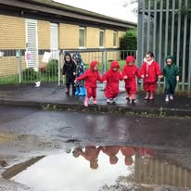
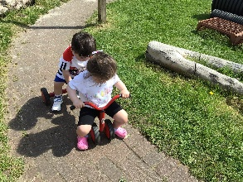
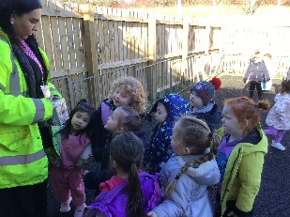
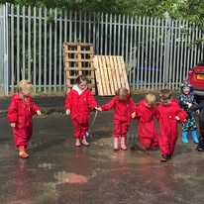

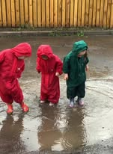
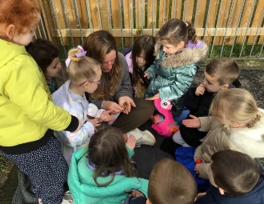
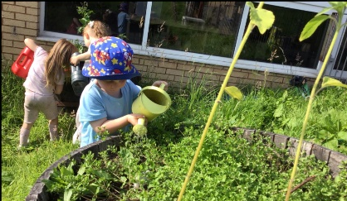
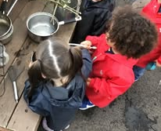

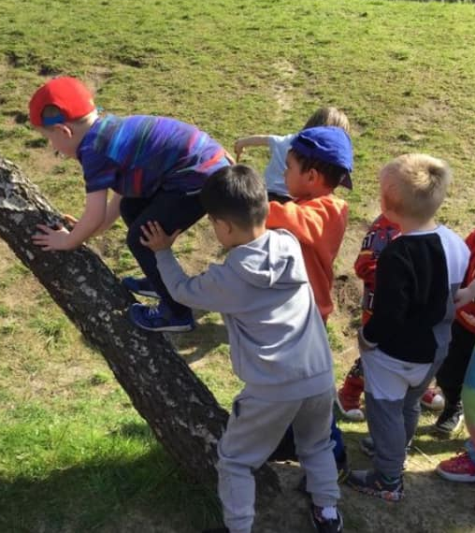
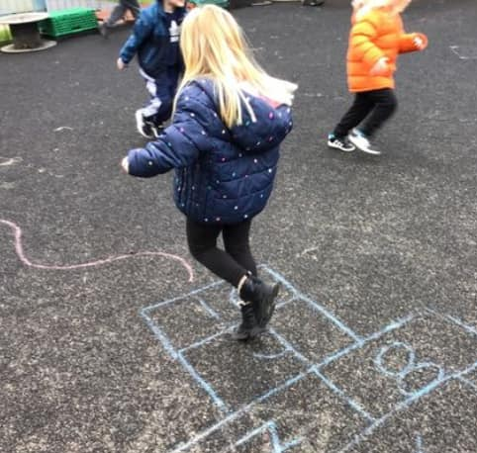
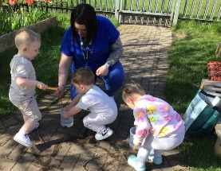
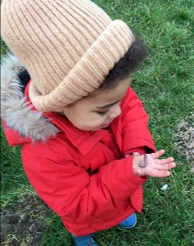
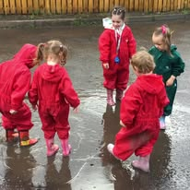


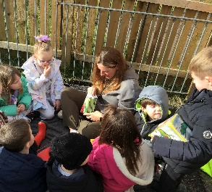
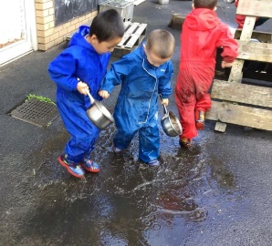
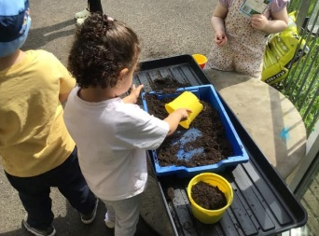
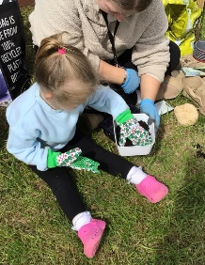

NURSERY GROUPS
In nursery there are various groups that you may be asked to join, for example:

- We have a parent committee.
- Fundraising – parents are asked to help in all aspects of fundraising.
- Molendinar Family Learning Centre has recently delivered several PDA courses in conjunction with Love Learning Scotland.

Communicating with Parents/Carers
We use various methods to keep parents/carers up to date with what’s happening in the nursery. For special events and reminders about upcoming school holidays etc, we will display posters around our nursery for your information, we will post on our social media platforms, nursery newsletters and in some cases, email you via groupcall.
Our Facebook page is a private member only area. With your permission, we will post pictures of the children’s activities on this page as well as the nurseries dedicated learning platform.

Breast Feeding Friendly Nursery

Molendinar Family Learning Centre will actively promote breastfeeding, in line with the needs of mothers and their families and promote an environment where breastfeeding is seen as the normal way to feed babies.


OTHER INFORMATION
We would like to take this opportunity to advise you that Glasgow City Councils Health and safety Code of practice states that “Personal effects (e.g., jewellery, body piercings, items of Religious significance, watches, hair slides and belts constitute a hazard and may cause injury if worn whilst participating in physical education and MUST BE REMOVED.” In February 2013 early years and Health and safety agreed that Physical education is a large part of the early years Curriculum offered several times a day and that this would-be risk assessed about wearing personal effects such as, jewellery, earrings, necklaces, bangles, rings, watches and large hair slides. Glasgow City Council recommends that they are not worn within Molendinar Family Learning centre. Risk assessment is available in main office if you wish to view it.
No child will be permitted to access the centre under any circumstances when wear hooped or dangly earrings regardless of risk assessment.

CAR PARKING
We do have a parent car park for you to park your vehicle when dropping off and picking up your child. We do operate a gate and ask all parents/carers NOT to park beyond the gate even if it is open as it needs to be kept clear at all times for service deliveries. Additionally, for health and safety reasons as children are prone to run across this area and it is sometimes utilised for learning activities.
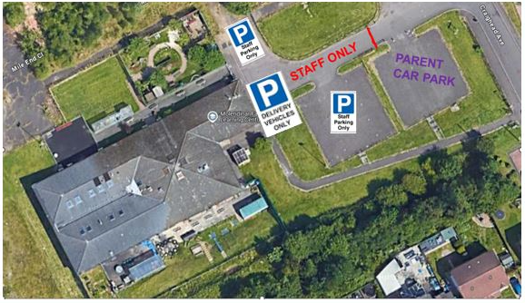

CHILD SAFETY/CHILD PROTECTION POLICY
All educational establishments and services must take positive steps to help children protect themselves by ensuring that programmes of health and personal safety are central to the curriculum and should have in place a curriculum that ensures that children have a clear understanding of the difference between appropriate and inappropriate behaviour on the part of another person, no matter who.

The health and personal safety programme for your child’s establishment will be fully discussed with you on a regular basis.

Schools, establishments, and services must create and maintain a positive ethos and climate which actively promotes child welfare and a safe environment by:

- Ensuring that children are respected and listened to.
- Ensuring that programmes of health and personal safety are central to the curriculum.
- Ensuring that Practitioners are aware of child protection issues and procedures.

Establishing and maintaining close working relationships and arrangements with all other agencies to make sure that professionals collaborate effectively in protecting children.

Should any member of Practitioners have concerns regarding the welfare or safety of any child they must report these concerns to the head of establishment. The head, or the person deputising for the head, after judging that there may be grounds for concern regarding the welfare or safety of any pupil must then immediately advise the duty senior social worker at the local social work services area office of the circumstances. At Molendinar we have two child protection co-ordinators.
- Sharon McLarnon: - child protection coordinator
- Susan Murdoch, Jaqueline Smyth: - deputising child protection co-ordinators
The role of the child protection officer is to attend and update child protection training annually for all Practitioners and students within the centre.
To ensure the child protection procedures are sign posted throughout the centre for all stakeholders.

Copies of departmental guidelines (Management Circular 57) are available from the Head of centre on request.


Molendinar
Family Learning Centre

Child Protection
Co-ordinator

Sharon McLarnon
(Head of Centre)



If unavailable, please speak to

Susan Murdoch
(Depute Head of Centre)


Or
Jaqueline Smyth
(Team Leader/
Depute Head of Centre)

OFFICIAL - SENSITIVE: Personal Data

MC57: Child Protection and Safeguarding
Insert for Establishment Handbooks

Keeping Children and Young People Safe

Educational establishments and services must create and maintain a positive ethos and climate which actively promotes child welfare and a safe environment by:

Ensuring that children are respected and listened to.
- Ensuring that health and wellbeing is central to the curriculum.
- Ensuring that staff are aware of Management Circular 57 and child protection procedures and concerns.
- Ensuring that any CP or Safeguarding concerns are progressed as per MC57 guidance.
- Establishing and maintaining close working relationships and arrangements with all other agencies to make sure that professionals collaborate effectively in protecting children.
- Ensuring the name of the Child Protection Coordinator and Depute Child Protection Coordinator(s) is on display within the establishment.

Name of CP Coordinator: Sharon McLarnon, Head of Centre
Name of Depute CP Coordinator(s): Susan Murdoch, Depute Head of Centre
Jacqueline Smyth, Team Leader/ Depute Head of Centre

All educational establishments and services must take positive steps to help children and young people by ensuring that safeguarding is promoted through all elements of education including leadership, values, vision, the curriculum, learning and teaching, positive relationships, ethos and building resilience in our learners.

Safeguarding supports the development of learner’s knowledge, skills and resilience to keep themselves safe and to protect themselves and develop an understanding of the world so that they can respond to a range of issues and potential risky situations arising throughout their lives.

Safeguarding and wellbeing issues are addressed through our personal, social and health education curriculum and care should be taken to ensure our children have opportunity to develop such knowledge and understanding within our establishments.
As with other areas of the curriculum, you will be kept informed of the health and well-being program for your child’s establishment.

TO ALL PARENTS AND CARERS.

PLEASE SWITCH OFF ALL MOBILE PHONES WHEN IN THE BUILDING.


NO PICTURES TO BE TAKEN IN
NURSERY UNLESS AUTHORISED BY A MEMBER OF THE NURSERY MANAGEMENT TEAM.
Thank you.

LINKS WITH PRIMARY SCHOOLS
The centre has links with St Philomena’s, Carntyne, St Thomas’ and Wallacewell. We will be able to let you know when their enrolment and induction days for new primary one’s are and infant teachers may visit the Centre to meet their new pupils too, in order to make the transition from nursery to primary school as smooth as possible. Transition records, which outline for the infant teacher a new primary one child’s prior learning, are passed onto their schools, with parents having been given the opportunity to read and comment on them first. We will endeavour to support you in any way we can with your child’s transition to primary however, the enrolment of your child in primary school remains the responsibility of Parents, carers and/or legal guardians.

ACCESSIBILITY STRATEGY
Standard Statement

The centre has a duty to ensure that all our pupils have equal access to the curriculum, supported as appropriate to their individual needs. This covers not only the content of lessons and teaching strategies but also minor adaptations to the physical environment of our building to address the needs of pupils with physical or sensory impairments, including the relocation of classes to the ground floor where feasible.

We also need to ensure that parents who have a disability have equal access to information about their children. This could involve, for example, relocating the venue for parents’ meetings to facilitate physical access at parents’ evenings or individual interviews; provision of an interpreter for the deaf; agreeing a telephone contact system to provide direct feedback to parents.

SUGGESTIONS AND COMPLAINTS
In the first instance speak to Sharon McLarnon Head of Centre or another Manager on Duty.

Complaints Procedure
If you have a complaint, please contact the Head of Centre in the first instance who will investigate matters and report back to you within 5 days. (You may call in person, write, telephone or email)
If you feel unable to do so or your complaint remains unresolved you may then Contact:

Customer Liaison Unit
City Chambers – East Building
Glasgow City Council
40 John Street Glasgow
G1 1JL
Telephone 0141 287 5384
Who will:
- Take a totally neutral stance in fully investigating your complaint.
- Acknowledge receipt of your complaint within five working days.
- Give a full written response within a further 10 working days unless another timescale has been agreed.

The Customer Liaison Unit can be contacted by phone or e-mail.
Phone 0141 287 5384
Email education@glasgow.gov.uk
If you do not wish to contact Glasgow City Council directly you may instead contact
The Care Inspectorate. They ensure that our Early Years service meets the Health & Social Care, My Support, and My Life policies published by the Scottish Government (2017)

You may contact the Care Inspectorate in person, in writing, by e-mail or by telephone Care Inspectorate
Compass House
11 Riverside Drive
Dundee
DD1 4NY
01382 207100
Fax 01382 207289

www.careinspectorate.com
Email: enquiries@careinspectorate.com. Enquiries: 0345 6009527

ADDRESSES AND CONTACTS

Mr Douglas Hutchison | Ms Jackie Fulton
Director of Education Services | Glasgow City Council
Glasgow City Council | City Chambers East Building
City Chambers East Building | 40 John Street
40 John Street | Glasgow
Glasgow | G1 1JL
G1 1JL
Early Childhood & Extended Services | Social Work Department
Glasgow City Council | Westwood House
40 John Street | 1250 Westerhouse Road
Glasgow | Glasgow
G1 1JL | G34 9EA
Tel: 0141 287 7350 | Tel: 0141 276 3410

Easterhouse Police Station | 0141 532 4300
Easterhouse Sports Centre | 0141 276 1630

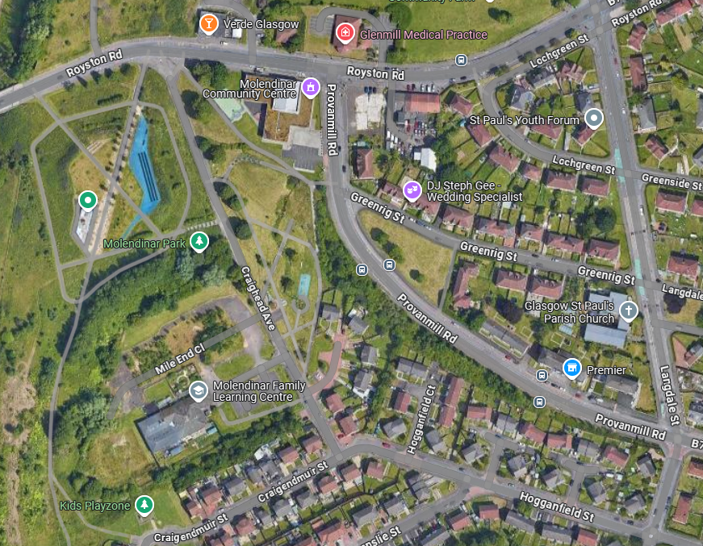
Bus Stop: 8, 8A, 19 & 19A
Glenmill Medical
Bus Stop: 8, 8A
WE ARE HERE!

