Establishment Handbook

Fortrose Nursery School

74 Peel Street
Glasgow G11 5LR

0141 339 1808
headteacher@fortrose-nursery.glasgow.sch.uk

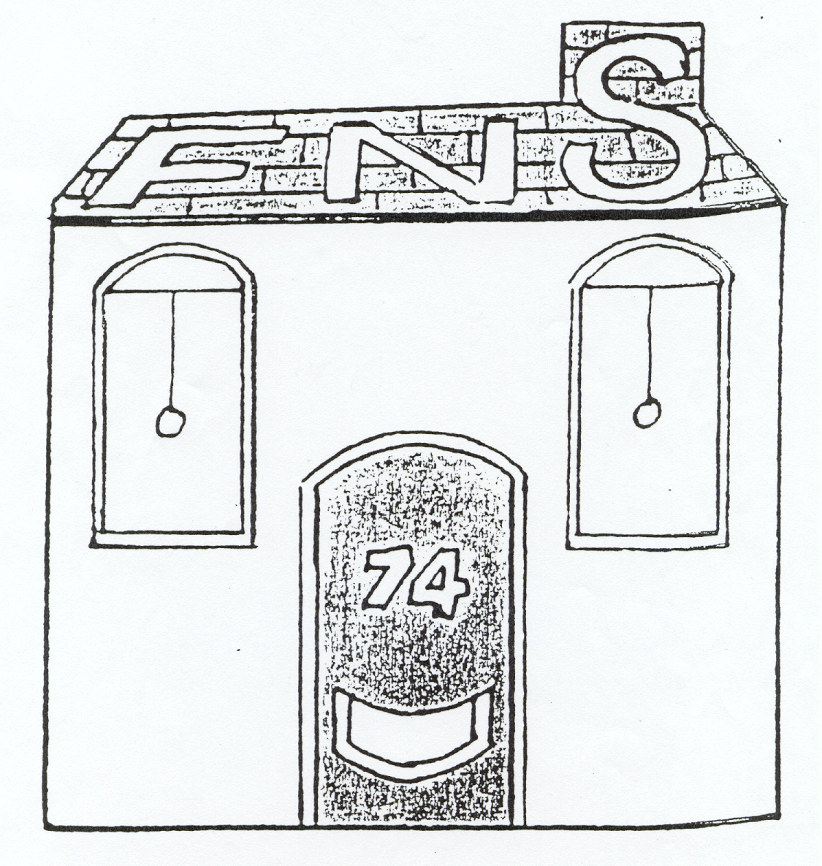

Session 2022/23
Contents

Section One | Establishment Aims
Section Two | General Information  - Names and job titles of our staff members  - Hours of opening  - Daily sessions  - Length of year including details of holidays  - Admissions Policy  - Age range of children in the establishment  - Numbers of children at each daily session and patterns of attendance  - Suitable clothing  - Registration of applicants  - Enrolment procedures  - Arrival and collection of children  - Insurance  - Excursions and consent forms  - Transport  - Emergency closure arrangements  - Emergency contacts  - Meals  - Snacks and the promotion of healthy eating habits  - Statement on Non-Smoking Policy  - Other General Information
Section Three | Medical Information  - Medication  - If your child becomes ill  - Minor accidents and upsets  - Illness
Section Four | The Nursery Curriculum  - The aims of our curriculum  - How we promote learning  - What we do  - Assessment
Section Five | Parental Partnership  - Working together to support learning  - Supporting children with difficulties  - Working with you  - Working together to promote positive behaviour  - Keeping children safe
Section Six | Other Information  - Suggestions and complaints  - Useful addresses  - Disclaimer on changes to information given
Appendices | - Map showing location of nursery  - Travel information

Section One: Establishment Aims

Our shared vision at Fortrose Nursery is to provide and promote the following values:
- A sense of belonging
- Trust
- Integrity
- Fairness
We aim for success and achievement, and are passionate about reaching our goals.
During this year’s cycle we aim to:

- Develop children’s skills in Literacy and Numeracy
- Develop children’s skills in Digital Technology

In addition to the above we particularly would like you to note the following:

Non-denominational policy of the nursery
The nursery is non-denominational. We respect and welcome children and parents of all religions, faiths and beliefs.

Our equal opportunities policy
All pre-five services should reflect the council’s equal opportunities policies and be anti-racist, anti-sexist, multi-cultural, and recognise the rights of both men and women to work or to care for children. Provision will take account of the needs of children with handicaps, disabilities or chronic illnesses. These principles are reflected in the criteria used to admit children to nursery and in the curriculum of all the establishments.

Accessibility Strategy
The school has a duty to ensure that all our pupils have equal access to the curriculum, supported as appropriate to their individual needs. This covers not only the content of learning and teaching strategies, but also minor adaptations to the physical environment of our building, to address the needs of pupils with physical or sensory impairments. We also ensure that parents who have a disability have equal access to information about their children.
Internally, the nursery occupies two floors, the first of which is accessed by a large stairwell, fitted with a hand-rail.
At present there is no lift access in the building.
The staff will ensure that anyone who is restricted by the stairwell, can access all nursery communication/ curriculum/ information and meetings, on the ground floor.
Please notify the headteacher if you, or members of your family, are experiencing difficulty using the facilities, so that appropriate measures can be taken.
Section Two: General Information

Names and job titles of our staff members

Below is a list of staff at the nursery and details of our regular opening hours.

Headteacher Alison Campbell

Team Leader (Acting) Eva Canning

Child Development Officer Kirsty Streager

Child Development Officer Jemma Sinclair

Child Development Officer (Job Share) Alison Cochrane

Child Development Officer (Job Share) Marielle Hood

Child Development Officer (Job Share) Andrea Pirie

Child Development Officer (Job Share) Joanne Hunter (currently on Mat leave)

Clerical Assistant (Job Share) Janice Smith/ Melanie Chambers

Janitor/Cleaner Patrick Lyons

Catering Assistant Margaret McFadyen

Evening Cleaner Sandra Munro



Hours of opening

8.30 am – 4.00pm

Daily sessions

Morning Session: 8.30am – 12.15pm
Afternoon Session: 12.15pm – 4.00pm
Full-time session: 8.30am - 4.00pm
Proposed School Holidays 2022/ 2023

Staff In-service Days Monday 15th August 2022 & Tuesday 16th August 2022

Pupils Return Wednesday 17th August 2022
September Weekend Friday 23rd September and

Monday 26th September 2022

Staff In-Service Day Friday 14th October 2022 (closed to pupils)

October Break Monday 17th October to

Friday 15th October 2022 (inclusive)

Christmas/New Year Thursday 22nd December 2022
to Tuesday 3rd January 2023 (inclusive)

February Break Monday 13th February to
Wednesday 14th February 2023 (inclusive)

Staff In-Service Day Wednesday 15th February 2023 (closed to pupils)

Spring Break Monday 3rd April 2023 to
Friday 14th April 2023 (inclusive)

May Day Holiday Monday 1st May 2023

In-Service Day Thursday 25th May 2023 (closed to pupils)

Mid Term Holiday Friday 27th May 2023

Monday 26th May 2023

School Closes at 1pm Friday 23rd June 2023

Please note on In-Service Days children DO NOT attend school. These days are reserved for Staff Development.



Admissions policy
All nursery places are allocated in line with the Council’s Admissions Policy and the nursery staff will be happy to advise you how this policy operates when you apply for a place for your child. A leaflet detailing the Council’s policy is also available from all establishments.

An Admissions Panel will meet at regular intervals throughout the year to decide how nursery places will be allocated.

The panel consists of all heads of pre-five establishments in the area, a representative from divisional offices and if required, representatives of the other agencies involved in supporting children and their families eg Social Work Department, Health Board.

Age range of children in the establishment
This nursery admits children aged 3-5 years.

Numbers of children at each daily block and patterns of attendance
Maximum of 32 children at any one time.
All children are offered 30 free hours per week i.e. 3 full days and 2 half days OR 4 full days and one day off.

Regular attendance is very important. If your child is going to be absent please telephone the nursery school to let us know the reason.

Suitable clothing
Children have the best fun when they are doing messy work. We will always try to make sure they wear aprons but accidents happen, so please dress your child in suitable clothes. Stiff fastenings on trousers and belts can make going to the toilet difficult, please bear this in mind when dressing your child for nursery.

Please ensure also that your child is suitably dressed to play safely on climbing equipment, etc in the physical room, i.e. no jewellery, loose ribbons, belts etc.
It is important also that your child wears clothing which is suited to the weather, as much of their day is spent outdoors. You will be asked at enrolment to submit a pair of wellingtons for your child to keep at nursery.
Please write names on all items of clothing, and footwear to prevent mix-ups.

Register of Applications

A register of all applicants will be kept by the headteacher, and the information contained in the applications will be considered by the Admissions Panel to assist in the allocation of places. Parents can ask to see their application at any time. If circumstances change which affect the application, you should speak to the headteacher.
Funding Your child will be eligible for a free place (30 hours per week) from the Monday after their third birthday. Admission to the nursery and pattern of hours will depend on availability of spaces at the time.

Nursery Charges If you require more than your entitlement of 30 hours per week, and there is space to allow this, the following charges will apply.
Standard Hourly Rate (3-5 years) £5.00
- If the parent/ carer is not eligible for the Discounted Hourly Rate (see below) and other resident hourly rates
- If parent/ carer is a student and the college/ university pay for the children’s charges
Discounted Hourly Rate: £4.00 (available for all Glasgow residents’ children 3-5 years)
- If the parent/ carers’ joint income (whether partner, lone parent or student receiving SASS award) exceeds £16,480
- If parent/ carer is a working student and the college/ university does not pay childcare charges, and joint household annual income (whether with partner or lone parent) exceeds £16,480
Resident Reduced Rate: £1.00
- If parent/ carers’ joint household annual income (whether with partner, lone parent or student) household income is less or equal to £16,480
- If parent/ carer is a student and the college/ university do not pay for childcare charges and household income is less than or equal to £16,480
- If a parent/ carer is a kinship carer by statute/ law or Social Work Services have agreed a Kinship Carer agreement
(Please note the residents reduced rate does not include free meals for children. Parent/ carers are required to apply for free school meals to Glasgow City Council claims section for consideration).
Resident Second Child Rate; £2.20
- If a parent/ carer has two children in nursery and are incurring charges for the eldest child. Parent/ carer will be eligible for second child rate for younger child.
Resident Third Child Rate: £1.70
- If a parent/ carer has three children in nursery and are incurring hourly charges for the two eldest children. Parent/ carer will be eligible for third child rate for youngest child
Any additional lunches not included in your 1140 hours will cost £1.52 each

Enrolment
The headteacher will contact you around the time of your child’s 3rd birthday to inform you of the availability of places, and the options available to you at that time. If we are unable to offer you the place of your choice, your Application Form shall be passed onto your 2nd choice of nursery (as named on your Application Form).

Arrival and collection of children
It is expected that a responsible adult will bring a child to and from the nursery. We will not allow your child to go home with anyone under the age of 16.

Insurance
Sometimes children like to bring something special or new to nursery for their friends to see. However, parents should ensure that valuable items are not left at nursery, particularly as the authority has no insurance to cover the loss of such personal items.

Excursions and consent forms
When your child is attending a nursery outing, you will be asked to complete an “Outings Consent Form”. You shall be advised in advance of all planned outings as they occur, and will be required to complete a consent form each time.

Transport
Transport is not normally provided for children attending pre-five establishments. The council may, however, provide transport to and from nursery for children with additional needs who may require travelling some distance to take up their placement. A few establishments have their own transport but this is exceptional, and generally parents should make their own travel arrangement.

Emergency closure arrangements
The nursery will be opened on the times already outlined, but on some occasions, circumstances arise, which mean the nursery has to close.
The establishment may be affected by, for example, severe weather, transport problems, power failures or difficulties with fuel supplies, or more recently, lockdown restrictions due to the pandemic. If this happens, we will do all we can to let you know about the details of closure and re-opening.
We may keep in touch by telephone, e-mail, in the press and on local radio.

Emergency contacts
Parents whose children are in the nursery must provide the establishment with the names, addresses and telephone numbers of two local contact persons for use in case of an emergency. You are also asked to keep the nursery up-to-date with any changes in this information.
Meals
The nursery offers free lunch provision for children who are accessing 1140 hours. Any requests for more than 1140 hours will be carefully considered and agreed by an Admissions Panel.
Below is a sample of a 2week menu. Vegetarian / Halal options are also available as required.
Week One
Monday | Tuesday | Wednesday | Thursday | Friday
Soup & bread  Baked Potato & Cheese  Coleslaw | Beefburger Roll  Potato Wedges  Mixed veg  Cake & Custard | Fish Fingers  Potatoes and Peas  Yoghurt | Steak Pie  Yoghurt | Soup & bread  Roast Chicken  Potatoes  Green Beans
Week Two
Monday | Tuesday | Wednesday | Thursday | Friday
Soup & Bread  Macaroni Cheese  Potatoes & Vegetables | Lasagne  Garlic Bread  Yoghurt | Sausages in Gravy  Potatoes & veg  Yoghurt | Baked Potato & cheese  Coleslaw  Yoghurt | Lentil Soup  Fish  Garden Peas  Potatoes

Snacks and the promotion of healthy eating
A free selection of fruit will be issued each day for children’s snack. We shall use Toy Fund* (see below) to purchase a variety of other healthy foods to complement the fruit. Examples of this include oatcakes, cheese, bread sticks etc

- Staff will ensure that a range of healthy foods is offered.
- Children will be encouraged to try the full range of foods available.
- Staff will be aware of children who have food allergies and procedures for dealing with allergic reactions.
- Staff will raise the children’s awareness of value of specific foods for growth, energy and protection.
- Cold, safe drinking water will be available at all times.
- Staff will encourage the children to drink milk/water.

No smoking policy
All children within the nursery school have the right to a healthy and smoke-free environment.
The nursery school operates a NO SMOKING policy. Any staff member, parent or visitor wishing to smoke must do so outwith the nursery school building and grounds.

Other general information

Birthdays
Each child will be given a card and a small gift on his/her birthday. We operate a Healthy Eating Policy, and therefore request that you DO NOT bring cake or sweets to nursery for this, or for any other occasion.

Toy Fund Contribution (for Nursery Funds)
We ask each family for a weekly contribution of £2.50 per child to go towards nursery funds. This fund enables us to pay for flour for playdough, baking ingredients, materials for sensory experiences, birthday cards, birthday gifts, parties, photographs, hire of water cooler, name badges, outings and any extra material needed. This contribution helps to enrich the experiences your child is offered.
Our Clerical Assistant, Janice will collect your £2.50 Toy Fund on a Wednesday.
A list of items we have bought with Toy Fund will be attached to each monthly newsletter.

Settling In
Each child takes their own time to settle into a new place and to get to know and trust the new people they meet there. Our settling-in policy requires each child to start on a Monday and stay for one hour on their first day. We shall then increase their time by 30mins each day so that they are fully settled by the Friday of the same week. It is important that a familiar adult is around during this first week to support this transition.

With your co-operation and support we hope that your child will be happily independent and constructively occupied.

Fire Register
Your child will be required to be signed in “in” at the beginning of each session and the name given of the person who will be collecting your child later. If someone other than the named person comes for your child we will require phoning you to gain verbal permission to allow your child to leave with this person. It would be helpful to phone the nursery if someone other than the named person is coming for your child. When you leave you must sign your child “out”.

Badges
Each child wears a badge showing his/her name. This assists your child in developing early literacy skills. Please help your child to select and put on their badge at the start of each session. Remember to leave the badge in the nursery at the end of the session.

Section Three: Medical Information

Medication
If your child needs medication during his/her time at nursery you should discuss his/her requirements with the headteacher. Prescribed drugs will be given at the discretion of the Head Teacher and you require filling in a form, which authorises nursery staff to administer the medicine to your child. The headteacher will give you the necessary form to complete.

If your child suffers from asthma you must tell the headteacher if there are any activities or specific circumstances which are likely to bring on an attack.

If your child suffers from epileptic attacks you must tell the headteacher the nursery what emergency treatment to give.

Absence
If your child is unable to attend nursery, you must telephone the school giving reasons for absence.

If your child becomes ill while at nursery a phone call will be made to the parent, carer or emergency contact person to collect the child. It is important that any change of address/telephone number/work number/emergency contact number is reported immediately to the Head Teacher.

Minor accidents and upsets
These will be dealt with on the premises by staff. All such incidents are recorded and parents informed.

Illness
Children should not attend nursery if they are unwell in any obvious way including diarrhoea, fever, coughing spells and untreated infections of the skin. Mild or convalescing infection can still pose an infectious risk. Please let us know if your child contacts an infectious disease.

Covid-19
If your child begins to develop symptoms of Covid-19 whilst at nursery, they will be taken to a separate room, and you will be called to collect them immediately.


Section Four: The Nursery Curriculum

Our aims
We aim to create a happy, stimulating secure environment where we can share in and encourage your child’s love of life through a carefully delivered curriculum.

Curriculum
The curriculum followed in all Scottish schools is “A Curriculum for Excellence”, which outlines experiences and activities to develop social, emotional, physical, aesthetic and intellectual growth. Through planned and spontaneous opportunities for play, the children develop abilities, attitudes, skills and concepts. You may find out more about this curriculum by typing “A Curriculum for Excellence” into your search engine.

How we promote learning
We promote learning by ensuring that activities and resources are appropriate in terms of children’s interests, stage of development, ability and experiences.

What we do
The nursery day is organised to allow children’s choice in selecting and planning their own activities. There will be planned periods of self-selected play and also of adult-led activities. There will be a balanced programme of indoor and outdoor play.

Planning & Assessment
Planning and Assessment is ongoing throughout the year. Staff and pupils agree their learning intentions and set their standards for achieving maximum potential. We engage in formative assessment, and in self-and peer assessment in accordance with the Curriculum for Excellence. Children are observed closely to ensure that they are progressing satisfactorily. These observations and discussions form the basis of planning for next steps.

Section Five: Parental Partnership

Working together to support learning
Everything you do with the children at home contributes to your child’s development and we aim to work alongside you to give the children the best opportunities possible. You will learn more about our curriculum from our newsletters and information board. We encourage you to share the activities and information with your child. Please do not hesitate to speak to the headteacher if you require advice about helping your child to acquire specific skills.

Supporting children with difficulties
In order to achieve their maximum potential, children will experience a curriculum appropriate to their needs. There may be occasions where it is felt that children may benefit from specialist help. The nursery school may make referrals, with the consent of parents, to other agencies such as speech and language therapists or an educational psychologist, where appropriate.

Working with you
At the beginning of the session, parents are asked to share their knowledge of their child with the staff. This enables the staff to understand what the child is like at home and what their specific interests are.

Parents are encouraged to discuss any problems or worries and share information about events in family life, holidays, visits, illnesses, accidents, separation, etc.

We would like volunteers to accompany the children on outings. Please read the notice board regularly to keep up to date with information. Monthly newsletters are sent home to keep you informed of nursery life. If you have any other ideas on how we can work together please let us know.

Working together to promote positive behaviour
The children are encouraged to co-operate with each other, to share and to be considerate. We promote a positive ethos and adopt positive behaviour management strategies. Good behaviour is praised and encouraged. When inappropriate behaviour occurs, staff members intervene sensitively to redirect the child, explain the inappropriateness of the earlier behaviour, and provide opportunities for children to express and explore their feelings, needs and preferences in socially appropriate ways.

Keeping Children Safe
All educational establishments and services must take positive steps to help children protect themselves by ensuring that programmes of health and personal safety are central to the curriculum and should have in place a curriculum that ensures that children have a clear understanding of the difference between appropriate and inappropriate behaviour on the part of another person.

Schools must create and maintain a positive ethos and climate which actively promotes child welfare and a safe environment by:

- ensuring that children are respected and listened to
- ensuring that programmes of health and personal safety are central to the curriculum
- ensuring that staff are aware of child protection issues and procedures
- establishing and maintaining close working relationships and arrangements with all other agencies to make sure that professionals collaborate effectively in protecting children

Should any member of staff have concerns regarding the welfare or safety of any child they must report these concerns to the head teacher. The headteacher, or the Team Leader, after judging that there may be grounds for concern regarding the welfare or safety of any pupil, must then immediately advise the duty senior social worker at the local social work services area office of the circumstances.

Copies of departmental guidelines (Management Circular 57) are available from the head teacher on request.

If you need information, advice or support, please contact Mrs Campbell, headteacher.


Section Six: Other Information

Suggestions and complaints

We are always anxious to maintain and improve our service. If you have any suggestions to make about the service, please contact the Head Teacher in the first instance. Similarly, if you have a complaint about any aspect of the service you should contact the Head Teacher. She will investigate matters and report back to you within 5 days (you may call in person, write or telephone)

If you feel your complaint has not been satisfactorily resolved with the establishment head, please contact the Corporate Customer Care Team.:

customercare@glasgow.gov.uk
Tel – 0141 287 0900

If you do not want to contact Glasgow City Council directly you may instead contact the CARE INSPECTORATE, a non-departmental body set up under the Regulation of Care (Scotland) Act 2001 to regulate care services throughout Scotland

The Care Inspectorate has established a complaints procedure approved by Scottish Ministers and will investigate on your behalf.

Headquarters Regional Office for Central West
Compass House 4th Floor
11 Riverside Drive 1 Smithhill Street
Dundee DD1 2NY Paisley PA1 1EB

Telephone: 01382 207100 Telephone: 0141 843 4230
Fax: 01382 207289

www.careinspectorate.com

Privacy Statement
As a local authority our schools and early years establishments process information about children and young people in order to provide education and care. In doing so we must comply with the Data Protection Act (1998). This means, amongst other things that the data held about children and young people must only be used for specific purposes.
However, you should be aware that we may use this information for other legitimate purposes and may share this information where necessary with other public bodies or where otherwise required by law. We may also use any information for research purposes. However, all personal data is treated as confidential and used only in accordance with the Data Protection Act and the Information Use and Privacy Policy approved by the City Council.

For further information please see our full privacy statement at www.glasgow.gov.uk/index.aspx?articleid=2895.

Please note

Although the information in this handbook is correct at the time of printing there could be changes affecting any of the matter dealt with in it, either before your child’s placement begins or during the course of their placement. The headteacher will tell you of any important changes to the information.
Appendices

Appendix One: Map Indicating Position of the Establishment

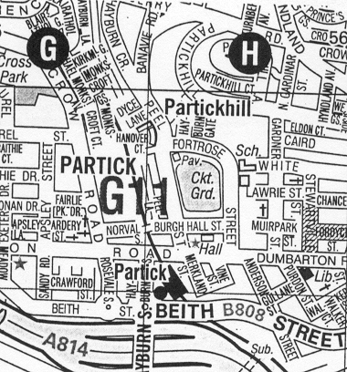
Fortrose Nursery School

Partick Train and Underground Stations

Appendix Two: Travel Information

The nursery can be easily reached by public transport:

By train to Partick Station
By Underground
By bus to Dumbarton Road

