Rowena Nursery
20 Knightscliffe Avenue
Glasgow City Council
G13 2TE
Tel: 0141 959 9056


Nursery Handbook
2025-2026

“Let’s join together today, to create a fabulous tomorrow”

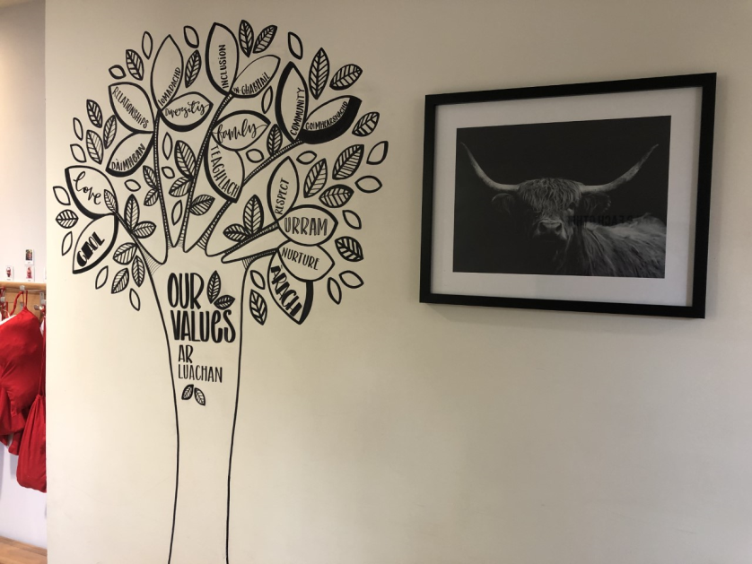

Rowena Nursery / Sgoil Araich Rowena is a dual language early year setting where we provide English medium and Gaelic medium education.

At Rowena Nursery, we aim to

- be advocates of children and childhood, safeguarding and celebrating the importance of early years as a crucial stage in its own right. Children’s rights and children’s voice will underpin all that we do within our diverse and inclusive service.

- strive for excellence to provide a sector leading early learning and childcare environment that meets the holistic needs and aspirations of our very young children, families, community and local and national priorities.

- have the highest expectations for all children ensuring barriers to the attainment and wellbeing of children are supported fully by a service that understands and promotes equality and equity to narrow the gap of disadvantage.

- develop our team ensuring that all educators are well supported, enthusiastic, reflective and highly motivated with high standards of professionalism and pedagogical understanding underpinning practice.

- involve families in every step of their child’s learning journey, genuinely respecting and embracing the skills and attributes of parents and the importance of the home as the first and most important learning environment. As such we will embark on a flexible family engagement programme that will be shaped by the needs of Rowena families.

- provide meaningful learning that is grounded in nurturing practice, is developmentally appropriate, differentiated, connected, exciting and relevant to children’s own experiences and interests.

- promote the acquisition and learning of Gaelic through a play-based pedagogy, utilising strong links with the wider Gaelic community to further enrich and develop learner experiences. We aim to enhance the status of Gaelic throughout our setting exposing all children to Scotland’s heritage, national identity and cultural life.

- support children to “Be all You can Be” linking Pre-Birth to Three, Realising the Ambition and the 4 capacities of early level Curriculum for Excellence.

Senior Leadership Team:
Gillian Pollock-Ogden Head of Nursery
Lynn Hughes Acting Nursery Depute
Chloe Douglas Acting Team Leader
Erica Weir Acting Team Leader

Rowena Team:
Ainsley Clark Child Development Officer Lauren Leverage (Job Share) Child Development Officer
Arlene Armstrong Child Development Officer Katie Gallagher Child Development Officer
Amanda Carr Child Development Officer (Supply) Mhairi McAuley Child Development Officer
Yvonne Conley Child Development Officer Megan Bernacca Child Development Officer
Gael Dempster (Job Share) Child Development Officer Shelby Butler Child Development Officer
Stephanie McCann Child Development Officer Jordan Cairns (Job Share) Child Development Officer
Melissa McCulloch Child Development Officer Jordyn Lyden Child Development Officer
John O’Brien Child Development Officer Julie Nelson Child Development Officer
Lisa Baxter Child Development Officer(supply)
Taylor Cairney Modern Apprentice Michaela Dreeling Graduate Apprentice

Christine Keefe Support for Learning Worker
Iwona Madejska Support for Learning Worker
Abeer Hussein Support for Learning Worker – lunch cover
Iqra Ayyaz Support for Learning Worker – lunch cover

Maureen Deans Clerical
Irineu Cruz Clerical
Carol McPhee Cleaner
Alex Owens Janitor

Anne Melly Kitchen Staff
Margaret McKew Kitchen Staff


Meet the staff


Emergency Contacts:
We ask that you please provide the nursery with the names, addresses and telephone numbers of two persons for use in the case of emergency. It is important that the emergency contacts are physically able to come to the nursery on your behalf when needed. You are asked to keep the nursery up to date with any changes in this information - this is very important.
Admissions:
You are welcome to request an application at any time. Once you have completed this you are required to make an appointment either in person at the nursery office or via the phone to hand in the application and accompanying paperwork. You can make an application from the child’s birth, and they will remain on our applications list until they are 2 years old or aged 3. You will be notified as soon as a place becomes available. If you intend for your child to attend Glasgow Gaelic School, you can apply for a place in our Tiree playroom for when your child turns 3. Admission to Rowena Nursery is in accordance with Glasgow City Council’s Admissions Policy.
Nursery Information
Session Times and lunch sittings:
Session times
Morning 8am-12.30pm
Afternoon 13.00- 17.30pm
Full day 8am- 17.30pm

Lunches
At Rowena we provide all children with a lunch each day, our lunch time runs from 11:15 to 12:30 and 13.00-13.30 for children who attend in the afternoon.
At lunch times we have a rolling lunch which promotes children’s choice and independence choosing when to have lunch. Supporting children to make these decisions is all part of the process of enabling children to develop positive eating habits and building their autonomy. Staff will play a key role in role modelling and encouraging children to have lunch each day. We will promote a home like environment that is calming and nurturing with a self-service approach with the children developing their independence and self-help skills. This will also provide great opportunities for social interactions and develop positive relationships during rich and purposeful experiences.


Start Date:
Your child will be invited to the nursery and begin their settling in. On the first day your child will be introduced to a member of staff, known as their key worker, to offer a sense of security for your child. Should you have any concerns or wish to discuss any matters regarding your child, your child’s key worker is the first point of contact.

Settling Process:
At first, nursery may seem a very big, strange place to your young child. Please be patient and be prepared to stay for your child’s first visit. From there the keyworker will discuss a plan to move forward.
Time spent on really settling in, is time well invested for your child’s security and confidence. Staff are very experienced in this and will guide you and your child through this process.


Nursery Fund
We would like to say THANK YOU for your parental contributions to our nursery fund, we appreciate your continued support. Whilst this is a voluntary contribution of £2.50, we rely heavily on these additional funds to supplement extra resources for the children so your support is very much appreciated. If you would prefer to pay monthly or termly, please have a word with Maureen or Elspeth in the office and this can be arranged.

General Information
Toothbrushing:
All children at Rowena, with parental consent, participate in tooth brushing programme. Children are closely supervised whilst toothbrushing.
We also participate in
‘child smile programme’
for children to receive fluoride varnishing at nursery.
Attendance:
Regular attendance is very important. If your child is going to be absent, please telephone the nursery to let us know the reason. Children should not attend nursery if they are unwell in any obvious way including diarrhoea, fever, coughing spells and untreated infections of the skin. Mild or convalescing infection can still pose an infectious risk. You are required to phone the nursery on day 1 of any absence whether it is planned or unplanned. If your child is off for two consecutive days without notifying us, we will contact you about this.
Health Promoting Nursery:
A healthy snack is provided daily. Please inform us of any medical or dietary needs. Children must not bring their own food / sweets to nursery. Some children have allergies and may become ill if given food by other children, this includes having food items in your child’s bag on their peg in the corridor.

Administration of medication:
It is very important that full details of your child’s medical and allergy history is provided when completing admission forms and that any new information is communicated promptly to the Nursery.
Children cannot be given medicine in nursery unless by prior agreement in writing and medication forms have been filled in. All medication must have pharmacy labels on with children’s name and the first dose been given by the parent. On-going medication must be replaced when required as per used by date. All medications will be reviewed every 28 days by the team leader, and you will be asked to sign every review regardless of any changes.




Clothing:
We are registered as an indoor/outdoor nursery, and children will have the choice to be outdoors all day every day and in all weathers. We have outdoor suits to keep children warm and dry, but we ask you to provide wellie boots. Please ensure a change of clothes is kept in Nursery with your child’s name is clearly marked on their clothing. As well as outdoor play, children enjoy messy activities, so please do not wear ‘good’ clothes to nursery. We will always try to make sure that they wear aprons or overalls, but accidents do happen so please dress your child in suitable clothing. Remember the children have to go to the toilet themselves and braces, belts, etc, are difficult for them to unfasten and refasten. If you have any questions regarding clothing, please contact the Nursery.

Nursery Year
All term time children will be off when the schools are off, these dates are below. All children will be off public holidays and in-service days; these dates are subject to change but we will keep you informed.
August
- Tuesday 12 August 2025 (In-Service Day closed to all children)
- Wednesday, 13 August 2025 (In-Service Day closed to all children)
- Thursday, 14 August 2025 (Return date for Pupils)
September
- Friday, 26 September and Monday, 29 September 2025 (September weekend holiday closed to all children)
October
- Friday, 10 October 2025 (In-Service Day all children)
- Monday, 13 to Friday, 17 October 2025 (October Week closed to Term Time Children)
December - Christmas and New Year
- Nursery closes Friday 19 December 2025 (Term Time children)
- Nursery closes Wednesday 24 December 2025 (52wk children)
- Thursday 25 December 2025 – Thursday 1 January 2026 (Christmas holidays)
January
- Nursery returns on Monday 5 January 2026
February mid-term break
- Monday, 16 February 2026 (Closed to term Time children)
- Tuesday, 17 February 2026 (Closed to term Time children)
- Wednesday, 18 February 2026 (In-service day closed to all children)
April - Spring Holiday (Easter)
- Nursery closed on Friday 3 April -6 April 2026 (inclusive) (closed to all children)
- Tuesday 7 April - Friday, 17 April 2026 (Spring Break) (closed to Term Time children)
May
- Monday 4 May 2026 (May Holiday)
- Thursday 7 May 2026 (in-service closed to all children)
- Friday, 22 May 2025 and Monday, 25 May 2025 (May Weekend closed to all children)
June
- Nursery closes 25 June 2026 for Term Time children



Learning at Rowena



At Rowena Nursery we follow in the moment responsive planning. In our 2-3 room this in line with the Pre-birth to three documents, our 3-5 Gaelic unit follows Gaelic Medium Education in line with early level Curriculum for Excellence, and our English 3-5 also follows planning in line with Curriculum for Excellence.
We are recognised as an indoor/outdoor nursery and along with the curriculum we use supporting documents from my world outdoors.
We have a library that the children can borrow books to read at home and home links learning bags for all children to participate in some family learning and return to nursery to let us see what they have been getting up to. This takes the form of simple, low-cost repeatable activities parents can then learn and do at home.

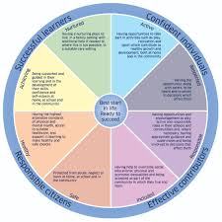

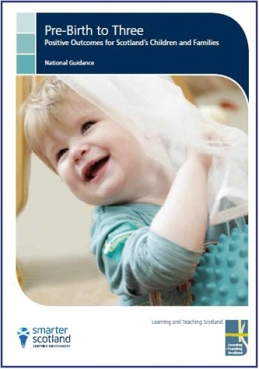


Partnership with Parents
Sharing and documenting Children’s Learning
At Rowena we now use online learning journals to document and share your child’s learning. These are filled with enriched learning that depict and celebrate your child’s learning and development. You will be sent a link that you then change to a password and pin, this enables you to access your child’s journal and you will be notified when something has been added. You are also encouraged to add your own comments and important events happening at home.
Please give us a call if you need any support with this.

Our Guiding Principles
- At Rowena relationships are fundamental to us. We are a kind and caring team who provide a safe base for all. We have a real focus on getting to know our children and families and work together to enable everyone to reach their full potential.
- At Rowena, we pride ourselves in treating all children and adults equally. Everyone is included, valued and celebrated as individuals, from different stages, backgrounds and cultures. Listening to their ‘voice’ with or without words is central to everything we do. We take a holistic approach respecting children’s rights in a way that is appropriate for them.
- At Rowena we value a child centred pedagogy where children’s interests and needs are placed at the heart of everything we do. We do this by listening to their voices, actions and emotions. Children are active participants and c0-creators in their learning and in the life of their nursery.
- At Rowena we provide a nurturing environment where children are loved, cherished and cared for by kind and understanding adults who know them well. Each child’s interests and aspirations are encouraged and supported to ensure they reach their full potential.

There is a private Nursery
‘Facebook’ page.
This is only open to parents and staff. If once your child has started at Nursery you would like to become a member, please send us a ‘friend request’ and we will accept it.
If you do not want your child to be included on our page, please let your key worker know at your induction meeting.
We have regular meetings with parents, however, please do not hesitate to contact the nursery if you wish to share any information or would like a chat about your child.

Useful Information and contacts

SUGGESTIONS AND COMPLAINTS
We are committed to maintaining and improving our service. If you have any suggestions to make about the service, please contact the Head of Centre in the first instance. Similarly, if you have a complaint about any aspect of the service, you should contact the Head of Centre. If you feel your complaint has not been dealt with satisfactorily, please contact

Customer Liaison Unit
Education Services
Glasgow City Council
City Chambers East
John Street
Merchant City
Glasgow
G1 1HL

The Scottish Care Commission regulate all Care Services under the
Regulations of Care (Scotland) Act 2001.

You can contact them at:

Renfrewshire House
Cotton Street
Paisley
PA1 1BF

Contact telephone number : 0345 600 9527
E-mail : concerns@careinspectorate.gov.scot

Heather Douglas
Early Years Manager
0141 287 4493
Executive Director of Education
0141 287 4551

