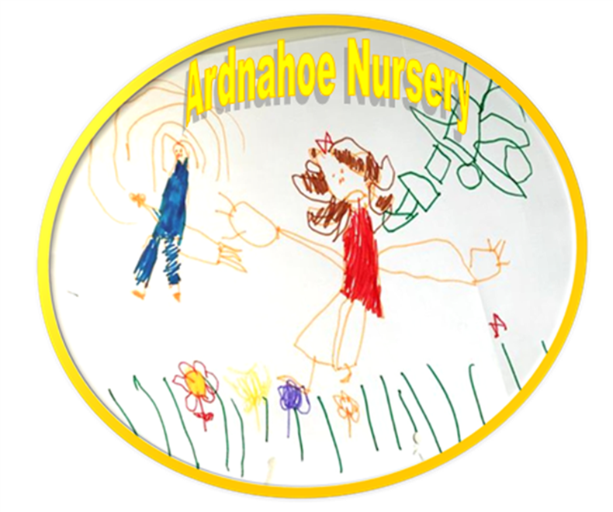

Ardnahoe Nursery Handbook


Ardnahoe Nursery
18 Ardnahoe Place
Toryglen
GLASGOW
G42 ODQ

Telephone Number: (0141) 647 8934
E-mail: headteacher@ardnahoe-nursery.glasgow.sch.uk
Web: www.ardnahoe-nursery.glasgow.sch.uk
Twitter: @Ardnahoe Nursery
Seesaw for attending families

Vision, Values and Aims
In Ardnahoe Nursery the vision and values of staff, parents and children is to:

Communication starts with you and me,
building relationships is the key,
feeling safe and loved we all agree
are the foundations of the
Ardnahoe family.

‘Learning to Learn’
John Dewey (1958)

Priorities for development:
Priorities for development:
1: Leadership and Management - (1.1, 1.2, 1.4, 1.5) Digital Strategy - Rollout the use of Seesaw learning journals for all children

2: Learning Provision - (2.5, 2.7) Continue to build on our partnership links with and for families within the local community.

3: Successes and achievements - (3.1, 3.2, 3.3) Build on the support in place for our EAL children and families.

Staff Members

Our Staff Team will contribute to your child's learning journey at Ardnahoe Nursery. Below is a list of our staff.

Head of Nursery  Depute Head  Child Development Team Leader  Lead Practitioner of Attainment  Child Development Officers  Support for Learning Worker  Support for Learning Worker  Support for Learning Worker  Clerical Assistant  Clerical Assistant  Janitor/Cleaner  Catering Assistant  Catering Assistant  Cleaning Assistant | Mary Houston  Ashley McGregor  Natalie Jolly  Laura Mallon  Mirsie Caka  Yellow  Groups  Patricia Kirk (Part Time)  Gayle Wozencroft (Part Time)  Kirsty McCallum  Louise Wright (Tues – Fri)  Connor Thomson (Supply)  Red  Groups  Lauren Murphy  Danielle Saunders  Robyn Meek  Purple  Groups  Angela Drum  Carly Gardiner  Beata Cisowska  Nicole MacLeod  Paula Houston  Nicole Robertson  Claire O’Reilly  Nancy Pearson  Lynn Hay  Caroline Maghee  Taylor Wells  Michelle Mackie


Contact with the Nursery
All staff want you and your child to be happy in our nursery; we therefore operate an open door policy whereby if you need to speak to you child’s Key Worker, Team Leader or Head of Nursery please approach them. There will be times when we are working with the children, please talk to another member of staff about your concerns or ask them to pass on information. Time can also be arranged for you to have a private conversation, if required. You can also telephone the nursery on 0141 647 8934 at any time during nursery hours.

Please respect other people’s right to privacy. If the door to the office is closed over, please knock and wait, try later or let another member of staff know that you wish to speak to someone in the office.
Admissions Policy
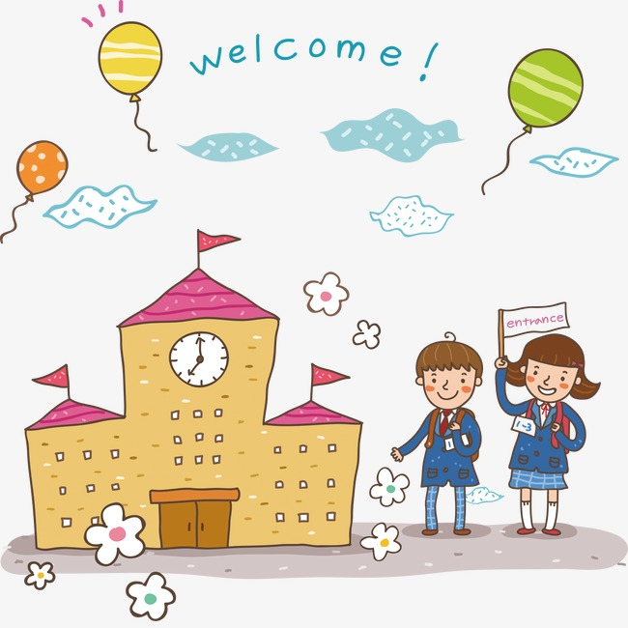
All nursery places are allocated in line with the Council’s admissions policy and the nursery staff will be happy to advise you how this policy operates when you apply for a place for your child. A leaflet detailing the Council’s policy is also available from all establishments. If you wish a copy, please ask for one.

This can also be found on the following web site:
www.glasgow.gov.uk/en/YourCouncil/Service Department/EducationServices/managementcircular.htm Circular No. 3.

An admissions panel meets at regular intervals throughout the year to discuss applications and allocate places. The panel consists of all Heads of Pre-five establishments in the area and representatives of the other agencies involved in supporting children and their families e.g. Social Work Department, Health Board.

You can also find a database of early years establishments and places on Glasgow’s Family Information Service at: http://www.gfis.org.uk/

Non-Denominational Policy of the Nursery
The nursery is non-denominational. We respect and welcome children and parents of all religions, faiths and beliefs.

Our Equal Opportunities Policy
All pre-five services should reflect the council’s equal opportunities policies and be anti-racist, anti-sexist, multi-cultural and recognise the rights of both men and women to work or to care for children. Provision should take account of the needs of children with disabilities or chronic illnesses. These principles are reflected in the criteria used to admit children to nursery and in the curriculum of all the establishments.

Attendance
Regular attendance is very important if children are to benefit from the many social and educational opportunities offered. Please notify the nursery of illness or absence by telephoning 0141 647 8934 or emailing us at headteacher@ardnahoe-nursery.glasgow.sch.uk on the first day of absence. We will contact you through text or email if you have not notified the nursery of your child’s absence.

If you no longer require your nursery place please notify the Head of Nursery.

Register of Applicants
A register of all applicants will be kept by the Head of Nursery and the information contained in the applications will be considered by the admissions panel to assist in the allocation of places. It is therefore important to complete all sections of the application. Please note that the length of time a child’s name has been on the register will not affect the child’s priority for admission. Parents can ask to see their application form at any time. If circumstances change which affect the application you should speak to the Head of Nursery. The Admission Policy can be found on Glasgow City Council’s web site www.glasgow.gov.uk

Enrolment Procedures
The names of children aged two and over can be placed on the nursery register of applications. Children will be enrolled at nursery after their third birthday when a place becomes available.

When your child has been allocated a place, you will be contacted to arrange a home visit. Should you choose not go ahead with the home visit you will be given information regarding the settling procedure which is carefully planned and monitored to ensure both you and your child feel happy and secure. If you are a working parent a Childminder, Carer or family member would be more than welcome to settle your child on your behalf.

Home Visits
Home visits are immensely helpful for planning the transition from home to nursery for all children. Visits are carried out by your Child’s Key Worker and a member of the Senior Leadership Team. Whilst the Key Worker is getting to know your child the senior will complete all necessary paperwork with you. During home visits staff are able to get to know your child and begin building connections/relationships. Any interests and likes observed or shared during these visits will be used to support your child as they come through the door on their first day. Whilst the home visit is very helpful parents are still required to remain in the building for the first couple of days or until your child is happy and content to let you go. Please remember that the time taken for this process is different for every child.

Home visits are particularly important for children with additional support needs as it allows staff to gather key information to support the transition, and to plan for any training/risk assessments that may be required to meet your child’s needs and to keep them safe. If your child has an additional support need please let us know as soon as possible; it is vital in allowing us to meet their needs.

Settling Procedure

The settling in programme is flexible to meet the individual needs of each child. Children take their time to settle in a variety of ways. Some children are happy to wave good-bye to their parent as soon as they walk in the door. Others may need their parent with them in the playroom or have a shorter session at first and others will need a lot of support from parents and staff to help them adjust to nursery life. Please be prepared during your child’s first few days at nursery for yourself or another family member to stay with your child. Please stick to the times agreed for your return so that we can reassure your child if they become upset.

It is important that you help your child by keeping to the routine of taking them to their member of and having a quick chat with the Key Worker at the start of the session. Please inform a member of staff when you are taking your child home from the nursery. If there is a change of collection person please let the nursery know and share a password. This prevents staff from having to make phone calls to check the identity of the unfamiliar person. We do this to keep your child safe.

The nursery operates a ‘Buddy Group’ system whereby if your child’s named Kay Worker is not in staff in the Buddy Group will be available to welcome your child and for you to talk to.

Accessibility Strategy

Ardnahoe Nursery has a duty to ensure that all our pupils have equal access to the curriculum, supported as appropriate to their individual needs. This covers not only the content of lessons and teaching strategies but also minor adaptations to the physical environment of our building to address the needs of pupils with physical or sensory impairments, including the relocation of groups to another area where feasible. We also need to ensure that parents who have a disability have equal access to information about their children. This could involve, for example, relocating the venue for parents meetings to facilitate physical access at parents evenings or individual interviews; provision of an interpreter for the deaf; agreeing a telephone contact system to provide direct feedback to parents.

Please make the Head of Nursery aware of any requirements you may have.

Physical Access There is a ramp with railings at the main door. Please ask for assistance with the door when entering or leaving the building. All other areas in the nursery are level. There is no lift, Ardnahoe is a single-story building.

Communication The nursery adopts a flexible approach to communicating with parents. The nursery will be happy to make arrangements to talk to parents out with the regular meetings system.

Curriculum Curriculum for Excellence is used in this nursery. The eight areas are Health and Wellbeing, Numeracy and Mathematics, Literacy and English, Social Studies, Technologies, Religious and Moral Education, Science and Expressive Arts. Resources are laid out to provide children with easy access and choice. We will gather information from the parent/carer to cater for the child’s needs and make reasonable adaptations where necessary.

Staff Development Staff will be kept up to date on all children/parents and staff who have disabilities. Relevant training will be requested to develop staff in supporting the child.

As a staff team, we are committed to including all people, including those with any disabilities in the corporate life of our nursery and will endeavour to ensure that obstacles to inclusion will be dealt with quickly.

Age range, capacity of children and hours of opening at each daily session

Age Range 3 – 5 years
Capacity 70 Full time equivalent at any time
Provision 52 Weeks
Hours Of Opening: 8.00 am - 6.00 pm
Daily Sessions: Full Time 8.00 am - 6.00 pm
Part Time AM 8.00 am - 1.00 pm
Part Time PM 1.00 pm - 6.00 pm

We ask that all children are collected no later than 15 minutes prior to their leaving time to make sure they are out of the building on time and to ensure we continue to work within the statutory guidelines required for adult to child ratio.

All children are entitled to 1140 hours free childcare per year and this is generally provided as five sessions over 50 weeks or six sessions for term time placements.

Full time places are available and are allocated in accordance with the Council’s admissions policy and availability. There is a charge for any additional hours over the free 1140 hours. Lunches are available for part time children at present but they are not an entitlement until August 2020. Flexible hours can be offered to meet specific needs of families. Please ask for a Parent Pack from the office which details Glasgow city Council’s charging policy.

Glasgow City Council – Charges 2023/2024
Standard Hourly Rate (children 3-5 years): £5.50
- If parent/carer is NOT Glasgow resident and not eligible for the Resident Discounted Hourly Rate
or other Resident Rates.
- If parent/carer is a student (resident / not resident) AND the college/university pay for childcare charges.

Standard Hourly Rate (children 0-3 years): £4.00
- If parent/carer is NOT Glasgow resident and not eligible for the Resident Discounted Hourly Rate or other Resident Rates.
- If parent/carer is a student (resident / not resident) AND the college/university pay for childcare charges.
Discounted Hourly Rate: £4.50 (available for ALL Glasgow resident children
aged 3-5 years)
- If parent/carers are Glasgow resident and household annual income (whether joint with Partner, Lone parent or Student receiving SASS award) exceeds £18,725.
- If parent/carer is a Glasgow resident student, the college/university do NOT pay childcare charges and household annual income (whether joint with partner or lone parent) exceeds £18,725.
- If parents/carers are Foreign Nationals or Foreign Students and have no recourse to public funds
- Discounted Hourly Rate: £3.00 (available for all Glasgow resident children aged 0-3 years)
- If parent/carers are Glasgow resident and household annual income (whether joint with Partner, Lone parent or Student receiving SASS award) exceeds £18,725.
- If parent/carer is a Glasgow resident student, the college/university do NOT pay
childcare charges and household annual income (whether joint with partner or lone parent)
exceeds £18,725.
- If parents/carers are Foreign Nationals or Foreign Students and have no recourse to public funds.
Resident Reduced Hourly Rate: £1.00
- If parent/carer is a Glasgow resident and household annual income (whether joint with partner, lone parent or student receiving SASS Award) is less than or equal to £18,725.
- If parent/carer is a Glasgow resident student and college/university do not pay for childcare charges and household annual income (whether joint with partner, lone parent or student receiving SASS Award) is less than or equal to £18,725.
- If a parent/carer is a Glasgow resident Kinship Carer by statute/law or Social Work Services have agreed a Kinship Care agreement

Please note: The Resident Reduced Hourly Rate does not automatically include free meals for children other than for those entitled to a free meal as part of their 1140 hours entitlement. Non-entitled parents/carers are required to submit an application for Free School Meals to Glasgow City Council, Grants Section for consideration.

Resident Second Child Hourly Rate: £2.20
- If a Glasgow resident parent/carer has two children in nursery and are incurring charges for eldest child (1st child). Parent/carer will be eligible for second child rate for younger child.
Resident Third Child Hourly Rate: £1.70
- If a Glasgow resident parent/carer has three children in nursery and are incurring charges for the two eldest children. Parent/carer will be eligible for third child rate for youngest child.

Arrival and Collection of Children
It is expected that a responsible adult (someone over the age of 16 and not under the influence of any substance or alcohol) will bring a child to and from the nursery. Please ensure you follow arrival/departure policy.

In the interest of your child’s safety you must inform either the Head of Nursery, Team Leader, your child’s Key Worker or a member of staff in your child’s ‘Buddy Group’ if he or she is to be collected by someone not known to staff. This avoids difficult situations as a child cannot be allowed to leave with an adult who is not known to the staff.

Holiday Dates 2025/2026

Nursery Term Time Contract

Holiday and In-service Closure Dates 2025-2026

August
Tuesday, 12 August 2025 (In-Service Day) - Closed to all children
Wednesday, 13 August 2025 (In-Service Day) - Closed to all children

September
Friday, 26 September 2025 - Closed to all children
Monday, 29 September 2025 - Closed to all children

October
Friday, 10 October 2025 (In-Service Day) - Closed to all children
Monday,13 to Friday, 17 October 2025 Closed to Term Time children only.

December - Christmas and New Year
Friday, 19 December 2025 - Term Time children stop for Christmas

January
Monday, 5 January 2026 - Nursery opens to all children

February mid-term break
Monday, 16 February 2026
Tuesday, 17 February 2026
Wednesday, 18 February 2026 (In-service day) Closed to all children

April - Spring Holiday (Easter)
Friday, 3 April - Friday, 17 April 2026 (Spring Break) - Closed to Term Time children only.

May
Monday, 4 May 2026 (May Holiday) - Closed to all children
Thursday, 7 May 2025 (In-service day) - Closed to all children
Friday, 22 May 2026 - Closed to all children
Monday, 25 May 2026 - Closed to all children

June
Thursday, 25 June 2026 Term Time children stop today.

Nursery 52 Week Contract

Holiday and In-service Closure Dates 2025-2026

August
Tuesday, 12 August 2025 (In-Service Day) - Closed to all children
Wednesday, 13 August 2025 (In-Service Day) - Closed to all children

September
Friday, 26 September 2025 - Closed to all children
Monday, 29 September 2025 - Closed to all children

October
Friday, 10 October 2025 (In-Service Day) - Closed to all children

December - Christmas and New Year
Wednesday, 24 December 2025 - Nursery stops for Christmas holiday

January
Monday, 5 January 2026 - Nursery opens to all children

February

Wednesday, 19 February 2025 (In-service day) - Closed to all children

April - Spring Holiday (Easter)
Friday, 3 April 2026 - Good Friday - Closed to all children
Monday, 6 April 2026 - Easter Monday - Closed to all children

May
Monday, 4 May 2026 (May Holiday) - Closed to all children
Thursday, 7 May 2025 (In-service day) - Closed to all children
Friday, 22 May 2026 - Closed to all children
Monday, 25 May 2026 - Closed to all children

July

Monday, 20 July 2026 - Glasgow Fair Monday - Closed to all children

Insurance
Sometimes children like to bring something special or new to nursery for their friends to see. However parents should ensure that valuable items and unnecessarily expensive items of clothing are not brought to nursery as the authority has no insurance to cover the loss of personal items. Claims submitted are likely to be met only where the authority can be shown to have been negligent.

Suitable Clothing

The children will be involved in a wide range of activities – some messy, some energetic. We will always try to make sure they wear aprons but accidents happen so please dress your child in suitable manageable clothes. Please, also make sure that your child has suitable outdoor clothing as outdoor play sessions form part of the daily programme. Soft Shoes without laces are recommended. We do not allow football colours or clothing which may cause offence. Jewellery should not be worn to prevent injury in physical activity.

We recommend that any muddy or pain marked clothing is soaked in cold water prior to washing. Hair spray can also take some ink from clothing.


Sun Safety
On sunny days, please ensure you protect your child from the sun. Long sleeves, hats with neck guards and high factor sun screen are recommended. We will keep outdoor play to shaded areas in hot weather. We hold a stock of high factor sun cream in the nursery; please ask for this if you have forgotten to protect your child. With consent children in nursery for a full day will have sun cream re-applied as necessary and after lunch.

More information can be found on the NHS Scotland web site.
http://www.nhs.uk/Livewell/skin/Pages/Sunsafe.aspx#safety

Excursion and Consent Forms
When outings or excursions for children are planned, the Head of Nursery or a member of staff will advise you in advance. You will be asked to complete consent forms which give your permission for your child’s participation. Please note that children cannot participate in outings unless completed consent forms have been submitted by their parent/guardian.

Transport
Transport is not normally provided for children attending pre-five establishments. The council may, however, provide transport to and from nursery for children with special needs who may require to travel some distance to take up their placement. A few establishments have their own transport but this is exceptional and generally parents should make their own travel arrangements.
Emergency Closure Arrangements
The nursery will be opened on the times already outlined, but on some occasions, circumstances arise which mean the nursery has to close. Establishments may be affected by, for example, severe weather, transport problems, industrial action, power failures or difficulties with fuel supplies. If this happens, we will do all we can to let you know about the details of closure and re-opening. We may keep in touch by telephone, notices in local shops and community centres, announcements in local churches, in the press and on local radio. Please also check Glasgow City Council Education Web page for updates http://www/glasgow/gov.uk and @GlasgowCC

Emergency Contacts
Parents whose children are in the nursery are asked where possible to provide the establishment with the names, addresses and telephone numbers of two contact persons for use in case of emergency. You are also asked to keep the nursery up-to-date with any changes in this information.

Fundraising

Parents are asked to contribute weekly to nursery Learning Fund to cover expenses incurred by curricular programme – snacks, cooking, outings, specific materials related to topics, parties, festival celebrations and shows. It is used to supplement per capita allowance allocated annually by Glasgow City Council. £3.00 is suggested as a suitable amount payable on a Tuesday. The nursery accounts are audited by Glasgow City Council and are always available for inspection. We aim to have at least one annual fundraising event. The format changes and we always welcome ideas and help from parents.

Meals
Lunches are available to all children attend nursery daily but are not an entitlement until August 2020. At the moment full time children will have a hot lunch and part time children a cold. The meals are supplied from Toryglen Primary Nursery Kitchen. A menu is displayed in the hallway. Information may be obtained from the nursery or from Glasgow City Council offices.

Snacks and Promotion of Health Eating
Children are provided with a snack which consists of milk or water and fruit/vegetables during each morning and afternoon session. The snacks are also supplied from Toryglen Primary Nursery Kitchen. Fresh wholesome natural food is used whenever possible for cooking sessions. We are committed to the promotion of healthy eating and healthy living.


Accommodation
There is no permanent room for parents but parents’ arrangements can be made. We are a breast feeding friendly building.

Currently COVID 19 procedures are in place which restrict access. Please ask staff for details of current risk assessment procedures.


No Smoking or Vaping Policy
Smoking and Vaping is not permitted in the nursery building or grounds.

Drugs/Alcohol Policy
The taking of drugs or the consumption of alcohol is not permitted in the nursery building or the grounds. In line with Glasgow City Council policy, any incident will be reported to the Education Department and the Police. A child cannot be collected from the nursery by anyone under the influence of either drugs or alcohol. The child will be looked after, within normal nursery hours, by the nursery staff until a responsible adult arrives. The Social Work Department will be contacted if the child has not been collected by 6.00pm and no contact with family can be made.

Getting It Right For Every Child – GIRFEC

GIRFEC and the Named Person
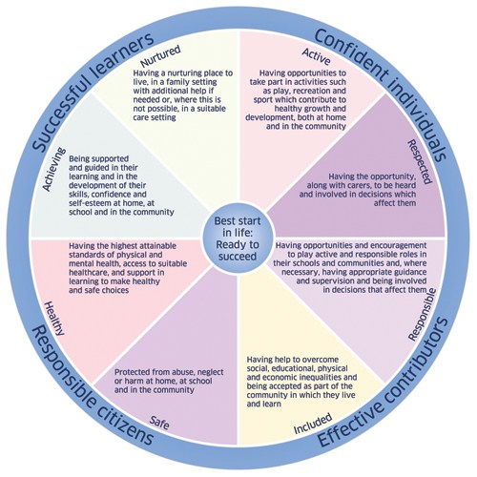
GIRFEC isn’t an extra thing people have to do. It’s a way for those who support children to work differently, making sure that they are all on the same page. Where needed, GIRFEC links day-to-day work in education, health, policing, social work and the voluntary sector – in fact any organisation whose staff come into direct contact with children. It makes it easier for those different organisations to communicate consistently with each other, and with parents, carers, children and young people.
GIRFEC provides a structure that helps people to work in the same way and use the same language. This allows discussions with the child and their family to focus on what is good in a child’s life, and what might need attention or support.
It’s the bedrock for all children’s services and can also be used by practitioners in adult services who work with parents or carers.
The approach helps practitioners focus on what makes a positive difference for children and young people – and how they can act to deliver these improvements. Getting it right for every child is being woven through all existing policy, practice, strategy and legislation affecting children, young people and their families.
What ‘Getting it Right for Every Child’ means:
For children, young people and their families:
- They understand what is happening and why
- They have been listened to carefully and their wishes have been heard and understood
- They will feel confident about the help they are getting
- They are appropriately involved in discussions and decisions that affect them
- They can rely on appropriate help being available as soon as possible
- They will have experienced a more streamlined and co-ordinated response from practitioners
For practitioners:
- Putting the child or young person at the center and developing a shared understanding within and across agencies
- Using common tools, language and processes, considering the child or young person as a whole, and promoting closer working where necessary with other practitioners
If you would like to access support from the Named Person Service, please contact the nursery. (For Early Years establishments this should be “please contact your Health Visitor”)



MC57: Child Protection and Safeguarding

Keeping Children and Young People Safe

Educational establishments and services must create and maintain a positive ethos and climate which actively promotes child welfare and a safe environment by:
• ensuring that children are respected and listened to.
• ensuring that health and wellbeing is central to the curriculum.
• ensuring that staff are aware of Management Circular 57 and child protection procedures and
concerns.
• ensuring that any CP or Safeguarding concerns are progressed as per MC57 guidance.
• establishing and maintaining close working relationships and arrangements with all other
agencies to make sure that professionals collaborate effectively in protecting children.
• ensuring the name of the Child Protection Coordinator and Depute Child Protection

Coordinator(s) is on display within the establishment.

Name of CP Coordinator: Mary Houston – Head of Nursery
Name of Depute CP Coordinator(s): Ashley McGregor – Depute Head of Nursery

All educational establishments and services must take positive steps to help children and young people by ensuring that safeguarding is promoted through all elements of education including leadership, values, vision, the curriculum, learning and teaching, positive relationships, ethos and building resilience in our learners.

Safeguarding supports the development of learner’s knowledge, skills and resilience to keep themselves safe and to protect themselves and develop an understanding of the world so that they can respond to a range of issues and potential risky situations arising throughout their lives.

Safeguarding and wellbeing issues are addressed through our personal, social and health education curriculum and care should be taken to ensure our children have opportunity to develop such knowledge and understanding within our establishments.

As with other areas of the curriculum, you will be kept informed of the health and wellbeing programme for your child’s establishment.

MANAGEMENT CIRCULAR NO. 57 Appendix 6 Insert for Handbook

Medication
It is important that staff are informed about any medical condition which requires treatment. If your child is in need of prescribed medication during his/her time at nursery you should discuss his/her requirements with a member of the management team. You will need to fill in a form that authorises nursery staff to administer the medication to your child. Please inform your child’s key worker when the medicine was last administered. A member of the management team will give you the necessary forms to complete.

If your child suffers from asthma you must tell a member of the management team if there are any activities or specific circumstances that are likely to bring on an attack. If your child suffers from epilepsy you must tell member of the management team what emergency treatment to give.

Medical and Health Care
If medical attention is necessary it will be obtained immediately. Staff will attend to cuts, bruises, minor accidents and upsets. The Head of Nursery will be informed and the incident recorded in nursery accident book. You will be informed about the incident when you collect your child. If a child becomes ill while at nursery we will contact the parent/carer or the emergency adult immediately so that he/she can be taken home.

If the accident/illness is of a serious nature the parent/carer will be informed, the child taken to hospital by car/taxi or ambulance – where he/she will be met by parents. Accident reports, where appropriate, are reported to Glasgow City Council Health & Safety Group, Education Department. The Care Inspectorate are also informed of accidents and incidents.

Staff will advise you on any exclusion period needed if your child suffers from an infectious or contagious disease. If you suspect that your child has symptoms of diarrhoea or/and sickness, please keep your child away from nursery until 48 hours after the last sign of diarrhoea or sickness. If your child generally has loose bowels due to medication, please provide a letter from your GP stating that this is the case. Impetigo (weeping sores on skin) is most contagious and medical advice should be sought. Conjunctivitis can be treated by bathing infected eyes with cooled boiled water and strict hygiene procedures. There is no exclusion period for mild conjunctivitis. We follow NHS Scotland’s exclusion advice and also seek assistance from Glasgow’s Public Health Department. You can access the NHS exclusion information for yourself on http://www.nhsggc.org.uk/your-health/public-health/public-health-protection-unit-phpu/childcare-settings-infection-prevention-and-control/#

Birthdays

We recognise that a child’s birthday is a very special event in their life. We will celebrate a child’s birthday on the day. The staff member will provide a birthday card from the nursery. Parents should inform the child’s key worker that they are bringing in a cake the day before the birthday. We are unable to give the children home baked cakes therefore the cake would have to be shop bought and be in the original packaging. Children from the birthday child’s group will join them for a birthday snack/party during the session.

Visits to the Nursery by Medical Staff
The nursery has visits from eye screening health professionals, oral health hygienists etc. Please ensure that you completed the health care form to allow your child to be seen by these people. This form is only for specialists who will be looking at all the children in the nursery. Any specialist who needs to see your child on a one to one basis must have your permission first.


Head Lice
You are advised to examine your child’s hair once per week. Please notify the Head of Nursery if any infestation occurs. Your doctor can prescribe the current lotion to treat head lice. If you take a louse to your pharmacist, you can also obtain the lotion free of charge. One application of the lotion may not be enough to kill the lice and their nits. A further application of the lotion 7-10 days later may also be needed. Please see the Head of Nursery if you need further information. We have a small supply of head lice combs, please ask if you do not already have one at home. http://www.healthscotland.com/documents/25.aspx

Positive Behaviour Management
Our children are learning how to co-operate and share with other adults and children. There will be times when children have to be helped to understand how to work alongside others. We encourage children to say ‘I am sorry for upsetting/hurting you _______’. This helps children understand that their behaviour has had an effect on another person.

We praise children for the behaviours we would like to see at all times. We give children positive examples of what we expect. Instead of ‘don’t run’, we remind children to keep safe walking.
Any incidents will be dealt with in nursery by relevant staff. Please speak to your member of staff if you have any concerns about your child’s behaviour. If we have cause for concern with regards to your child, we will discuss with you any help and advice which may benefit you child.

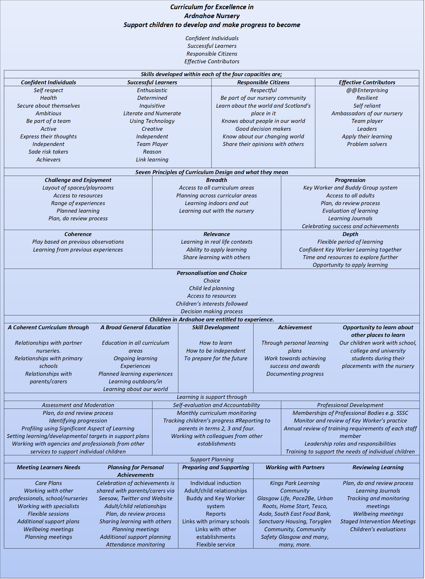

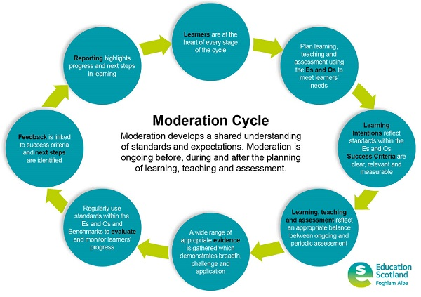
Planning
Our planning follows Curriculum for Excellence guidance. We follow children’s interest in the work that we carry out with the children. Our children learn best through play. We do not carry out group times or any other time where the child’s play is interrupted. Practitioners are skilled in their interactions with children and know where and when to extend children’s learning.

Assessment
Assessment is a continuous process. Staff observe the children in a wide range of situations, looking at what they do and listening to what they say. Staff discussion and systematic record keeping aid the assessment process. Photographs and examples of children’s work throughout the year are taken to support assessment and provide valuable information and evidence of children’s progress.

Children are encouraged to discuss their own performance in whatever tasks they are doing. Encouragement, praise, pride in achievement are valued and acknowledged as important factors in the provision of a positive learning environment.

There are two opportunities to formally discuss your child’s progress each year. We also provide a written report at the end of the year. The report is a picture of how your child learns in our nursery.
You can speak to the Head of Nursery or your child’s Key Worker at any time of the year to ask how your child is doing. If you would like to arrange a meeting to discuss an aspect of your child’s development, please let the Head of Nursery or Team Leader know and this will be organised.

Nursery/Primary – Transition Reports
This will be completed in May and discussed with you for your information prior to being forwarded to your child’s primary nursery. The record will note your child’s development and learning in:
  - Expressive Arts
  - Health and wellbeing
  - Languages
  - Mathematics
  - Religious and Moral Education
  - Sciences
  - Social Studies
  - Technologies

There will also be a verbal mid-term report and also an opportunity to meet with your child’s Key Worker. However, please remember that we are available at any time to speak to you about your child’s development or progress. Please arrange this meeting through the Head of Nursery. Parents of children who have their 4th birthday in December, January or February can choose to have an additional year at nursery. If your child’s 5th birthday fall after the first day of term they too could have a deferred year and remain in nursery. Please speak to the Head of Nursery if you would like your child to have a deferred year.

Where a child has been receiving additional support an Enhanced Transition meeting will be held with the receiving Primary School to share relevant information about support required and what is already in place for your child. An Enhanced Transition Passport will also be discussed at the meeting to ensure all information being shared is current. Parents, agencies involved and a member of the receiving Primary school will attend alongside parents/carers.

Supporting Children with Difficulties
Experiences and materials appropriate to the child’s age and stage of development are provided. If a child is in need of support to help his/her development and learning, discussion with all staff will take place and a strategy to deal with this will be devised. Parents will be involved in this process.
If there are concerns about a child’s speech we are able to do a referral to a Speech and Language Therapist, thereafter if appropriate a programme involving the child, parents, therapist and staff will be drawn up. Speech and Language Therapy offer a telephone support line an can be contacted on
Wednesday 1pm and 4pm 0141 211 6056 Friday 9.30am until 11.30pm 0141 531 6843

Working Together To Support Learning
Where specialist help is required to support a child’s learning/development and parental consent is given, a referral will be made as a means of identifying child’s specific needs. The agencies involved are Educational Psychologist, Speech and Language Therapist and Community Paediatrician.

Parental Partnership
The learning that has taken place within the family and community is recognised, valued and built upon within the nursery setting. We seek to work with parents to form a partnership that supports not only the child’s learning and development but also the work of the nursery and the community.
Regular and effective communication will take place throughout the year.
Parents Committee

We will:

- Inform parents regularly of events taking place in the nursery
- Exchange and share information about their child’s progress
- Tell parents about their child’s achievements
- Discuss any problems that may arise
- Develop a professional relationship with parents that reflects an ethos of tolerance, respect, warmth and courtesy
- Work together to create a rich learning environment where the learning experiences offered to children are of a high quality
- Provide curricular information to enable parents to support and extend
children’s learning

We have a Parent Committee who supports the nursery. The committee meet once each term. The purpose of the Committee is:-

- To improve the work of the nursery through self-evaluation, Quality Assurance visits, Care Commission and HMIE inspections
- To encourage parents and the local community to support the work of the nursery
- To represent the nursery at special events
- To contribute to the policy making of the nursery
- To put forward the view of parents of the nursery on nursery matters
- To fundraise for the nursery

The Freedom of Information (Scotland) Act 2002
The Freedom of Information (Scotland) Act 2002 enables any person to obtain information from Scottish public authorities. The Act applies to all Scottish public authorities including:
The Scottish Government and its agencies; Scottish Parliament; Local Authorities; NHS Scotland; Universities and further education colleges; and the police. Public authorities have to allow access to the following information:

- The provision, cost and standard of its service;
- Factual information or decision-making;
- The reasons for decisions made by it.

The legal right of access includes all types of “recorded” information of any data held by the Scottish Public Authorities. From 1st January 2005, any person who makes a request for information must be provided with it, subject to certain conditions.

Further information is provided on the Glasgow City Council web-site:
www.glasgow.gov.uk/en/yourcouncil/freedomofinformation

Internet facilities are provided at all Glasgow City Council Public Libraries and Real Learning Centres.

Social Media
Glasgow City Council, the General Teaching Council and the Scottish Social Service Council all have policies on staff members’ use of social media sites. Please do not be offended if your requests go unanswered or are declined. We ask you to respect the service users of Ardnahoe Nursery and Glasgow City Council.

Data Protection Act 1998
Information on children and young people, parents and carers is stored on a computer system and may be used for teaching, registration, assessment and other administrative duties. The information is protected by the Data Protection Act 1998 and may only be disclosed in accordance with the Codes of Practice. For further information please contact the establishment.





Glasgow City Council
Education Services
Privacy Statement
As the local authority our nurseries and early years establishments process information about children and young people in order to help administer education and care. In doing so we must comply with the Data Protection Act (1998).
This means (amongst other things) that the data held about children and young people must only be used for specific purposes allowed by law. The following information explains the types of data held, why that data is held, and to whom it may be passed on.

Types and use of data
Data held by nurseries and educational establishments includes contact details, curriculum assessment results, attendance information, characteristics such as ethnic group, additional support needs and any relevant medical information.
Our data includes information about individuals for whom it provides services, and the details of services provided. This data helps us:
- support learning and teaching
- monitor and report on progress
- provide appropriate pastoral care
- assess how well the nursery/establishment and Council are doing as a whole
- monitor progress and develop good practice in the services received
- carry out specific functions (such as social care)
- to evaluate and develop education policy and strategies
In addition, we may use this information for other legitimate purposes and may share this information where necessary with other bodies responsible for administering services to children and young people or where otherwise required by law.

We also hold information about parents/carers, emergency contacts etc. that is provided in the annual data check. This allows us to carry out the Council’s functions as the education authority and may sometimes involve releasing personal information to other agencies and other parts of the Council, particularly in relation to child protection issues or criminal investigations, and it may also be used for research purposes (see the link below for more details regarding this).

Information held by the nursery is, in legal terms, processed by Glasgow City Council. The Council is registered as a data controller under the Data Protection Act 1998 (number Z4871657) and all personal data is treated as confidential and used only in accordance with the Data Protection Act and the Information Use and Privacy Policy approved by the City Council. For more information on how we use personal information, or to see a copy of the Information Use and Privacy Policy, see www.glasgow.gov.uk/privacy.

Data rights and access
As a data subject (or the parent of a data subject), you have certain rights under the Data Protection Act, including a general right to be given access to personal data held by any data controller.
The presumption is that by the age of 12 a child has sufficient maturity to understand their rights and to make an access request themselves if they wish. If you are a parent of a child younger than 12, you would normally be expected to make a request on their behalf.
The Council may use this information for other legitimate purposes and may share this information where necessary with other bodies responsible for administering services to children and young people or where otherwise required by law. The Council also has a duty to protect the public funds it administers, and to this end it may use the information you have provided for the prevention and detection of fraud.

Education Services

Privacy statement for Consent for Photography/Videos

Who we are:
Glasgow City Council is a local authority established under the Local Government etc. (Scotland) Act 1994. Its head office is located at City Chambers, George Square, Glasgow G2 1DU, United Kingdom, and you can contact our Data Protection Officer by post at this address, by email at: dataprotection@glasgow.gov.uk, and by telephone on 0141 287 1055.

Why do we need your personal information and what do we do with it?
You are giving us your personal information to allow us to take and use images for educational purposes. We also use your information to verify your identity where required, contact you by post, email or telephone and to maintain our records.

Legal basis for using your information:
We provide these services to you as part of our statutory function as your local authority. You can find more details of our role on our website at www.glasgow.gov.uk/privacy. Processing your personal information is on the basis of your consent.

We are also processing more sensitive personal information about you on the basis that you have given us your explicit consent for this.
Who do we share your information with?
We are legally obliged to safeguard public funds so we are required to verify and check your details internally for fraud prevention. We may share this information with other public bodies (and also receive information from these other bodies) for fraud checking purposes. We are also legally obliged to share certain data with other public bodies, such as HMRC and will do so where the law requires this. We will also generally comply with requests for specific information from other regulatory and law enforcement bodies where this is necessary and appropriate. Your information is also analysed internally to help us improve our services. This data sharing is in accordance with our Information Use and Privacy Policy and covered in our full privacy statement on our website. It also forms part of our requirements in line with our Records Management Plan approved in terms of the Public Records (Scotland) Act 2011.
We may share information with other external agencies and organisations who provide or assist with educational provision.

How long do we keep your information for?
We only keep your personal information for the minimum period amount of time necessary. Sometimes this time period is set out in the law, but in most cases it is based on the business need. We maintain a records retention and disposal schedule which sets out how long we hold different types of information for. You can view this on our website at www.glasgow.gov.uk/rrds or you can request a hard copy from the contact address stated above.

Your rights under data protection law:
- access to your information – you have the right to request a copy of the personal information that we hold about you.
- correcting your information – we want to make sure that your personal information is accurate, complete and up to date. Therefore you may ask us to correct any personal information about you that you believe does not meet these standards.
- Deletion of your information – you have the right to ask us to delete personal information about you were:
- you think that we no longer need to hold the information for the purposes for which it was originally obtained
- we are using that information with your consent and you have withdrawn your consent – see Withdrawing consent to using your information below [delete if not on basis of consent]
- you have a genuine objection to our use of your personal information – see Objecting to how we may use your information below
- our use of your personal information is contrary to law or our other legal obligations.

Objecting to how we may use your information – You have the right at any time to tell us to stop using your personal information for direct marketing purposes.

Restricting how we may use your information – in some cases, you may ask us to restrict how we use your personal information. This right might apply, for example, where we are checking the accuracy of personal information that we hold about you or we are assessing the objection you have made to our use of your information. This right might also apply if we no longer have a basis for using your personal information but you don't want us to delete the data. Where this right is realistically applied will mean that we may only use the relevant personal information with your consent, for legal claims or where there are other public interest grounds to do so.

Withdrawing consent to use your information – Where we use your personal information with your consent you may withdraw that consent at any time and we will stop using your personal information for the purpose(s) for which consent was given.

Please contact us as stated above if you wish to exercise any of these rights.

Complaints:
We aim to directly resolve all complaints about how we handle personal information. If your complaint is about how we have handled your personal information, you can contact the Council’s Data Protection Officer by email at dataprotection@glasgow.gov.uk or by telephone on 0141 287 1055.

However, you also have the right to lodge a complaint about data protection matters with the Information Commissioner's Office, who can be contacted by post at: Information Commissioner's Office, Wycliffe House, Water Lane, Wilmslow, Cheshire, SK9 5AF. By phone on 0303 123 1113 (local rate) or 01625 545 745. Visit their website for more information at- https://ico.org.uk/concerns

If your complaint is not about a data protection matter you can find details on how to make a complaint on our website at www.glasgow.gov.uk/complaints

More information:
For more details on how we process your personal information visit www.glasgow.gov.uk/privacy
If you do not have access to the internet you can contact us via telephone to request hard copies of our documents.

Dealing with Racial Harassment
The Race Relations Act of 1976 makes it unlawful to discriminate against someone because of his/her colour, race, nationality, ethnic or national background. The Act makes it the duty of Glasgow City Council to eliminate unlawful racial discrimination. In 1999 the guidelines, ‘Dealing with Racial Harassment’ were issued to assist all teaching staff in dealing with such incidents. The adoption of an anti-racist approach should be seen as one part of the continuing attempt to improve the quality of education. Glasgow City Council recognises that support from the home is essential if these aims are to be achieved. Every child in Glasgow has the right to be happy and secure when attending any establishment.

Bullying
Bullying behaviour will not be tolerated within Glasgow City Council’s educational establishments. All children in Glasgow’s educational establishments have an entitlement “to work (and play) in a learning environment in which they feel valued, respected and safe and are free from all forms of abuse, bullying or discrimination”. (A Standard for Pastoral Care in Glasgow Establishments).

Policies
A copy of all the Nursery polices is kept at reception. Please feel free to browse.
These include the following:

Code of Conduct Grievance Procedures
Employee Harassment Code of Discipline
Absence Monitoring
Fire Precautions and Contingency Plan
Management & Administration of Medicines First Aid
Child Protection Social Studies
Admissions Eco Nursery Policy
Literacy and English Policy Numeracy and Mathematics Policy
Expressive Arts Planning
Observation Assessment
Policy Making Play
ICT Outdoor Play
Outings and Risk Assessment Hygiene and Infection Control
Personal Development and Review Resources
Positive Behaviour Management Race Equality
Referral of Children to Specialist Agencies Lunch Time Procedures
Health Promoting Nursery Drugs
Children’s Absence
Use of Volunteers and Student Training
Whistle Blowing Confidentiality
Complaints Smoking
Health and Safety Risk Assessments Code of Practice SSSC
Access to Personal Records Self Evaluation
Threatening Situation Policy Enterprise
Settling In Policy Changing a wet/soiled Child
Reporting to Parents Key Worker Policy
Asbestos Management Sciences
Religious and Moral
Procedures on Early Arrival and Late Collection of Children
Supporting Children with English as an additional language

The Wider Community
Toryglen Community Hall and Geoff Shaw Community Centre offer a range of adult groups. Information is available from the centres and the nursery.

Geoff Shaw 0141 647 0969
Toryglen Community Hall 0141 569 1031
Toryglen Community Base 0141 613 2777

The nursery has forged strong links with community groups. These links provide opportunities to share and exchange information and improve the facilities for children and families living in the local area.

We are involved in an exchange programme with Hampden Nursery. A small group of children take part in these visits and benefit from working alongside staff and children in a new learning environment in which they can build friendships, share experiences and resources.

Transition to Primary Nursery
Information on registration procedures is widely publicised in November via press, nursery’s and libraries. Parents should register their child for nursery on-line by accessing:-
https://www.glasgow.gov.uk/index.aspx?articleid=18007

We have forged strong links with the local primaries that enable children to settle happily when they transfer in August.

The nursery/primary transition programme involves staff exchange, visits for children and parents and sharing of curriculum information. All these positive aspects help ease the transition process.
The primaries associated with the nursery are Toryglen, St.Brigid’s and King’s Park.




Other Information
Suggestions/Complaints
You can make a suggestion by filling in a comments slip outside the office or emailing the Head of Nursery.

What happens when I have complained?
We will always tell you who is dealing with your complaint.
Glasgow City Council’s complaints procedure has two stages:

Stage one
Frontline Resolution
We aim to resolve complaints quickly and close to where we provided the service. This could mean an on-the-spot apology and explanation if something has clearly gone wrong and immediate action to resolve the problem. We will give you our decision at stage one, in five working days or less, unless there are exceptional circumstances.

If we can’t resolve your complaint at this stage, we will explain why and tell you what you can do next. We might suggest that you take your complaint to stage two. You may choose to do this immediately or sometime after you get our initial decision.

Stage two
Investigation
Stage two deals with two types of complaint: those that have not been resolved at Stage one and those that are complex and require a detailed investigation. When using stage two we will:

- Acknowledge receipt of your complaint within three working days
- Discuss your complaint with you to understand why you remain dissatisfied and what outcome you are looking for
- Give you a full response to the complaint as soon as possible and within 20 working days.

If our investigation will take longer than 20 working days, we will tell you. We will agree revised time limits with you and keep you updated on progress.

What if I’m still dissatisfied?
After we have fully investigated, if you are still dissatisfied with our decision or the way we dealt with your complaint, you can ask the Scottish Public Services Ombudsman (SPSO) to look at it.

In the event that you are still dissatisfied please contact:
Care Inspectorate
Europa Building, Ground Floor
450 Argyle Street
Glasgow
G2 8LG
03456009527
You may, at any time, contact the Care Inspectorate of any concern you have without going through the above process.
Useful Addresses
Douglas Hutchison  Education Service Director  City Chambers  40 John Street  Glasgow  G1 1JL  Tel: 287-4551 | Jacqueline Nimmo  Education Services  City Chambers  40 John Street  Glasgow  G1 1JL  Tel: 287-5453
Donnie McLeod  Area Manager  City Chambers  40 John Street  Glasgow  G1 1JL  Tel: 287-9682 | Early Childhood & Extended Services  Centenary House  Heather Douglas  100 Morrison Street  GLASGOW G5 8LN  Tel: 287-5223
Quality Improvement Officer  Claire Harvey  Education Services  City Chambers  40 John Street  Glasgow  G1 1JL  Tel: 287 4967 | Psychological Services  Govan High Nursery  12 Ardnhish Road  Govan  Glasgow  G51 4NB  Tel: 0141 276 3270  Fax: 0141 276 3269
Early Years’ Service Area Manager  Linda McIlroy  Education Services  City Chambers  40 John Street  Glasgow  G1 1JL  Tel: 287-4719 | Social Care and Social Work Improvement Scotland  Europa Building, Ground Floor  450 Argyle Street  Glasgow  G2 8LG  Tel: 0141-242-0391
Early Years’ Service Manager  Kathryn Farrow  Education Services  City Chambers  40 John Street  Glasgow  G1 1JL  Tel: 0141-287-5815 | Annmarie McGinn  Inspector  Care Inspectorate  Compass House  11 Riverside Drive  Dundee  DD1 4NY  General Enquiries:  Tel:0345-6009527

Privacy statement for Glasgow City Council and our Arms Length External Organisations

