GCC logo

Deanpark Nursery School

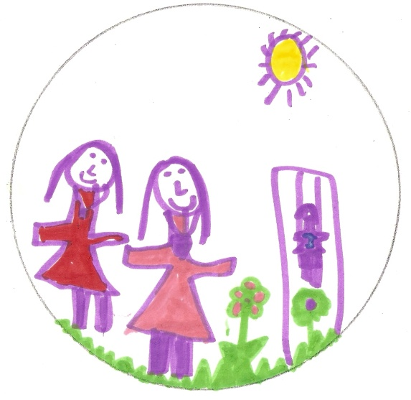

**Handbook 2024/2025**

**10 Deanston Drive**

**Shawlands**

**Glasgow**

**G41 3AE**

**Telephone number: 0141 649 8949**

**e-mail:** [**headteacher@deanpark-nursery.glasgow.sch.uk**](mailto:headteacher@deanpark-nursery.glasgow.sch.uk)

**Contents**

|  |  |
| --- | --- |
| **Index** | **Page** |
| Introduction  Our Ethos  OurVision, Values and Aims  Staff Team  Age Range and Capacity of children at Each Daily Session Opening Times  Admissions Policy  How to apply  Enrolment procedures  Settling in/ keyworker  Attendance  Collection of children from nursery  Medical and Health Care  Accidents  Birthdays  Meals/Snacks and the Promotion of Healthy Eating  Non Denominational Policy of the Nursery  Policies and Procedures  Equality Race Policy  Accessibility strategy  Children’s Safety  Child Welfare and Safety  Bullying  Promoting Positive Behaviour  GIRFEC  Additional Support Needs  Our Curriculum  Building the Ambition  Assessment  Self-evaluation  School Improvement Plan  Parental Partnership  Five to Thrive  Outdoor learning  Keeping You Informed  Emergency Closure Arrangements  Transfer to Primary School  Fund Raising/ toy fund  Charging Policy  Suggestions and Complaints Procedure  Nursery School Inspections  Important Addresses  Data Protection Act  Holidays | Page 3  Page 3  Page 4  Page 5  Page 5  Page 5  Page 6  Page 6  Page 7  Page 7  Page 8  Page 8  Page 9  Page 10  Page 10  Page 10  Page 11  Page 11  Page 11  Page 11  Page 12  Page 12  Page 13  Page 13  Page 14  Page 14  Page 15  Page 16  Page 19  Page 20  Page 21  Page 22  Page 23  Page 23  Page 24  Page 24  Page 24  Page 25  Page 25  Page 26  Page 26  Page 28  Page 27  Page 29/30 |

**Welcome**

Dear Parents/ Carers,

 The staff at Deanpark Nursery School would like to extend a warm welcome to you and your child. The nursery is a Glasgow City Council Early Years establishment which is non-denominational.

Each child is an individual and we aim, through working in partnership with families, to ensure we offer the best learning opportunities for your child.

The aim of this handbook is to give parents/carers information, which we hope you will find both useful and informative.

If you have any suggestions or require any additional information which you feel would benefit the service, please do not hesitate to speak to myself, or a member of our team.

Yours sincerely

Sam Nisbet

Head of Nursery

**In addition, please follow us on X @DeanparkNur**

**There, you will find updates and links to interesting information.**



**Our Ethos**

When you come to our nursery we want everyone to feel welcomed, relaxed, valued and included.

We feel that it is important that our children are valued by other children and adults.

We recognise that people who are respected themselves will show respect for others both now and later in life.

**Our Vision, Values and Aims**

**Vision**

We value and respect everyone and promote health, achievement and learning for life. Together we will create opportunities for all children to become successful learners, confident individuals, responsible citizens and effective contributors.

**Aims**

* To provide a welcoming environment where everyone feels cared for, valued and respected.
* Create a stimulating healthy environment where children are happy and eager to learn, feel valued, supported, confident and secure.
* To promote the health and wellbeing of children, staff, families and the community.
* To encourage and support our children to live happy, healthy, safe and rewarding lives in an ever-changing society.
* Maintain an environment which provides equal opportunities and celebrates achievement for all.
* Build and maintain effective partnerships between parents, staff and pupils to promote positive behaviour and raise achievement.
* To implement a Curriculum for Excellence and provide opportunities for pupils to become successful learners, confident individuals, responsible citizens and effective contributors.
* To self-evaluate to develop our practice

**Values**

* A supportive and stimulating environment which promotes achievement, effort and success
* The importance of health and wellbeing for all
* Every child is an individual and we treat them with fairness and respect

**Child Development Officers**

Elaine Kilday Full Time

Caroline Devlin Full Time

Karlie Smith Full Time

Caitlin Davidson Full Time

Lisa Rae Full Time

Lynsey Doyle Full Time

Michelle Potter Full Time

Gill Waddell Full Time

Tracy Morton Job share (Mon-Wed)

Maureen Green Job Share (Thu/Fri)

Anna Mulligan Part Time (Mon/Tue)

Sadaf Sufyaan Part Time (Alt Wed, Thu, Fri)

**Support for Learning Worker**

Natalie Butterly

Hameda Bushra

**Modern Apprentice**

Jenna Gillies Full Time

**Management Team**

Sam Nisbet Head of Nursery

Maria McLaughlin Team Leader

Christine Bird Acting Team Leader

**Support Staff**

Victoria MacDonald Clerical Administrative Support

Lesley Baber Janitor

Alice Law Catering Assistant

Guddi Kaur Catering Assistant

Kanta Chauhan Catering Assistant

Terry Healy Cleaner

**Our Staff Team**

**Admission**

**Allocation of hours**

Blocks of hours will be allocated at admissions

These hours include:

5 AM sessions

5 PM sessions

2 Full days and 1 half day

Further blocks can be purchased if required

**Age range**

3 – 5 years

**Capacity**

70 Children

**Opening times**

The nursery opens at 8.00am and closes at 6.00pm 52 weeks

**How to apply**

You should only complete one application form (application forms are available from all Glasgow City Council nurseries) and submit it to the nursery that is your first choice.

On receipt of the application form the nursery that is your first choice will ensure that the application is assessed and prioritised according to the banding and weighting categories within the Council’s Nursery Admissions Policy.

Applications will automatically be transferred to your second/third choice of nursery should a placement not be available at your first choice of nursery.

Parents can ask to see their application form at any time. Any change in circumstances which affect the application should be notified to the Head of Nursery or Team Leader.

**Admission policy**

All nursery places are allocated in line with Glasgow City Council’s Nursery Admissions Policy. The Head of Nursery or Team Leaders will be happy to provide you with any information you require at the time of application. Any relevant information is available on

[**https://www.glasgow.gov.uk/index.aspx?articleid=18136**](https://www.glasgow.gov.uk/index.aspx?articleid=18136)

All applications are discussed at a Local Area Admissions Panel made up of local nurseries. Once your child has reached the age of two years, you are entitled to place their name on the nursery waiting list.

**Enrolment Procedures**

The parent/carer and child will receive an **“Offer of Place”** letter that will state the child’s enrolment, start date and details of placement. The parent/carer meets with the child’s keyworker and together completes the enrolment paperwork,and receives a nursery “**Welcome Pack”.** Parents/carers with any questions are welcome to speak to any member of the Management Team to be offered assistance and reassurance.

**Enrolment**

**Starting nursery**

What will my child need?

Please bring a change of clothes, soft shoes and a jacket for your child.

Please do not put on any good clothing as nursery life can be very messy!

Please ensure your child has nappies and wipes if they are not toilet trained.

**Settling in**

The first few weeks at nursery can be scary and exciting; some children find this a difficult period; therefore, we have a staggered intake to best support your child, this is a settling in period. Your child’s key worker will work in partnership with you to ensure the transition from home to nursery runs as smoothly as possible. Your child needs to feel secure in this new situation. Each child is different and for this reason there is no set time limit for settling in. Some children take longer than others.

A **key worker system** is in place and your child will be linked to a staff member who will be first contact and involved in reporting your child’s progress.

When a member of staff is absent, a replacement is not automatically appointed -therefore members of the group may be allocated to another group for the duration of a staff absence.

All adults are in contact with and work with **ALL** children. This is why it is important that children are encouraged to develop a relationship with all staff.

**Collection of children**

To ensure the safety of each child, only responsible adults should collect him/her from Nursery. Children will not be released to any person under the age of 16.

If you are unable to come personally, please speak with the Head of Nursery, Team Leader or your child’s keyworker. We **MUST** know who will be collecting your child – children **WILL NOT** be given to an adult not known to nursery staff. We ask for your co-operation in this matter and know you will understand that keeping your child safe is our **FIRST PRIORITY**.

**Attendance**

Regular attendance is important for your child’s security and education.

If an absence is necessary, please let the Head of Nursery know how long it is likely to be. We **MUST KNOW** if for some reason your child can no longer attend the Nursery.

It is not advisable to bring your child to Nursery if he/she is feeling unwell or has been sick through the night or is likely to spread infection to others. Children with sickness or diarrhoea must be clear of any symptoms for 48hrs before returning

Any general instructions, information, problems or difficulties relating to your child should be given to your child’s keyworker. This procedure avoids misunderstandings and delay in any action necessary to help your child.

The Head of Nursery/Team Leader is available to discuss any problems of a more confidential nature.

Diversity

Equality

Achieving

Nurturing

Partnerships

Active

Rights Respecting

Kind

**Pre-School Vision Screening**

Children in their pre-school year at nursery will have the opportunity to have their vision checked. Consent forms will be available in nursery for parent/carers to complete and the date of vision screening will be communicated within the establishment.

.

**Emergency Contact Information**

Parents/cares who have children in the nursery are asked where possible to provide the establishment with the names, addresses and telephone numbers of two contact persons for use in the event of an emergency.

Please ensure this information is kept up to date.

.

**Medical and Health Care**

It is very important that full details of your child’s medical history are provided when completing admission forms. This ensures that staff are as well prepared as possible.

If your child becomes ill or has an accident while attending the nursery, every attempt will be made to inform you. If a child has a minor accident, they will be dealt with by a member of staff who may seek advice from the qualified first aider. The accident is then recorded in the Accident Book, detailing time and as much information as possible. When the child is collected the parent will be informed of the accident and asked to sign the accident book.

If the illness or accident is of a serious nature, your child will be taken to the nearest hospital and you will be contacted and advised to join the child at hospital.

Children who are obviously unwell should be kept at home where they will be more comfortable. Due to the risk of infection, if your child has sickness and/or diarrhoea then he/she must remain off nursery for 48 hours after symptoms have resolved. If your child has an infection such as measles or chicken pox, please inform the nursery and consult your GP

Should a child require medication this should, whenever possible, be administered by the parent, but in exceptional circumstances arrangements maybe made for medication to be administered by staff **after the first dose has been given by parent/carer**. All medications must be prescribed by the child’s doctor and must have the child’s name, date of birth and dose attached to the medication. Parents will be asked to complete a Parental Request Form-Administration of Medicines.

.



**Accidents**

If a child has a minor accident, they will be dealt with by a member of staff who may seek advice from the qualified first aiders, Maria McLaughlin or Sam Nisbet. The accident is then recorded in the Accident Book by a member of staff, detailing time and as much detail as possible.

Most staff are paediatric first aid trained and can administer basic first aid. However, advice will always be sought from the qualified first aiders with an incident relating to a head injury/bump or more serious injuries.

When the child is collected the parent will be informed of the accident and asked to sign the accident book. There is more information available in our First Aid policy which is available in the nursery policy folder.

If a child has a head bump, we will always contact the parent to let them know and you will be issued with a head bump form when you come to collect your child

**Meals/ Snacks and the promotion of healthy eating**

All meals and snacks provided in the nursery school are healthy and nutritious. Children who have special dietary requirements or allergies are catered for. If your child has an allergy or dietary requirement please inform your keyworker. It is important that you do not allow your child to bring sweets or food from home to leave in their jacket or bags.

**Nut Free Nursery**

Due to a number of service users having an allergy to nuts, Deanpark Nursery School is a nut free establishment. Please ensure your child does not bring any foods to nursery that contains nuts.

**Birthdays**

Your child’s birthday will be celebrated in nursery. If you wish you can bring in a small shop bought cake (no home baking due to children with allergies) to share with your child’s friends. Please speak to your child’s keyworker for further information.

**Policies**

**At Deanpark we continually update all our nursery policies and procedures to ensure that we maintain a high standard of care and education at all times. Children and families will be involved in compiling our policies and have the opportunity to share their views and thoughts.**

**Equal Opportunities policy of the nursery**

Our nursery reflects Glasgow City Council’s equal opportunities policy and is open to all. We at Deanpark recognise the right of both men and women working with children. Our provision takes account of the needs of all children; these principles are reflected in the criteria used to admit children into Glasgow City Council Nurseries and forms part of our curriculum.

**.**

**Race equality policy**

The Race Relations Act of 1976 makes it unlawful to discriminate against someone because of his/her colour, race, and nationality, ethnic or national background. The Act makes it the duty of Glasgow City Council to eliminate unlawful racial discrimination. In 1999 guidelines, ‘Dealing with Racial Harassment’ were issued to assist all teaching staff in dealing with such incidents. The adoption of an anti-racist approach should be seen as one part of the continuing attempt to improve the quality of education. Glasgow City Council recognises that support from the home is essential if these aims are to be achieved. Every child in Glasgow has the right to be happy and secure at their establishment.

**Data Protection – use of information about children and parents/carers**

We collect information about children attending school (and also about parents/carers, emergency contacts etc. provided in the annual data check) to allow us to carry out the Council’s functions as the education authority for the City of Glasgow. This may sometimes involve releasing personal information to other agencies and other parts of the Council, particularly in relation to child protection issues or criminal investigations, and it may also be used for research purposes (see the link below for more details regarding this).

Information held by the school is, in legal terms, processed by Glasgow City Council. The Council is registered as a data controller under the Data Protection Act 2018 and all personal data is treated as confidential and used only in accordance with the Data Protection Act, the General Data Protection Regulations, and the Information Use and Privacy Policy approved by the City Council. For more information on how we use personal information, or to see a copy of the Information Use and Privacy Policy, see <https://www.glasgow.gov.uk/index.aspx?articleid=18010> .

**Child Protection**

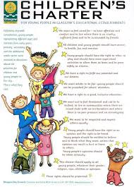

**Children’s safety**

Your child’s safety is of paramount importance to us. You **MUST** keep us up to date with any changes to your details e.g. changes to telephone numbers so that we can contact you.

We also ask that you discourage your child from opening the gate. Please also ensure that you check that the door and front gate is closed behind you. These small measures help us to keep all children safe and secure in the nursery school.

**Glasgow city council child protection policy**

‘The child protection programme seeks to support the child’s development in ways which will foster security, confidence and independence. It should be regarded as central to the well-being of the individual and is therefore seen to be an intrinsic part of all aspects of the curriculum. We must create and maintain a positive ethos and climate which actively promotes child welfare and a safe environment by:

* **ensuring that children are respected and listened to;**
* **ensuring that programmes of health and personal safety are central to the curriculum;**
* **ensuring that staff are aware of child protection issues and procedures;**
* **Establishing and maintaining close working relationships and arrangements with all other agencies to make sure that professionals collaborate effectively in protecting children.**

**Child Protection Co-ordinators**

All adults have a responsibility to protect children from harm. This includes not only parents and professionals but also family members, friends, neighbours and members of the public. If you witness or hear something whilst visiting the nursery and are worried about a child's safety or wellbeing, you should discuss your concerns with one of our Child Protection Co-ordinators. The co-ordinators at Deanpark Nursery School are Sam Nisbet, Maria McLaughlin and Christine Bird.

**Bullying**

Bullying behaviour will not be tolerated within Glasgow City Council’s educational establishments. All children in Glasgow’s educational establishments have an entitlement ‘to work (and play) in alearning environment in which they feel valued, respected and safe and are free from all forms of abuse, bullying or discrimination’. (A Standard for Pastoral Care in Glasgow City Council Establishments).

In 2009, Glasgow City Council published its revised Anti-Bullying Policy, incorporating, the requirement to record and report all discriminatory behaviours within educational establishments. All establishments are required to review their policy in light of this. Parents and carers have a significant role to play in helping to address this problem. For this reason any anti-bullying strategy must stress the importance of partnership with the parents and carers of their children.

**Promoting positive behaviour**

All children have the right to be in a calm, secure, supportive and purposeful environment which allows them the opportunity to develop respect for self, along with respect for other people’s needs, opinions and property. To this end our strategies for promoting positive behaviour will be based on a philosophy of negotiation and reconciliation endeavouring to

**‘make things better together’**

Staff will model good practice and positive behaviour which we want our children to learn. We show examples of this everyday by being considerate towards others, listening to others, respecting others and our nursery environment. We use the PAThS Programme (Promoting Alternative Thinking Strategies) in order to help children understand their emotional development. If we are experiencing difficulty with your child’s behaviour we will, of course, discuss this with you so we can agree a consistent method of working to develop more positive behaviour.

This year we will be introducing the Think Equal Programme to the children. Designed by global experts of education, neuroscience, psychology and human rights, Think Equal is a programme that exists as the tangible bridge between broad objectives and practical lessons within a nursery.

**GIRFEC**

Wellbeing sits at the heart of the GIRFEC (**G**etting **i**t **R**ight **for** **E**very **C**hild) approach and reflects the need to tailor the support and help that children, young people and their parents are offered to support their wellbeing. A child or young person’s wellbeing is influenced by everything around them and the different experiences and needs they have at different times in their lives.

Families and people working with children and young people can use the wellbeing indicators to identify what help a child or young person needs in order to help them access the right support or advice.

All services working with children and young

people, and those who care for them, must

play their part to promote, support and

safeguard children and young people’s

wellbeing.

.

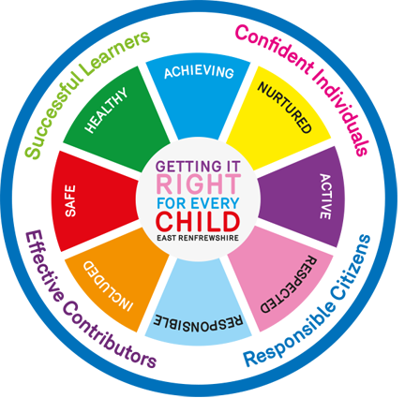

**Additional support needs**

When a child is having difficulties with any aspect of their learning or development you can be assured we will support you and your child the very best we can. The Head of Nursery will discuss this firstly with the parent(s)/carer(s) and if help is necessary, will ask their consent to seek further help through the Educational Psychologist, Speech and Language or Southbank Child Centre. Parent(s) / carer(s) can refer a child to any of these agencies directly if preferred.

It should be noted that there are five steps at the main entrance to the nursery. However, two ramps are available for wheelchair access at the rear of the building.

.

**A Curriculum for Excellence is bringing learning to life and life to learning**

We plan using the Scottish Executive’s Curriculum for Excellence 3-18.

Our children are actively involved in planning and assessing their learning. We aim to provide an inclusive, responsive, creative, exciting, challenging, enjoyable and reflective environment which respects diversity and promotes achievement.

We encourage independent and child-initiated learning – staff support this by offering learning experiences which support children’s needs, interests and learning styles.

.

**Curriculum for Excellence**

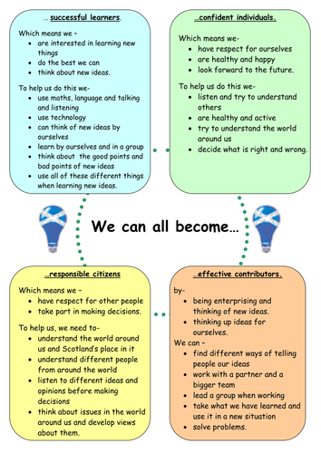

We promote children’s learning in a variety of ways - observing, planning and discussing next steps to extend, support or challenge children in their learning.

All staff in Deanpark Nursery School

* Listen and interact with children through play
* Show interest and pleasure in children’s achievement
* Use key questions to extend children’s learning

Staff will be glad to discuss with you what your child will be learning. We use SeeSaw to showcase children’s learning, as well as wall displays throughout the nursery. If given sent by parent/carers, we also share learning on X (formerly Twitter)

.

**Our curriculum ensures –**

* Active, experiential learning
* A holistic approach to learning
* Smooth transitions
* Learning through play

It is widely recognised that children learn best through play. In our nursery we support each child’s development through a play-based curriculum. We use the children’s interests to plan and support their learning. Play provides many opportunities for children to acquire knowledge and understanding and a capacity to learn. Children develop language, use their imagination and can be creative. During play, children learn to control their bodies, developing their movement and co-ordination skills which contribute to healthy growth and development. Children have opportunities to learn outdoors every day.

.

**Realising the Ambition**

Realising the Ambition is a document which provides national practice guidance to support staff in providing high quality early learning and childcare. It describes what is good practice in creating caring and nurturing settings that allow wellbeing, communication, curiosity, inquiry and creativity to flourish.



.

**There are 8 curriculum areas**

· Expressive arts

· Language and Literacy

· Health and Well- Being

· Mathematics and numeracy

· Religious and moral education

· Science

· Social studies

· Technologies

At the nursery we provide a broad and balanced curriculum. Literacy, numeracy and health and wellbeing are embedded in the curriculum. A wide range of activities and opportunities are offered to our children, both within the nursery, in our outdoor play area and on outings. The curriculum plans are based on the children’s interests, seasonal and cultural events and are designed to meet the needs of the individual. The curriculum offers challenge and flexibility.

**Assessment and reporting**

Assessment of children’s progress is essential to planning for future learning. Daily on-going assessment is undertaken by all staff using a range of everyday evidence to gather information about children’s learning.

These could include:

* Observing children at play
* Recording their comments and stories
* Collecting samples of children’s drawings, writing and art work
* Taking photographs
* Assessing specific skills e.g.in literacy and numeracy
* Collaborating with other professionals e.g. Speech and Language Therapists.

Staff will meet with you throughout the year to advise you of your child’s progress.

Children are provided with opportunities to review their learning and are encouraged to think about next steps.

A Glasgow City Council ‘*Nursery to Primary Transition Record’* is completed for each pre-school child. This record will be given to you in May/June when you will be invited to complete the parent(s)/carer(s) comment.

To ensure we are delivering high quality learning experiences we also use a document called **How Good is our Early learning and Childcare** (Scottish Government, 2016**)** which helps us to self-evaluate and monitor the impact on children’s learning. There are copies of these documents in the nursery and can also be accessed online at Education Scotland. (<http://www.educationscotland.gov.uk/>).

We also use A quality framework for daycare of children, childminding and school-aged childcare to self-evaluate and monitor the impact on children’s learning, this can be accessed online at Care Inspectorate <https://www.careinspectorate.com>

.

**Self-Evaluation**

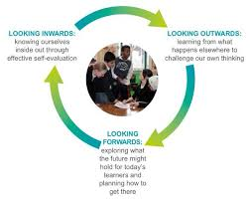

**Self-Evaluation**

The term ‘self-evaluation’ is used to cover the way in which individuals and settings explore their progress, development and practice to identify what has improved and what still needs to improve. It is a way of using evidence to assess achievements and success and areas that still need action.

Three questions, which remain at the heart of self-evaluation:

**•How are we doing?**

**•How do we know?**

**•What are we going to do now?**

Settings well on their way to excellence focus these questions on the core business of the setting to promote learning and development for children.

Key sources of evidence will come from, for example, what you actually observe, from data of various kinds and collating the views of people who actually are involved with the setting, such, parents and carers, partner agencies, practitioners and the children themselves. It is important not to underestimate the contribution of children, as they provide a thoughtful and valuable perspective of their experiences.

Through this approach, settings look inwards to analyse their own work, reflect on what they are providing, then make adjustments to make the provision better for children’s learning. At the same time, look outwards to find out more about what is working well for others locally and nationally, and look forwards to gauge what continuous improvement might look like.

.

**Play on Pedals**

This project aims to give every preschool child in Glasgow the opportunity to learn to ride a bike before starting school. First, they will learn about being safe on a bike then how to balance then pedal.

**School Improvement**

Information on our improvements in literacy, numeracy and health and wellbeing can be found in our current Standards and Quality report. You may view a copy within our establishment.

We celebrate many achievements throughout the past sessions and continuously seek new ways to improve the work we do with the children and families who attend Deanpark Nursery.

Our priorities for improvement within our Establishment and across the Learning Community for this session include.

* Children’s Rights
* Family Engagement
* Outdoor Learning
* Nurture and The Promise

.

**LCFE**

Glasgow City Council and NHS Greater Glasgow and Clyde have launched a joint initiative to develop the capacity of all educational establishments to support and develop the language and communication skills of all children. Deanpark Nursery School have been awarded the ***‘Language and Communication Friendly Status***’as we can provide evidence of good practice in supporting and developing speech, language and communication. This has been achieved through a self-evaluation and supportive assessment process

**Parental involvement**

The learning that has taken place within the family and community is recognised, valued and built upon within the nursery. We seek to work with parents/carers to form a partnership that supports not only the child’s learning and development but also the work of the nursery school and the community. Regular and effective communication will take place throughout the year.

We will:

* inform parents/carers regularly of events taking place in nursery
* exchange and share information about their child’s progress and achievements
* discuss any problems that may arise
* develop a professional relationship with parents/carers that reflects the ethos of tolerance and respect
* work together to create a rich learning environment where the learning experiences offered to children are of a high quality
* provide curricular information to enable parents/carers to support and extend their children’s learning

Visitors, especially parents and relatives of the pupils, are welcome to come into the school and see for themselves the opportunities Deanpark Nursery School offers children and their families. Education is a joint venture between children, staff and parents.

We actively encourage parents to participate in the learning environment e.g. with construction, model making, baking, storytelling, drama, music and also to facilitate outings.

Please share your talents with us!

We value parents as the first educators of your child and we encourage you to play a full and active role. We are always open to suggestions from parents of ways in which our services to them might be improved.

.

**Five to Thrive**

We all know that children need good food and healthy exercise for their bodies to grow strong. But recent research shows that brains need more than this to grow strong. Human beings need loving relationships for healthy brain development.

The parent/ carer needs to be there to Respond to the upset child. As they do this, the two brains, child and adult, connect together. Then being close together – Cuddle – links them together so that the child’s stress at being hurt passes to the parent. Adults can calm themselves, babies can’t. When the parent can Relax while connected with the child, the child also calms down. Then the adult shows through non-verbal communication – Play – how the adult is feeling, and this helps the child to feel better. And finally, the adult uses words – Talk – to help the child to make sense of feeling better.

.



**Outdoor Learning- Let them play. Let them be curious.**

Our outdoors is a maze of fun especially now areas have been developed through children consultation. The future wee architects will be designing the next constructions in the mud pit, mathematicians counting in the willow garden, the chefs making a range of delicacies in the mud kitchen, the farmers growing their own vegetables in our veggie patch and the explorers enjoying campfire marshmallows. Of course, when the elements are not favorable or children would like a cozy rest then the tarpaulin awaits which will provide shelter for the children. Den making materials are also available for children who choose to make their own shelter.

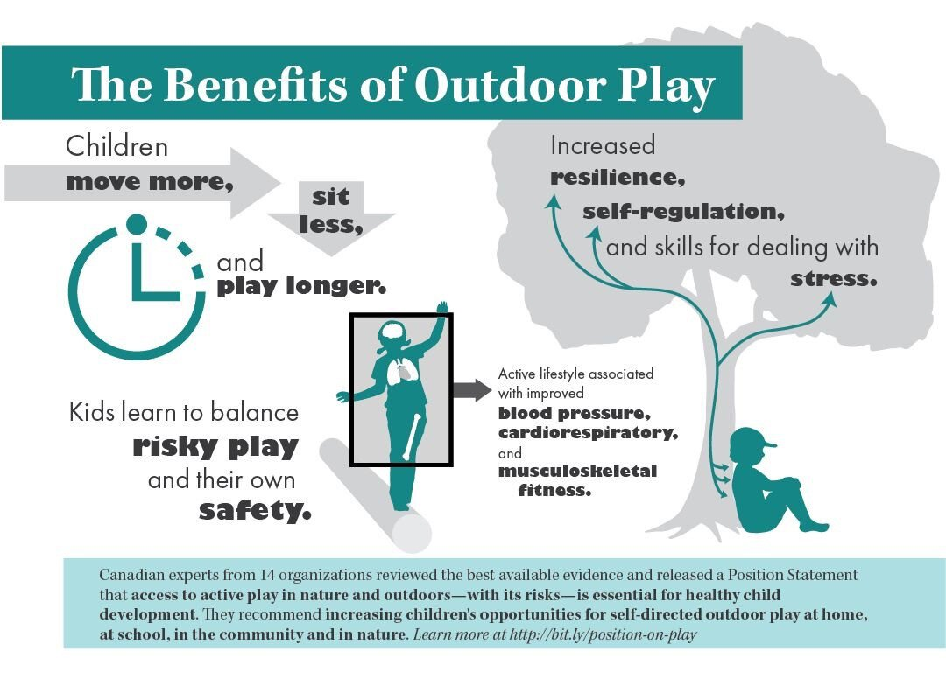

.

**Keeping you informed**

**Transition to Primary School**

Pupils normally transfer to Primary School between the ages of 4½ and 5½.

The move to “big school” is an important time for children and their parents.

We understand that moving onto Primary School can be a scary and worrying time for some children and parents!

At Deanpark Nursery School we have been looking at ways to improve the quality of the transition experience of children. We work closely with our primary partners, sharing information and also through an established induction programme.

Staff from local Primary Schools visit the Nursery School throughout the year. We share and participate in many joint ventures with staff and pupils from local Primary. We are part of Shawlands Learning Community and have a Transition Calendar – a calendar of pre-planned events which we hope to achieve and we hope will help make the transition to Primary School a happy, relaxed and smooth transition for all our children and parents.

**Keeping you informed**

We will keep you updated via newsletters, parent information displays as well as x and seesaw announcements. We have an open-door policy, so please come and speak to a member of the leadership team if you have any concerns or questions.

.

**Emergency closure arrangements**

In the event of an emergency closure, for example, industrial action or severe weather, we will do all we can to advise you of the details. This may be by Groupcall, phone or notices on X or SeeSaw. Glasgow City Council may post information on their web page, or updates may be announced on television or radio and on X

.

**Charging Policy**

Government funding is available to support the provision of free, part-time, term-time children. You should be aware that charges apply for any nursery provision in excess of this funding.

In the case of some children who attend for the whole day, a meal is provided free of charge, if the family circumstances warrant it. Information may be obtained from the school, from education offices and on line [www.gfis.org.uk](http://www.gfis.org.uk) (**Glasgow Family Information Service).**

**Charging rate 2024/2025**

Standard Hourly Rate £5.50 per hour

Glasgow Resident Discounted Hourly Rate £4.50 per hour

Glasgow Resident Reduced Rate £1.00 per hour

Glasgow Resident Glasgow Resident Kinship Carer Rate £1.00 per hour

Glasgow Resident College / University Rate £5.50 per hour

Glasgow Resident Second Child Rate £2.20 per hour

Glasgow Resident Third Child Rate £1.70 per hour

Non Glasgow Resident Rate £5.50 per hour

Lunch £1.52 per meal (no charge for eligible 3-5)

Snacks N/A

Please speak with the Head of Nursery to clarify the charging rate applicable to you.

If your child requires a special diet on medical advice or for religious reasons, please discuss this with the Head of Nursery.

**Toy Fund/ Fundraising**

This is a voluntary donation of £2 per child. If you are having problems paying toy fund, then please speak to a member of management.

This money helps to buy resources for the children as well as pays towards birthday presents, trips, parties and other essential items needed for the children.

A member of staff will be at the front foyer on a Tuesday and Thursday to collect toy-fund. Toy fund can also be handed in at any time during the week if you miss the other days. You only have to pay toy fund on one of those days, not both.

.

**SUGGESTIONS and COMPLAINTS PROCEDURE**

We are striving to be excellent in all that we do and we always welcome suggestions on how we can get better. If you have any suggestions, please contact the Head of Nursery in the first instance or use our suggestion box. We welcome your comments and ideas.

Similarly if you have a complaint and you feel it has not been satisfactorily resolved with the Head of Nursery please contact

Glasgow City Council complaints procedures are available: <https://www.glasgow.gov.uk/index.aspx?articleid=16133>

Customer Care Team

Customer & Business Services

Glasgow City Council

City Chambers

Glasgow G2 1DU

Tel: 0141 287 0900

e-mail: [customercare@glasgow.gov.uk](mailto:customercare@glasgow.gov.uk) or [education.customercare@glasgow.gov.uk](mailto:education.customercare@glasgow.gov.uk)

.



**Nursery School Inspections**

Education Scotland in partnership with the Care Inspectorate undertake nursery inspections. Parents will be notified of forthcoming inspection dates.

**His Majesty’s Inspectorate Of Education (HMIe)** provides an integrated system of regulation for the inspection of pre-school education. Integrated regulation and inspection is required by law because care and education of children are so closely linked. *(‘Regulation of Care (Scotland) Act 2001’*)

Parents will be notified of forthcoming inspection dates.

***Our last inspection was on the 11 May 2011, we did very well.***

***OUR EVALUATIONS WERE –***

**Improvements in performance – Very Good**

**Children’s Experiences – Excellent**

**Meeting Learners Needs – Very Good**

**The Curriculum – Very Good**

**Improvement through Self Evaluation – Very Good**

.

Important addresses

**Glasgow Family Information Service**

A service for parents, carers and professionals giving access to a range of high quality information about early learning and childcare services in Glasgow:

Phone: 0141 287 4702

[www.gfis.org.uk](http://www.gfis.org.uk)

**Executive Director**

Douglas Hutchison

Education Services, 40 John Street

GLASGOW

G1 1JL

Phone: 0141 287 2000

**Early Years**

Heather Douglas Head of Early Learning and Childcare

Education Services, 40 John Street

Glasgow

G1 1JL

Phone: 0141 287 4493

Early Years’ Service Manager

Sharon Constable

Phone: 0141 287 4719

**Specialist Children’s Services**

Gorbals Health & Care Centre  
2 Sandiefield Road  
Glasgow  
G5 9AB

Phone: 0141 201 5030

Care Inspectorate

Compass House

11 Riverside Drive

Dundee

DD1 4NY

Phone: 08456 009 527

Website: [www.careinspectorate.com](http://www.careinspectorate.com/)

**School holidays (Term Time) 2024/2025**

**August**

* Monday, 12 August 2024 (Return date for Teachers & In-Service Day)
* Tuesday, 13 August 2024 (In-Service Day)
* Wednesday, 14 August 2024 (Return date for Pupils)

**September**

* Friday, 27 September and Monday, 30 September 2024 (September weekend holiday)

**October**

* Friday, 11 October 2024 (In-Service Day)
* Monday, 14 to Friday, 18 October 2024 (October Week)

**December - Christmas and New Year**

* Monday, 23 December 2024 - Friday, 3 January 2025 (Christmas holidays)

**January**

* Schools return on Monday, 6 January 2025

**February mid-term break**

* Monday, 17 February 2025
* Tuesday, 18 February 2025
* Wednesday, 19 February 2025 (In-service day)

**April - Spring Holiday (Easter)**

* Monday, 7 April - Monday, 21 April 2025 (Spring Break)
* Schools return on Tuesday, 22 April 2025

**May**

* Monday, 5 May 2025 (May Holiday)
* Thursday, 22 May 2025 (In-service day)
* Friday, 23 May 2025 and Monday, 26 May 2025 (May Weekend)

**June**

* Schools Close on Wednesday, 25 June 2025

**School Term Dates 2024-2025 52wks**

**August**

* Monday, 12 August 2024 (Return date for Teachers & In-Service Day)
* Tuesday, 13 August 2024 (In-Service Day)
* Wednesday, 14 August 2024 (Return date for Pupils)

**September**

* Friday, 27 September and Monday, 30 September 2024 (September weekend holiday)

**October**

* Friday, 11 October 2024 (In-Service Day)

**December - Christmas and New Year**

* Wednesday, 25 December 2024 – Thursday, 2 January 2025 (Christmas holidays)

**January**

* Schools return on Friday, 3 January 2025

**February mid-term break**

* Wednesday, 19 February 2025 (In-service day)

**April - Spring Holiday (Easter)**

* Friday 18th April (Good Friday)
* Monday 21st April (Easter Monday)

**May**

* Monday, 5 May 2025 (May Holiday)
* Thursday, 22 May 2025 (In-service day)
* Friday, 23 May 2025 and Monday, 26 May 2025 (May Weekend)

**July**

* Glasgow fair 14th July 2025

Although this information is correct at time of printing, there could be changes affecting any of the matters dealt with in the document.

1. Before the commencement or during the course of the establishment year in question:
2. In relation to subsequent establishment years.