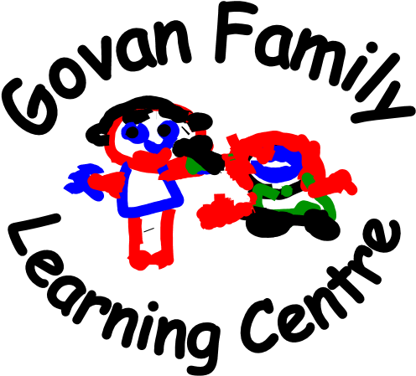

Head of Centre
Marilyn Steele
Child Protection Co-ordinator

Depute Head of Centre
Jillian Logan
Child Protection Co-ordinator

Acting Child Development Team Leader
Sophie Johnston

Lead Practitioner of Attainment
Carly Metcalfe

Dear Parent/Carer

The staff would like to extend a warm welcome to you and your child to Govan Family Learning Centre. We are a Glasgow City Council early years establishment which is non-denominational.

We see this as the beginning of a positive partnership which will help us all provide the best learning opportunities for you child.

The aim of this handbook is to give parents/carers information, which we hope they will find both useful and helpful.

If you have any suggestions, which you feel would benefit the service we provide, I would be more than happy to hear from you.

If you require any additional information or advice, please do not hesitate to speak to myself, or a member of our team.

Yours sincerely

Marilyn Steele
Head of Centre

Last updated 21 October 2025

Our Contact Details

Govan Family Learning Centre
337 Langlands Road
Glasgow
G51 4AW
Tel: 0141 445 1817
Fax: 0141 445 5018

Email: headteacher@govan-nursery.glasgow.sch.uk

Glasgow City Council: www.glasgow.gov.uk/en/residents/goingtoschool gfis@glasgow.gov.uk
www.gfis.org.uk

Roll and Capacity

Present Roll at each Stage

0-2 years 12
2-3 years 27
3-5 years 33
(Full Time equivalent)

Capacity

0-2 years |  | 12
2-3 years |  | 20
3-5 years |  | 24
(Full time Equivalent)

Stages Covered

We accept children from 6 weeks of age up to and including pre-school children.

OUR STAFF TEAM

Management Team

Marilyn Steele Head of Nursery (Child Protection Co-ordinator)
Jillian Logan Deputy Head of Centre (Child Protection Co-ordinator)

Sophie Johnston | Acting Team Leader
Carly Metcalfe | Lead Practitioner of Attainment
 | Baby Room
Michelle Devlin | Child Development Officer
Arlene Monaghan | Child Development Officer
Frances Kennedy (Temp) | Child Development Officer
 | 2-3 year olds
Sarah Haggis | Child Development Officer
Denise Kilpatrick-Stone | Child Development Officer
Ashley McGarrachan | Child Development Officer
Lisa Rennie | Child Development Officer
Ghazala Younas (Temp) | Child Development Officer

3-5 year olds

Lucy McBride | Child Development Officer
Michelle Durham | Child Development Officer
Jen Bryce | Child Development Officer
Toni McMahon | Child Development Officer (Maternity Leave)
Shannon O’Connor | Child Development Officer (Maternity Leave)
Victoria Reilly | Pupil Support Assistant

Clerical Support

Pauline Doherty Clerical Assistant

PALS

Mark Copstick Janitor
Caroline Dunn Domestic Assistant

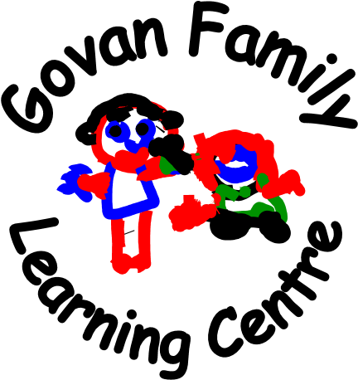

Our vision

In Govan Family Learning Centre, we work alongside the community to provide a safe, stimulating, inclusive and nurturing environment that encourages individuals to develop skills for life and become ambitious about their future. Everyone involved in the life of the centre will be encouraged to promote our values and embed them into everyday life. We aspire to continually develop a rich and relevant learning environment that is fun and inspiring and promotes individuality, diversity and equality.

We value:

Respect, Learning, Kindness, Trust and Friendships

We aim to:

- Provide a safe, stimulating learning environment, both inside and outdoors that nurtures and empowers each child, respects their individuality, builds their self-esteem, values and celebrates their individual achievements and successes.
- Ensure that every opportunity is taken to raise the attainment of our children and families.
- Value the role of the parents/carers and work in partnership to provide positive outcomes for all service users.
- Recognise the importance of play and the positive impact it has on a child’s development.
- Use a holistic approach to encourage, and where possible support, adults to explore opportunities for learning.
- To promote health and wellbeing through a healthy balanced diet and offer a wide variety of opportunities for children to explore emotions and enjoy exercise and physical activity.
- We strive to promote equity and encourage all service users to show respect towards each other.



HOURS OF OPENING

The nursery will be open between the hours of 8.00AM to 6.00 PM Monday to Friday.

DAILY SESSIONS

1140 SESSIONS 8.00 TO 12.45PM
13.00 TO 17.45PM

FULL TIME SESSION AS ALLOCATED AT ADMISSION.
Any session out with the above are considered depending on individual circumstances at the discretion of the admission panel. 8.00AM- 17.45PM

ESTABLISHMENT YEAR

The nursery is open 50 weeks of the year with the exception of the following days:
In-Service Days, Public Holidays and the days between Christmas and New Year.
Should an emergency closure of the centre be necessary i.e. in the event of a gas leak, abnormal temperatures, burst pipes we will endeavour to inform you as soon as possible

2025-2026 planned closure dates

2025
Return to Nursery for children and staff | Tuesday, 12 August 2025 (Return date for Teachers & In-Service)
In-Service | Wednesday, 13 August 2025
Return Date for all Children | Thursday, 14 August 2025 (Return Date for all Children)
September Weekend | Friday 26 and Monday 29 September 2025
In-Service | Friday 10, October 2025
October Week | Monday 13 to Friday 17 October 2025
Christmas/New Year (Term Time Contracts) | Friday 19 December to Friday 2 January 2026 (inclusive)
2026
Return to Nursery for children and staff | Monday 5 January 2026
Mid-Term | Monday 16 and Tuesday 17 February 2026
In-Service | Wednesday 18 February 2026
Easter Weekend | Friday 3 April and Monday 6 April 2026
Spring Holiday | Monday 6 April to Friday 17 April 2026
May Day | Monday 4 May 2026
In-Service | Thursday 7 May 2026 (In-service day to coincide with Scottish Parliamentary election, but may be subject to change)
May Weekend | Friday 22 and Monday 25 May 2026
Nursery closes for Term Time Contracts | Thursday 25 June 2026

CLOSURE

We make every effort to maintain a full educational service, but on some occasions, circumstances arise which lead to disruption. Establishments may be affected by, for example, severe weather and temporary interruption of transport, power failures or difficulties of fuel supply. In such cases we shall do all we can to let you know about the details of closure or re-opening. We shall keep you informed by using letters, notices in local shops and community centres, announcements in local places of worship and announcements in the press and on local radio.

ADMISSIONS POLICY

All nursery places are allocated in line with Glasgow City Council’s Admissions and Charging policy for early years.

Nursery Staff will be happy to advise how this policy works.

An admission panel is held for children aged 0-3 years within the Govan area. Presently our under-three’s admission panel consist of the Heads of Establishment of Govan Family Learning Centre, Festival Park Day Nursery and Broomloan Nursery School.

Our 3-5-year old Admissions Panel consists of the Heads of Establishments of Govan Family Learning Centre, Festival Park Day Nursery, Broomloan Nursery School, Ibrox Nursery Class and
St Constantine’s Nursery Class.
The panel meets at least three times a year and review applications for nursery places. If we are unable to allocate your first choice of place, we will then consider what else is available.

ENROLMENT

Once your child has been allocated a place in the centre you will be invited along with your child to meet his or her keyworker.

What is a keyworker?

A Keyworker is a qualified Child Development Officer who is responsible for a small group of children and their families, they are known as PRACTITIONERS.

They will be your first point of contact for any support difficulties or enquiries.
Time will be set aside for you to share information about your child and his or her interests with their keyworker.

They will get to know your child, provide experiences which encourage independent learning and support your child in reaching his or her full potential.
Your child’s keyworker will consult with you and keep you informed regarding your child’s development.

GETTING STARTED

Starting nursery can be challenging for some children, in order to support you and your child in this transition from home to nursery we have a settling in programme.
Children are individuals and adapt to new situations differently, therefore we ask that parents/carers support this programme by making themselves available during this period. practitioners will guide you through these transitions.

NURSERY CHARGES

The charges for nursery provision will vary according to individual circumstances; some families will be exempt from charging or entitled to a reduced fee’s level. The Head of Establishment can provide more information on the criteria for exemption or reduction. Charges will be payable four weekly in advance.
You are required to pay for any additional hours of childcare you child is allocated, whether or not they are used. (i.e. a family allocated 9am-5pm will be expected to pay for the full number of hours even if they choose to collect their child at 4pm). Confirmation of the additional hours allocated will be given in a written contract at the start of the placement.
The Government funding supports the provision of free part time nursery places for children eligible, aged 3-5 years, some 2-year-old children may be eligible for free funding.

CHARGING RATES 2024/2025

Non-resident Standard Rate (3 to 5’s) |  | £5.50 per hour
Resident Discounted Rate (3 to 5’s) |  | £4.50 per hour
Non resident Standard Rate (0 to 3’s) |  | £4.00 per hour
Resident Discounted Rate (0 - 3’s) |  | £3.00 per hour
Resident Reduced Rate |  | £1.00 per hour
Resident Second Child Rate |  | £2.20 per hour
Resident Third Child Rate |  | £1.70 per hour


MEALS AND SNACKS ARE PROVIDED BY CORDIA (SERVICES)

Lunch £1.52 per meal
Snacks FREE

All charges including those for meals are subject to annual review. Contact the Head of Establishment for up-to-date details.
Children and young people of parents/carers receiving Income Support, Income Based Job Seekers Allowance, Working Tax Credit, universal credit (where income is less than £19,995) are entitled to a free midday meal. Information and application forms for free establishment meals may be obtained from establishments and from Grants Section at Education Services headquarters.

TOY FUND CONTRIBUTIONS

To enable our staff to provide resources for your child, we ask for £2.00 per week. Contributions can be directly into the nursery bank account or by cash to Pauline our Clerical Assistant.



Items we can purchase include:
- Baking ingredients
- Sun cream
- Birthday cards, books
- Outdoor & Indoor resources
- Outings to places in Glasgow
- Celebrations such as Graduation, Mothers/Father’s Day etc.

ARREARS OF CHARGES

In accordance with Glasgow City Council’s Charging Policy, where a parent/carer is 4 weeks in arrears of payment, a review of the hours allocated will take place. This will, unless in the most exceptional circumstances, result in hours being reduced to part-time entitlement for eligible 3 and 4 year olds, or in the case of children under 3 years old the place may be withdrawn.

ABSENCES

We ask that you notify the centre if your child is going to be absent and advise us of any illnesses. Attendance is monitored and should no contact be made, we will contact you.

ARRIVAL AND COLLECTIONS

For any person collecting your child from nursery, information regarding who is collecting your child must be communicated to us at drop off or by telephone call. If the person is unknown to the nursery, we would provide a one-time password to allow for security and health and safety of your child.

EMERGENCY CONTACTS

Parents whose children attend the Centre are asked where possible to provide us with the names, addresses and telephone numbers of two contact persons for use of in an emergency. It is essential that these contacts and numbers are kept up to date.

ILLNESSES

Should your child become ill while at the centre he/she will be made as comfortable as possible whilst every attempt is made to contact you! Should the illness seem to be of a serious nature your child will be taken to the Queen Elizabeth South West University Hospital and you will be advised to come and meet us at the hospital.

ACCIDENTS

Should your child be involved in an accident at the centre it will be logged in Glasgow City Council’s Accident Book which you will be asked to sign on collection of your child. Should it be of a serious nature then we will contact you, and advise you that we are taking your child to Queen Elizabeth South West University Hospital where you will be asked to meet us.

MEDICATION

If your child needs medication whilst at the centre, you must discuss this with the Head of Centre.
Practitioners can only administer medicine prescribed by a G.P.
A form will have to be filled in authorising nursery staff to administer the medicine. Practitioners are not medically qualified.

Should you child have a medical condition requiring treatment and monitoring e.g. Asthma, Epilepsy, please notify a member of the management team so we can discuss a joint care plan. It is vitally important that we are kept up to date with any changes in your child’s medication/medical condition.

SECURITY

FRONT DOOR

It is important that on entering and leaving the building you secure the front door. Please be patient when you press the buzzer as practitioners are working with the children. Please always ensure you close the door behind you as you enter and exit the building.

FIRE DRILLS

Fire drills are held regularly. These involve complete evacuation of the building. All drills are logged. Alarm systems are tested weekly on a Monday 10.20am and 2.20pm – short blast. For a complete evacuation/alert you will hear a continuous siren and a voice to evacuate the building.
Should you be in the building and the alarm sounds please proceed immediately to the nearest exit and go to the assembly point at the entrance gate. Please don’t return to playroom as staff will evacuate children.


PRAMS/BUGGIES-OUTDOOR STORAGE UNITS

Many parents bring their children to nursery in buggies. There is a pram storage container available outside.
Remember we have no insurance cover for theft. Under no circumstances can prams or buggies be left at the front door. This creates a very serious fire risk to your children by blocking an emergency exit.

 SUITABLE CLOTHING

Children have the best fun when they are doing creative activities. We will always try to make sure they wear aprons, but accidents happen so please dress your child in suitable clothes. Remember lots of fun and learning takes place outdoors, could you please ensure your child is dressed for the weather hail, rain or shine.

If your child travels by car, please make sure they have a suitable jacket. It helps if you put your child’s name on their clothing to prevent confusion should we have two items the same. We also ask that your child has soft shoes in nursery to change into from their outdoor shoes.

There are forms of dress which are unacceptable, such as items of clothing which:
- potentially encourage animosity (such as football colours)
- could cause offence (such as anti-religious symbolism or political slogans)
- could cause health and safety difficulties, such as loose-fitting clothing, dangling earrings
- carry advertising, particularly for alcohol or tobacco: and could be used to inflict damage on other children or be used by others to do so

Glasgow City Council is concerned at the level of claims being received regarding the loss of children’s and young people’s clothing and/or personal belongings. Parents/Carers are asked to assist in this area by ensuring that valuable items and unnecessarily expensive items of clothing are not brought to the Establishment. Parents/Carers should note that the authority does not carry insurance to cover the loss of such items, and any claims submitted are likely to be met only where the authority can be shown to have been negligent.

SUPPORTING OUR CHILDREN’S HEALTH AND WELLBEING

We ask that you provide nappies, nappy sacks, wipes and a change of clothes if your child is a baby or is toilet training. We are a Health Promoting nursery, therefore we provide healthy choices of food and snack. At enrolment we will discuss any dietary requirement that you child may have. In support of this policy, we ask you to discourage your child from bringing along sweets and fizzy drinks to nursery. Birthdays are also a time for celebration. However, we ask that you refrain from bringing sweets and goody bags.


GUIDELINES ON BABY FEEDS

To assist us with the safe management of preparing baby feeds we have put the following guidelines in place.

- Staff will meet with parents on your child’s induction day to discuss feeding arrangements.

- A bottle with a cap and teat should be provided solely for nursery use, we will sterilize the bottle as required.

- An unopened tin of formula milk should be brought in for use in the nursery.

- On arrival at the nursery please inform the staff member when your child was last fed and when the next feed is due. Feeds will be prepared as required.

- For Health and Safety reasons NO readymade bottles or partial feeds will be accepted.

Thank you for your co-operation in helping us to keep your child safe in line with our infection control policy.

SUN CREAM AND SUN HATS 

In the early stages of Spring, parents/carers will be asked to provide the nursery with suncream. If you child has sensitive skin or an allergy to suncream then you will be asked to provide the necessary sun cream suitable for your child from the Doctor. We purchase suncream from our Toy Fund.

On starting nursery, we encourage all parents/carers to buy a nursery sunhat and drawstring bag. During periods of good weather all children attending nursery must wear a sunhat when learning outdoor. On very hot days children will not be outdoors during the hours of 11am-3pm unless they are in a shaded area.

GLASGOW CITY COUNCIL

CHILD SAFETY/CHILD PROTECTION POLICY

All education establishments and services must take positive steps to help children protect themselves by ensuring that programmes of health and personal safety are central to the curriculum. All education establishments should provide curriculum that ensures that children have a clear understanding of the difference between appropriate and inappropriate behaviour on the part of another person, no matter who.

Schools, establishments and services must create and maintain a positive ethos and climate which actively promotes child welfare and a safe environment by:

- Ensuring that children are respected and listened to
- Ensuring that programmes of health and personal safety are central to the curriculum
- Ensuring that staff are aware of child protection issues and procedures
- Establishing and maintaining close working relationships and arrangements with all other agencies to make sure that professionals collaborate effectively in protecting children.

Should any member of staff have concerns regarding the welfare or safety of any child they must report these concerns to the Head of Establishment, or the person deputising for the Head, after judging that there may be grounds for concern regarding the welfare and safety of any pupil must then immediately advise the duty Senior Social Worker at the local Social Work Services Area Office of the circumstances.

As well as the above, staff also have a responsibility to implement The Scottish Executive Document Safe and Well. This document offers guidance in relation to good practice; it also includes The Children’s Charter and National Framework Standards for protecting children and young people. An abbreviated version of Safe and Well can be found on the nursery notice board.



The National Framework Standards
&

The Children’s Charter



The National Framework for Standards is the means by which the ‘Charter for Children’ will be delivered. The Charter has been developed in consultation with children and young people who have experienced harm and require help and protection.

Standard 1 Children get the help they need when they need it

Standard 2 All professionals, including school staff, take timely and effective action to protect children

Standard 3 All professionals, including school staff, ensure children are listened to and respected

Standard 4 All agencies and professionals, including school staff share information about children when it is necessary to protect them

Standard 5 All agencies and professionals, including schools and school staff, work together to assess needs and risks and develop effective plans

Standard 6 All professionals, including school staff, are competent and confident

Standard 7 All agencies, including schools, work in partnership with members of the community to protect children

Standard 8 All agencies, individually and collectively, including schools and their partner, demonstrate leadership and accountability for their work and its effectiveness

Children’s Charter: “Children’s Views”

‘Speak with us’ ‘Listen to us’ ‘Involve us’ ‘Get to know us’

‘Respect our privacy’ ‘Be responsible to us’ ‘Take us Seriously’

‘Think about our Lives as a Whole’ ‘Put us in touch with the Right People’

‘Use your Power to Help’ ‘Make things Happen when they should’

‘Help us be Safe’ ‘Think carefully about how you use Information about us’

PARENTAL PARTNERSHIP

WORKING TOGETHER TO SUPPORT LEARNING 

Staffs recognise and value the important role parents have as prime educators of their children and look forward to working with you supporting our young people to become active curious independent learners.
Your child’s keyworker is available to discuss your child’s progress or any concerns you may have with regard to their learning.
Twice yearly normally in June and November parent’s evenings are held and you will be invited along to discuss your child’s progress with his/her keyworker.

PROMOTING POSITIVE BEHAVIOUR

In Govan Family Learning Centre, we encourage an ethos that promotes positive behaviour. All children at different periods will present aspects of challenging behaviour. Practitioners in Govan Family Learning Centre are trained in a variety of strategies that support challenging behaviour such as:

- Promoting Alternative Thinking Strategies
- Early Talk Strategies
- Promoting Positive Parenting (Triple P)

If we are experiencing difficulty with your child’s behaviour, we will discuss this with you so that we can work together with an agreed plan to encourage positive behaviour in your child.
Certain types of behaviour in young children can be disruptive and distressing to others e.g. biting, bullying, our main concern as a nursery staff is for the wellbeing and safety of the children in our care.
Staff will be respectful, firm and consistent as they guide your child towards acceptable behaviour. Under no circumstances would nursery staff smack your child.

*A Policy on Promoting Positive Behaviour is available to read at the centre. Please ask at the office.

TRANSITION

Coming to Nursery is a big event for children. When you child begins, you will be allocated a key worker. The key worker will work with you and your family and discuss your child’s likes/dislikes, preferences and routines. All this information will be logged in our “All About Me” booklets. This booklet will be added to during your child’s time at nursery and kept in their own personal folio.
Staff will use the children’s folios and “All About Me” booklets to support the children when moving rooms in the nursery. Transition from room to room in the nursery is both an exciting and anxious time for the children. Practitioners will work closely with parents/carers to support children within these transitions.

When your child is in their pre-school year, you should register your child in November or January of the following year with your local primary school. Practitioners will support the children in preparing for school and work alongside families to help the children be as prepared for their big move.

SUPPORT FOR PARENTS/CARERS

As a Family Learning Centre, we offer services to the whole family.

We have offered courses on various topics e.g. Computing, First Aid, Parenting Classes and parents have found these exciting and helpful.

If you have any specific interest you would like accessed in the centre, please let us know and we will try and secure delivery, and should you wish to book the parent’s room for an event please contact reception who will assist you.



GIRFEC AND THE NAMED PERSON

GIRFEC isn’t an extra thing people have to do. It’s a way for those who support children to work differently, making sure that they are all on the same page. Where needed, GIRFEC links day-today work in education, health, policing, social work and the voluntary sector – in fact any organisation whose staff come into direct contact with children. It makes it easier for those different organisations to communicate consistently with each other, and with parents, carers, children and young people.
GIRFEC provides a structure that helps people to work in the same way and use the same language. This allows discussions with the child and their family to focus on what is good in a child’s life, and what might need attention or support.
It’s the bedrock for all children’s services and can also be used by practitioners in adult services who work with parents or carers.
The approach helps practitioners focus on what makes a positive difference for children and young people – and how they can act to deliver these improvements. Getting it right for every child is being threaded through all existing policy, practice, strategy and legislation affecting children, young people and their families.

What Getting it Right for Every Child means:
For children, young people and their families:
- They understand what is happening and why
- They have been listened to carefully and their wishes have been heard and understood
- They will feel confident about the help they are getting
- They are appropriately involved in discussions and decisions that affect them
- They can rely on appropriate help being available as soon as possible
- They will have experienced a more streamlined and co-ordinated response from practitioners

For Practitioners:
- Putting the child or young person at the centre and developing a shared understanding within and across agencies
- Using common tools, language and processes, considering the child or young person as a whole, and promoting closer working where necessary with other practitioners

If you would like to access support from the Named Person Service, please contact your Health Visitor.

CURRICULUM PLANNING, ASSESSMENT AND REPORTING

In line with all other establishments, Early Years centres are implementing the new Curriculum for Excellence.

A Curriculum for Excellence is a curriculum for children and young people aged 3-18 years. It recognises that children learn through all experiences, in the family and community. The aspiration is that every young child should become successful learners, confident individuals, responsible citizens and effective contributors in life.

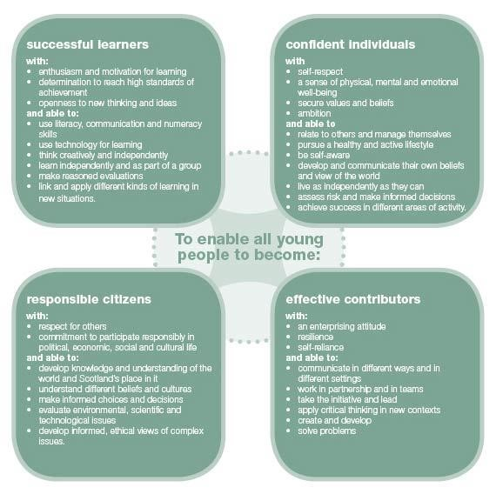

The curriculum is the totality of experiences which are planned for children and young people throughout their education. Experiences and outcomes set out expectations for children’s learning and development through 8 key areas.

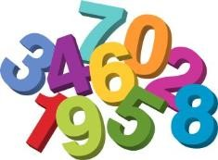

- Expressive arts
- Language and Literacy
- Health and Wellbeing
- Mathematics and numeracy
- Religious and moral education
- Sciences
- Social studies
- Technologies

Experiences set expectations for the kinds of activities which promote learning development.

Outcomes set out what the child or young person will be able to explain, apply or demonstrate.

All curriculum planning is displayed outside the playrooms, and parents/carers are invited to give their ideas and suggestions.

Planning in early years is based on the children’s developmental needs, and the children’s interests are at the core of this planning. At Govan FLC staff observe the children at different times within the nursery, this information is shared at a planning meeting, the key worker will then create the child’s own individual learning plan to take their interests forward.

Staff will set out individual learning activities to scaffold your child’s interests.

The centre also has a variety of resources, which can be borrowed and used at home.

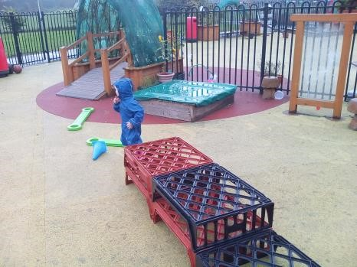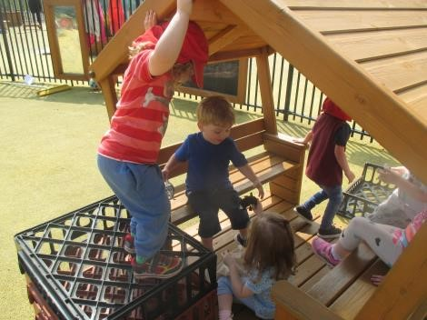

Planning for our younger children’s learning

Planning for our children under 3s is a vital part of our service. To ensure that positive outcomes for children under 3 are achieved we use the Scottish Executives Birth to Three guidelines to promote and support the rights of the child, respect, relationships and responsive care. Our aim is to give our youngest children a foundation on which to build and support them at this early stage in their learning journey. The guidelines focus on four key areas to promote learning and development for children aged 0-3. These are:

- Emotional Well Being and Social Competence
- Curiosity
- Communication
- Movement & Co-ordination
- Five to Thrive
- Schematic Play

We also focus on where each child’s individual interest is scaffolded by staff.

The curriculum we offer will be accessible to all children; each child’s needs shall be included in the curriculum planning and they will have access to all learning experiences.

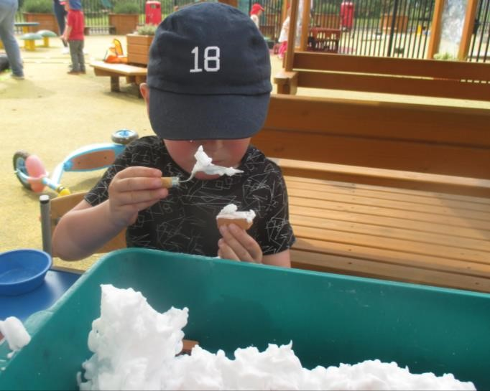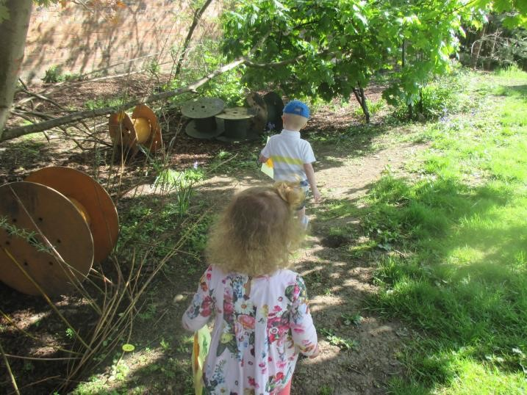

ADDITIONAL SUPPORT NEEDS/ACCESSIBILITY STRATEGY

The establishment has a duty to ensure that all our children and young people have equal access to the curriculum, supported as appropriate to their individual needs. This covers not only the content of planned activities and teaching strategies but also minor adaptations to the physical environment of our building to address the needs of children with physical or sensory impairments, including the relocation of playrooms to ground floors where feasible. We also need to ensure that parents/carers who have a disability have equal access to information about their child. This will involve, for example, relocating the venue for parents/carers meetings to facilitate physical access, provision of an interpreter for people who have a hearing impairment, agreeing a phone contact system to provide direct feedback to parents/carers.

If a child is identified as requiring additional support to help them learn then the Head of Centre will meet with you to discuss our concerns. Where it becomes apparent that a child needs such assistance for whatever reason, then every effort is made to consider how best to use the resources we have at our disposal for that child’s benefit. Parental co-operation is absolutely vital and staff will meet regularly with parents/carers to discuss how best to support the children. Nobody will be contacted without prior discussion with yourself. Parents can of course make referrals via their GP or Health Visitor.

Should your child have an additional support need we will work in partnership with you to identify additional support strategies all which would aid your child in accessing all curricular activities.

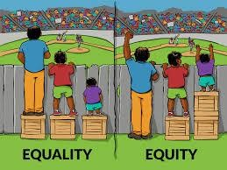

CENTRE IMPROVEMENT PLAN

Session 2025-2026

A number of areas which have been identified for development over the next year will be taken forward by staff and hopefully parents who may decide to join us in our task groups will mean we can work together to achieve successful outcomes for our children.

We will continue

- As we work towards a nurturing city: Recovery and Reconnecting, ensuring we meet the learning and care of all users.

- Raising attainment and achievement of all children through connecting education with the environment.

- An effective system for Self-Evaluation for improvement.

A full copy of our Improvement Plan and progress is displayed in the corridor.



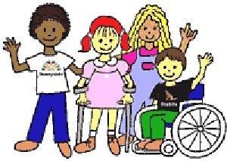

EQUAL OPPORTUNITIES and SOCIAL INCLUSION

There are equal opportunities for all children and young people in the centre irrespective of sex, race, religion and ability to participate fully in all aspects of the centre’s activities.

We aim to:

- Promote respect for each other and recognise and value difference.
- Help our children understand and challenge discrimination.
- Ensure that our approach and materials used in nursery are appropriate and meet the needs of all children.

The Head of Centre is responsible for ensuring that the City Council’s Equal Opportunities policy is adhered to and can be contacted for further information and advice.

The Education Authority requires every nursery to produce its own Race Equality Policy to comply with The Race Relations (Amendment) Act 2000. A copy of the policy is held in the nursery’s office.

DEALING WITH RACIAL HARASSMENT

The Race Relation Act of 1976 makes it unlawful to discriminate against someone because of her/his colour, race, ethnic or national background. The Act makes it the duty of Glasgow City Council to eliminate unlawful racial discrimination.

In 1999 the guidelines “Dealing with Racial Harassment” were issued to assist all staff in dealing with such incidents.
The adoption of an ant-racist approach should be seen as one part of the continuing attempt to improve the quality of education
Glasgow City Council recognises that support from the home is essential if these aims are to be achieved. Every child in Glasgow has the right to be happy and secure at nursery.

BULLYING

Bullying behaviour will not be tolerated within Glasgow City Council’s educational establishments. All children in Glasgow’s educational establishments have an entitlement ‘to work (and play) in a learning environment in which they feel valued, respected and safe and are free from all forms of abuse, bullying or discrimination’. (A Standard for Pastoral Care in Glasgow Establishments). In 2009, Glasgow City Council published its revised Anti-Bullying Policy, incorporating the requirement to record and report all discriminatory behaviours within educational establishments. All establishments are required to review their policy in light of this. Parents and carers have a significant role to play in helping to address this problem. For this reason, any anti-bullying strategy must stress the importance of partnership with the parents and carers of their children.



THE FREEDOM OF INFORMATION (SCOTLAND) ACT 2002

The Freedom of Information (Scotland) Act 2002 enables any person to obtain information from Scottish public authorities. The Act applies to all Scottish public authorities including; Scottish Executive and its agencies; Scottish Parliament; Local Authorities; NHS Scotland; Universities and further education colleges; and the Police.
Public authorities have to allow access to the following information:

- The provision, cost and standard of its service
- Factual information for decision-making
- The reasons for decisions made by it

The legal right of access includes all types of ‘recorded’ information of any data held by the Scottish public authorities. From 1st January 2005, any person who makes a request for information must be provided with it, subject to certain conditions.

Further information is provided on the Glasgow City Council web-site; www.glasgow.gov.uk/en/yourcouncil/freedomofinformation

Internet facilities are provided at all Glasgow City Council Public Libraries and Real Learning Centres

DATA PROTECTION ACT 2018

Information on children, parents and carers is stored on a computer system and may be used for registration, assessment and other administrative duties. The information is protected by the Data Protection Act 2018 and may only be disclosed in accordance with the Codes of Practice. We shall not share any of your information with a third party. All personal details will be kept in a locked cabinet. If we require your permission for any personal information a member of the management team will speak to you personally.

If you require any further information please contact the Centre

Suggestions and Complaints
We are always anxious to maintain and improve our service. If you have any suggestions to make about the service, please contact the Head of Establishment in the first instance. Similarly, if you want to complain about us, and feel that your complaint has not been satisfactorily resolved with the Establishment Head you can contact the Customer Liaison Unit at:

Education Services:
Customer Liaison Unit
Education Services
Glasgow City Council
City Chambers
40 John St
GLASGOW
G1 1HL

Telephone: - 0141 287 5384
E-mail: - education@glasgow.gov.uk

LEARNING COMMUNITY

Govan Family Learning Centre is part of the Govan Bellahouston Learning Community.

All local Education establishments form pre-5 to secondary work together to support learning, achievement and positive transitions for children and young people in the Govan/Bellahouston area. A copy of the Learning Community Improvement Plan is displayed in the hall.

Useful Addresses

Social Care and Social Work Improvement Scotland
Europa Building
Ground Floor
450 Argyle Street
Glasgow
G2 8LG
Telephone Number - 0141 242 0391
Fax 0141 242 0425

You may also find the following names and addresses useful:

Nicola Sturgeon MSP South West
Suite 298 Social Work Services
3rd Floor Rowan Business Park
93 Hope Street Ardlaw Street
Glasgow Glasgow
G2 6LD G51 3RR
Tel.: 0141 276 8840
Out of Hours: 0800 815505

Queen Elizabeth University Hospital Govan Health Centre
Govan Road |  | 5 Drumoyne Road
Govan |  | Govan
Glasgow |  | Glasgow
G51 |  | G51 4BJ
Tel.: 0141 201 1100 |  | Tel.: 0141 531 8400

Public Transport Arrangements:

First Bus No 3 & 34 stop outside the school on Langlands Road

Although this information is correct at time of printing, there could be changes affecting any of the matters dealt with in the document:
• before the commencement or during the course of the establishment year
• in relation to subsequent establishment years

