

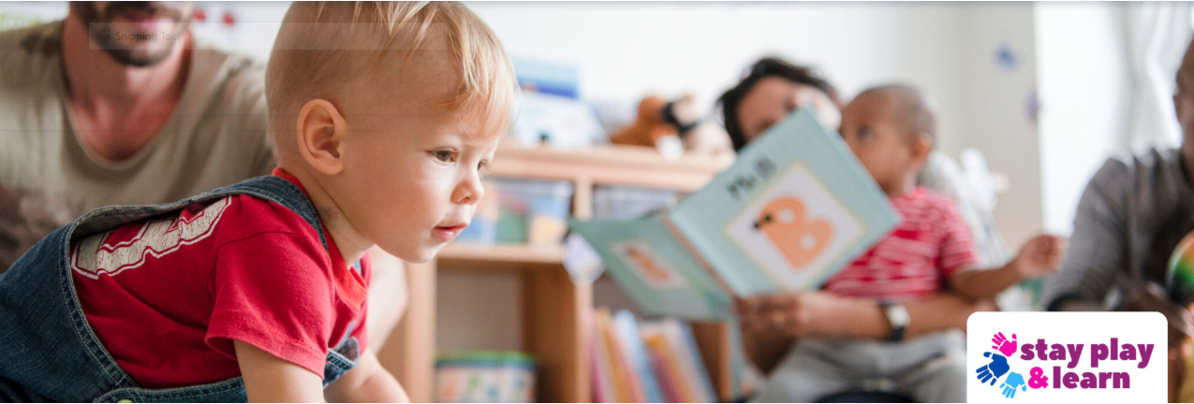

Stay Play and Learn
Family Wellbeing Services are designed for eligible children aged 9 months to 3 years in Barmulloch and Bridgeton, Glasgow. Our services provide a supportive and nurturing environment for families.
During these sessions, families work with our specialist staff to develop their skills, bond with their child and other parents, and enjoy new experiences as a group.
Parents also have the opportunity to take some wellbeing time for themselves, participating in activities at the community centre such as ESOL classes, group activities, and music classes. This allows parents to recharge and engage in personal development while their children are cared for in a safe and supportive environment.
Our sessions are designed to help parents build improved parent-child bonding and attachment, access practical information and support on baby and child health, nutrition, early development, and family health and wellbeing. We aim to build essential parenting knowledge and skills, helping parents feel stronger, better supported, and more confident in meeting their child’s holistic needs.

